Project Summary
Project: Project 1
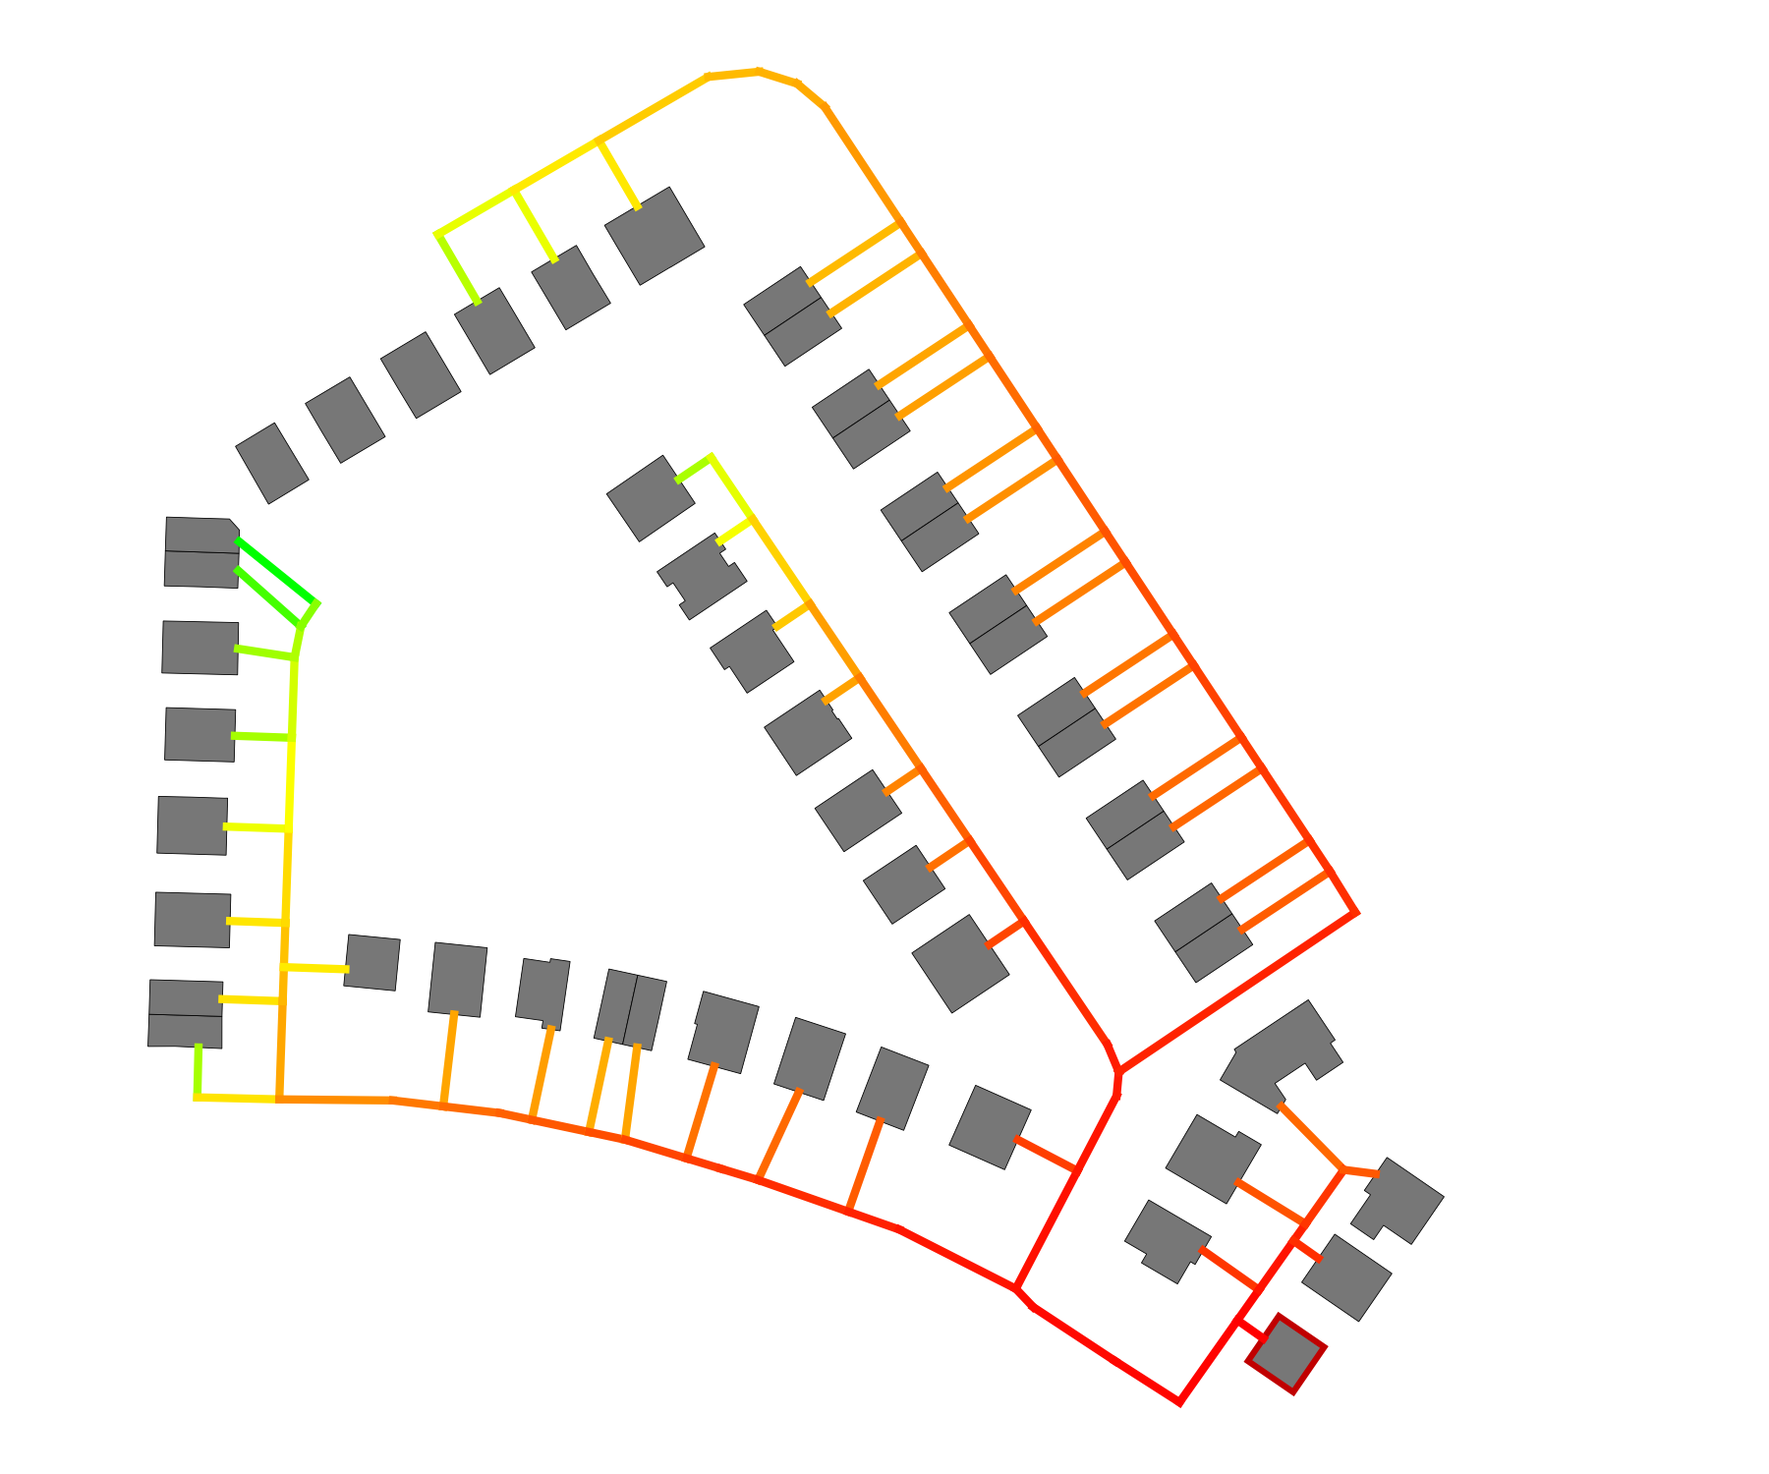
Client: | Example Company
 | Example street 1
 | 12345 Example city
Created by: | Engineering office Example company
 | Example street 2
 | 12345 Example city

Report created by: Test
Creation date: 09.09.2026 (13:46)

Table of contents
1 Summary 1
1.1 Scenario comparison 1
2 Supply scenarios 2
2.1 Scenario 1: Scenario 1 2
2.1.1 Buildings 2
2.1.2 Heat network 4
2.1.3 Energy hub 8
2.1.4 Economic results 11
2.2 Scenario 2: Scenario 2 15
2.2.1 Buildings 15
2.2.2 Heat network 16
2.2.3 Energy hub 20
2.2.4 Economic results 23
3 Scenario comparison 28
4 Appendix 33
4.1 Buildings 33
4.1.1 Buildings: Economic parameters 33
4.2 Heat network 35
4.2.1 Heat network: General parameters 35
4.2.2 Heat network: Pipe parameters 36
4.2.3 Heat network: Design criteria 37
4.2.4 Heat network: Fluid parameters 39
4.3 Energy hub 39
4.3.1 Energy hub: General parameters 39
4.3.2 Energy hub: Technology settings 40
4.3.3 Energy hub: Economic parameters 42
4.3.4 Energy hub: Import and feed-in 43
4.4 Economic parameters 44
4.5 Project and weather data 45
4.5.1 General project data 45
4.5.2 Weather data 45
4.6 Additional information and data sources 50

Tables
Table 1: Scenario 1: Fact sheet for the supply scenario: Scenario 1 2
Table 2: Scenario 1: Heat demands of the buildings 3
Table 3: Scenario 1: Cooling demands of the buildings 3
Table 4: Scenario 1: Electricity demands of the buildings 3
Table 5: Scenario 1: Installed building energy systems 4
Table 6: Scenario 1: Heat balance of the heat network 4
Table 7: Scenario 1: Cooling balance of the heat network 4
Table 8: Scenario 1: Electricity balance of the district 4
Table 9: Scenario 1: Properties of the heat network 5
Table 10: Scenario 1: Pump work and pressure 8
Table 11: Scenario 1: Pressure losses (critical path) 8
Table 12: Scenario 1: Sizing of the technologies in the energy hub 8
Table 17: Scenario 1: Energy import 9
Table 18: Scenario 1: Energy feed-in 10
Table 19: Scenario 1: Electricity generation and import 10
Table 20: Scenario 1: Heat generation and import 10
Table 21: Scenario 1: Emissions 10
Table 22: Scenario 1: Primary energy factor 10
Table 23: Scenario 1: Economic KPIs 11
Table 24: Scenario 1: Subsidies 11
Table 25: Scenario 1: Cost breakdown in € 11
Table 26: Scenario 2: Fact sheet for the supply scenario: Scenario 2 15
Table 27: Scenario 2: Heat demands of the buildings 15
Table 28: Scenario 2: Cooling demands of the buildings 15
Table 29: Scenario 2: Electricity demands of the buildings 16
Table 30: Scenario 2: Installed building energy systems 16
Table 31: Scenario 2: Heat balance of the heat network 16
Table 32: Scenario 2: Cooling balance of the heat network 16
Table 33: Scenario 2: Electricity balance of the district 17
Table 34: Scenario 2: Properties of the heat network 17
Table 35: Scenario 2: Pump work and pressure 20
Table 36: Scenario 2: Pressure losses (critical path) 20
Table 37: Scenario 2: Sizing of the technologies in the energy hub 20
Table 42: Scenario 2: Energy import 21
Table 43: Scenario 2: Energy feed-in 22
Table 44: Scenario 2: Electricity generation and import 22
Table 45: Scenario 2: Heat generation and import 22
Table 46: Scenario 2: Emissions 22
Table 47: Scenario 2: Primary energy factor 22
Table 48: Scenario 2: Economic KPIs 23
Table 49: Scenario 2: Subsidies 23
Table 50: Scenario 2: Cost breakdown in € 23
Table 51: Optimization of the energy hub 28
Table 52: Economic KPIs 28
Table 53: Cost breakdown in € 28
Table 54: Emissions and primary energy 32
Table 55: Cost parameters decentral technologies for scenario 'Scenario 1' 33
Table 56: Cost parameters decentral technologies for scenario 'Scenario 2' 34
Table 57: Heat network settings 35
Table 58: Hydraulic settings 36
Table 59: Pipe parameters: Kunststoff (Doppelrohr): BruggPipes: CALPEX DUO (normal) for scenario 'Scenario 1' 36
Table 60: Pipe parameters: Kunststoff (Doppelrohr): BruggPipes: CALPEX DUO (normal) for scenario 'Scenario 2' 36
Table 61: Pipe costs for all scenarios 37
Table 62: Sizing criteria: Kunststoff (Doppelrohr): BruggPipes: CALPEX DUO (normal) for scenario 'Scenario 1' 37
Table 63: Sizing criteria: Kunststoff (Doppelrohr): BruggPipes: CALPEX DUO (normal) for scenario 'Scenario 2' 37
Table 64: Fluid parameters 39
Table 65: Settings of the design optimization 39
Table 66: Settings of energy demands 39
Table 67: Ecologic parameters 40
Table 68: Emission and primary energy factors for scenario 'Scenario 1' 40
Table 69: Emission and primary energy factors for scenario 'Scenario 2' 40
Table 70: Biomass CHP 1: Settings 40
Table 71: Photovoltaics: Settings 40
Table 72: Solar thermal: Settings 41
Table 73: Geothermal probes 1: Settings 41
Table 74: Air-source heat pump: Settings 42
Table 75: Heat storage: Settings 42
Table 76: Cost parameters for scenario 'Scenario 1' 42
Table 77: Cost parameters for scenario 'Scenario 2' 43
Table 78: Electricity grid 43
Table 79: Natural gas 43
Table 80: Biomass 44
Table 81: Economic parameters 44
Table 82: Other costs: One-time costs for all scenarios 44
Table 83: Other costs: Annual costs for all scenarios 44
Table 84: Revenue settings: Components 44
Table 85: Revenue settings: Prices for all scenarios 45
Table 86: Project settings 45
Table 87: Geographical location (weather data) 45
Table 88: Customization of weather data 45

Figures
Figure 1: Specific costs and emissions 1
Figure 2: Scenario 1: Hourly total heat demand of all buildings 2
Figure 3: Scenario 1: Hourly total cooling demand of all buildings 3
Figure 4: Scenario 1: Distribution of pipe diameters 5
Figure 5: Scenario 1: Design result: Pipe Diameter and floor area of buildings 6
Figure 6: Scenario 1: Annual profile of supply and return temperature in the heat network 6
Figure 7: Scenario 1: Design result: Supply temperature and heat demand of buildings 7
Figure 8: Scenario 1: Heat flow: network to ground 7
Figure 9: Scenario 1: Diversity factor 8
Figure 10: Scenario 2: Distribution of pipe diameters 17
Figure 11: Scenario 2: Design result: Pipe Diameter and floor area of buildings 18
Figure 12: Scenario 2: Annual profile of supply and return temperature in the heat network 18
Figure 13: Scenario 2: Design result: Supply temperature and heat demand of buildings 19
Figure 14: Scenario 2: Heat flow: network to ground 19
Figure 15: Scenario 2: Diversity factor 20
Figure 16: Specific costs and emissions 31
Figure 17: Total costs and emissions 31
Figure 18: Energy import and feed-in 31
Figure 19: Energy demands 32
Figure 20: Design criteria: pressure gradient (Kunststoff (Doppelrohr): BruggPipes: CALPEX DUO (normal)) 38
Figure 21: Design criteria: flow velocity (Kunststoff (Doppelrohr): BruggPipes: CALPEX DUO (normal)) 39
Figure 22: Ambient air temperature (Annual profile) 46
Figure 23: Ambient air temperature (Heatmap) 46
Figure 24: Wind speed (Annual profile) 47
Figure 25: Wind speed (Heatmap) 47
Figure 26: Global horizontal irradiance (annual profile) 48
Figure 27: Global horizontal irradiance (Heatmap) 48
Figure 28: Direct normal irradiance (Annual profile) 49
Figure 29: Direct normal irradiance (Heatmap) 49
Figure 30: Horizontal infrared radiation (Annual profile) 50
Figure 31: Horizontal infrared radiation (Heatmap) 50

1 Summary

1.1 Scenario comparison
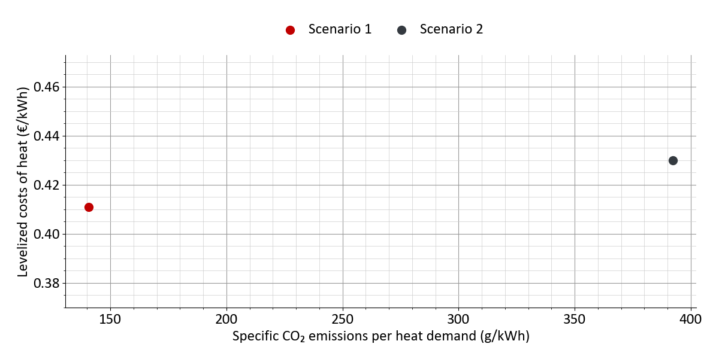
Figure 1: Specific costs and emissions

2 Supply scenarios

2.1 Scenario 1: Scenario 1
Fact sheet for the supply scenario
Table 1: Scenario 1: Fact sheet for the supply scenario: Scenario 1
Heat network | yes
Buildings | 38 residential buildings, 12 non-residential buildings
Connected buildings | 47
Installed Heatpumps in buildings | 3
Heat network type | Conventional district heating network  75 °C (constant) / 55 °C (constant)
Technologies in energy hub | Biomass CHP 1, Photovoltaics, Solar thermal, Geothermal probes 1

2.1.1 Buildings
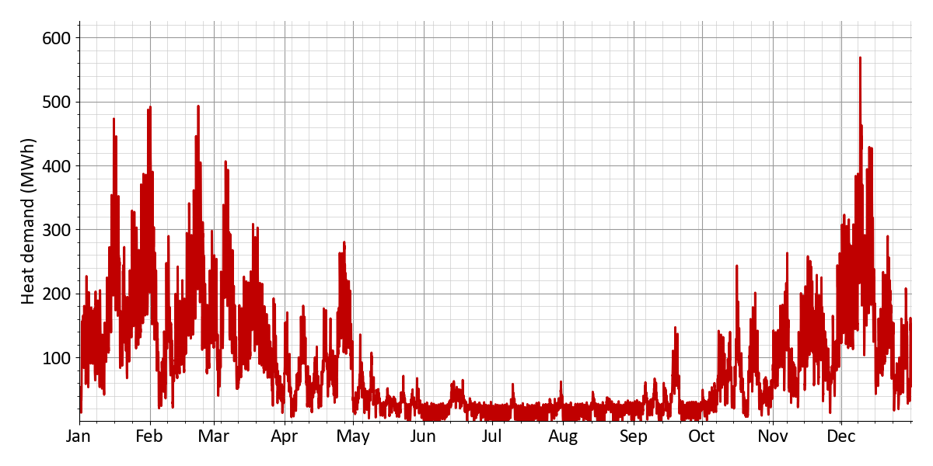
Figure 2: Scenario 1: Hourly total heat demand of all buildings
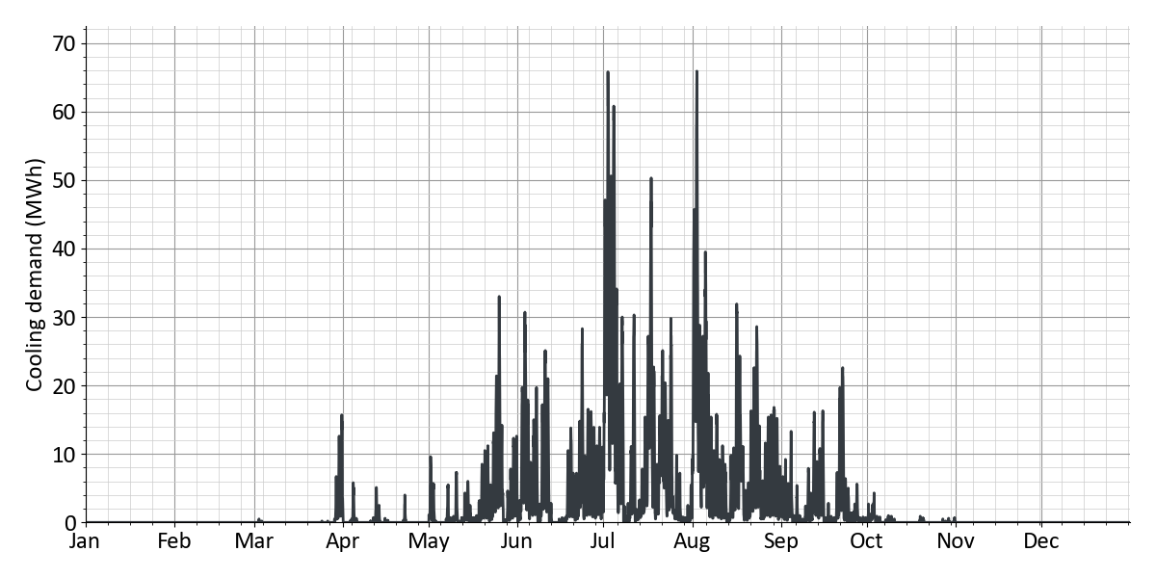
Figure 3: Scenario 1: Hourly total cooling demand of all buildings
Table 2: Scenario 1: Heat demands of the buildings
 | Annual energy | Peak power
Space heating | 623 MWh | 563 kW
Domestic hot water | 143 MWh
Total | 766 MWh
Heat generation of air-source heat pumps | – 39.4 MWh
Heat generation of decentral hot water heaters | – 9 MWh
Heat import of all buildings | 718 MWh | 516 kW
Heat losses | 164 MWh | 21.4 kW
Heating load at energy hub | 881 MWh | 537 kW

Table 3: Scenario 1: Cooling demands of the buildings
 | Annual energy | Peak power
Space cooling | 22.4 MWh | 66 kW
Process cooling | 0 MWh | 0 kW
Total | 22.4 MWh | 66 kW
Cooling generation of air-cooled chillers | – 22.4 MWh
Waste heat feed-in heat network | 0 MWh | 0 kW

Table 4: Scenario 1: Electricity demands of the buildings
 | Annual energy | Peak power
Plug loads | 6 MWh | 2.7 kW
E-mobility | 498 MWh | 153 kW
Total | 504 MWh | 154 kW
Operating power of all buildings | + 20.4 MWh
Electricity import of all buildings | 524 MWh

Table 5: Scenario 1: Installed building energy systems
 | Count | Installed capacity | Useful energy | Electricity demand | Fuel demand | SCOP
Heat transfer station | 47 | 987 kWₜₕ | 718 MWh | --- | --- | ---
Air-source heat pump | 3 | 52 kWₜₕ | 39.4 MWh | 8.9 MWh | --- | 4.4
El. hot water heater | 6 | 214 kWₜₕ | 9 MWh | 9 MWh | --- | ---
Storage (domestic hot water) | 47 | 14,100 l | --- | --- | --- | ---
Air chiller | 7 | 66 kWₜₕ | 22.4 MWh | 2.5 MWh | --- | 9

2.1.2 Heat network
Table 6: Scenario 1: Heat balance of the heat network
 | Annual energy | Peak power
Heat import of all buildings | 718 MWh | 516 kW
Heat losses | + 164 MWh | 21.4 kW
Heating load at energy hub | 881 MWh | 537 kW

Table 7: Scenario 1: Cooling balance of the heat network
 | Annual energy | Peak power
Waste heat feed-in heat network | 0 MWh | 0 kW

Table 8: Scenario 1: Electricity balance of the district
 | Annual energy | Peak power
Electricity import of all buildings | 524 MWh
Pump work | + 6.7 MWh | 4.9 kW
Electricity demand district | 531 MWh

Table 9: Scenario 1: Properties of the heat network
Network properties
Route length | 1.4 km
of which distribution pipes | 0.78 km
of which connection pipes | 0.62 km
Supply temperature | 75 °C (constant)
Return temperature | 55 °C (constant)
Water mass | 4.1 t
Water volume | 4.2 m³
Linear heat density | 0.51 MWh/m
District area | 2.7 ha
Heat density | 284 MWh/ha

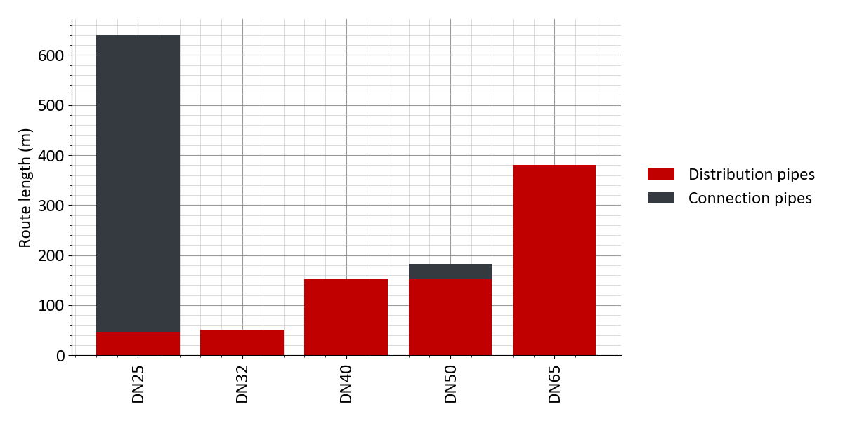
Figure 4: Scenario 1: Distribution of pipe diameters
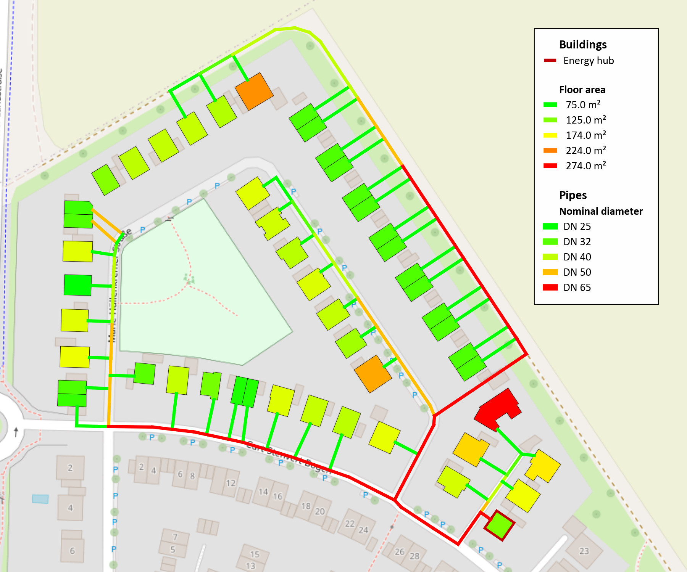
Figure 5: Scenario 1: Design result: Pipe Diameter and floor area of buildings
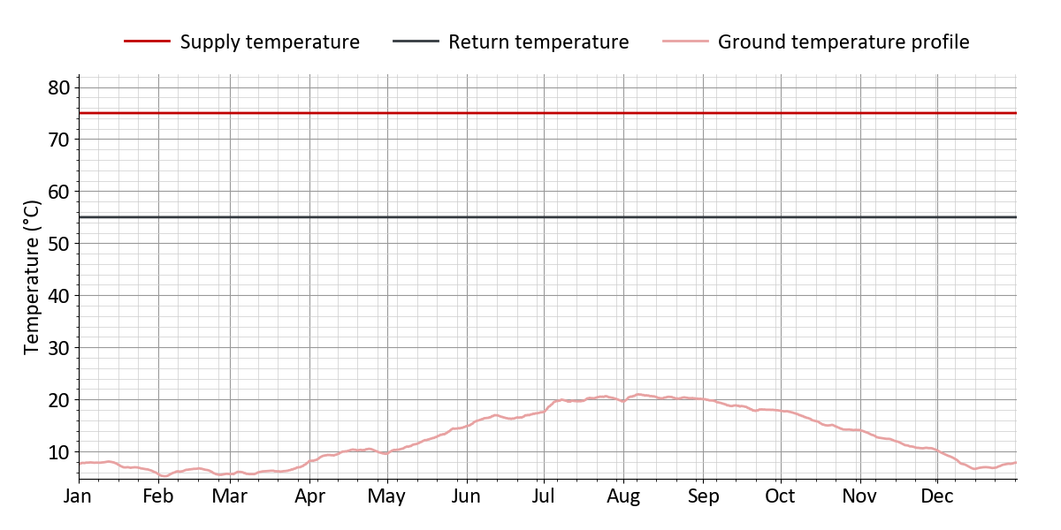
Figure 6: Scenario 1: Annual profile of supply and return temperature in the heat network
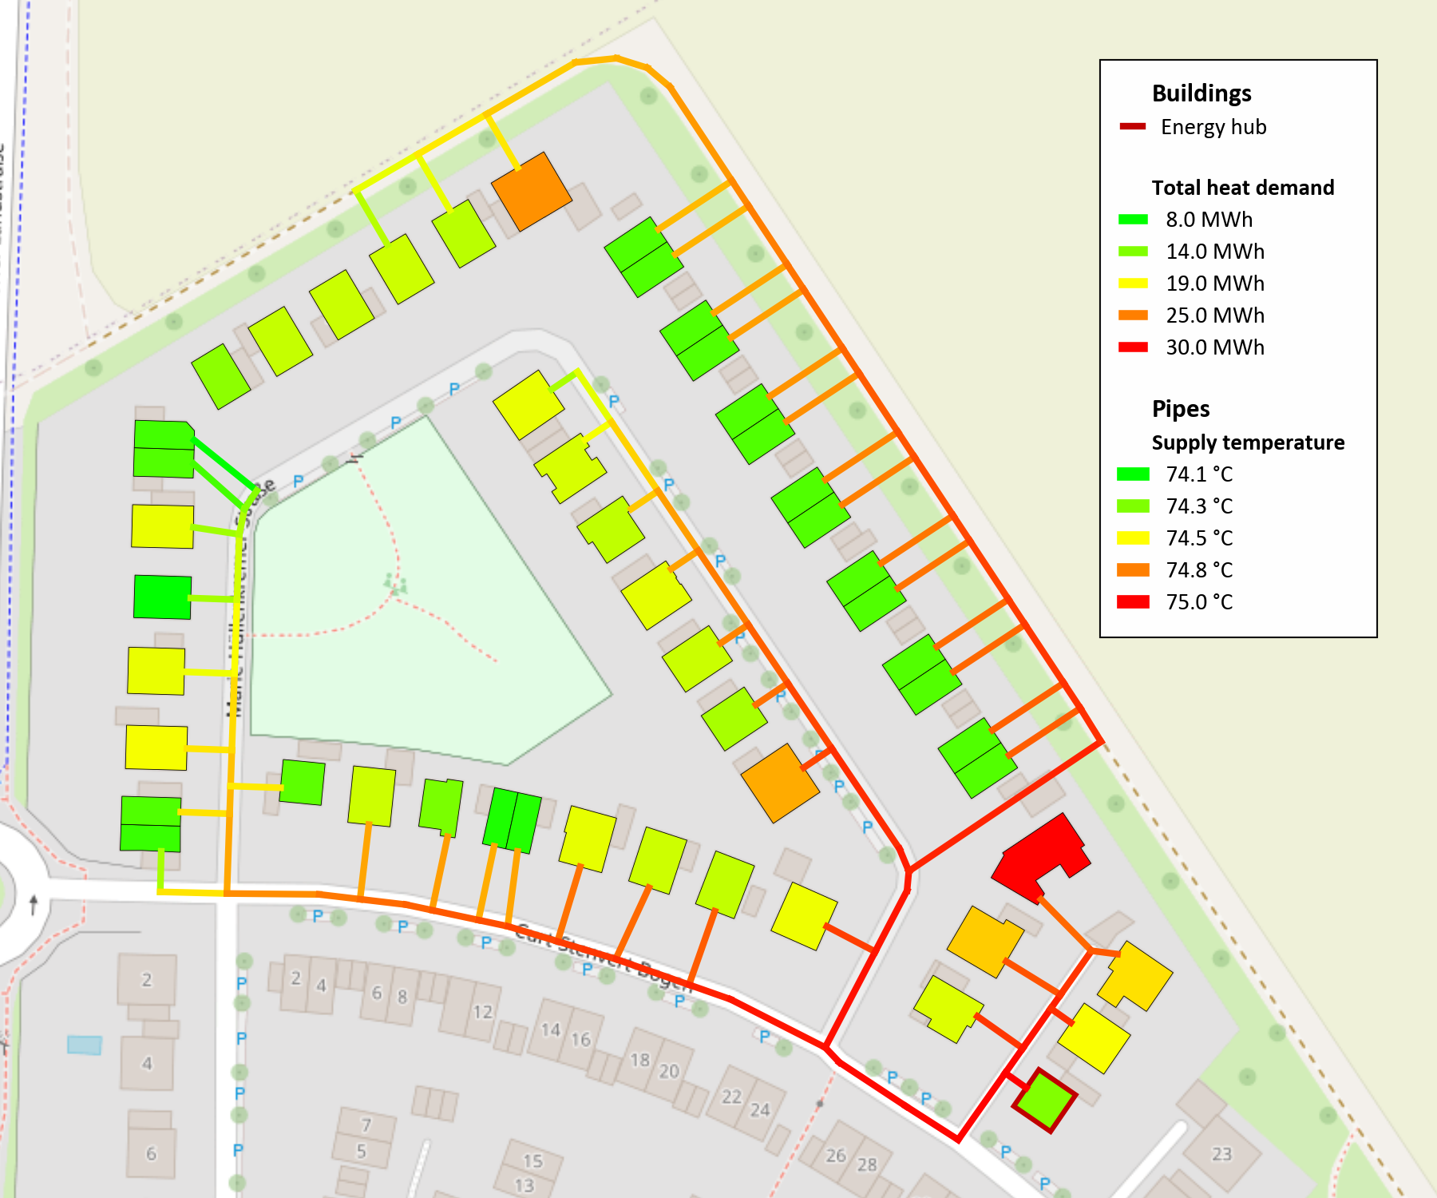
Figure 7: Scenario 1: Design result: Supply temperature and heat demand of buildings
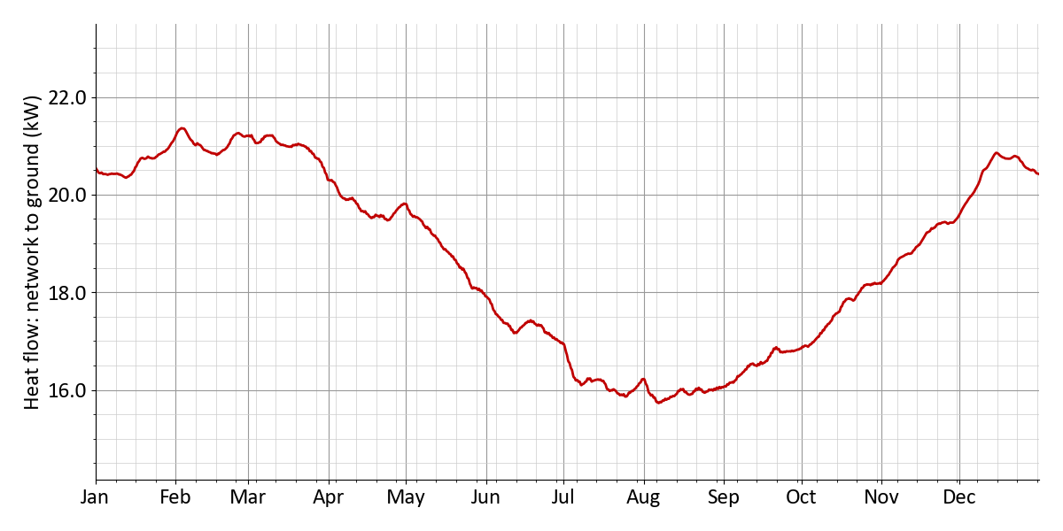
Figure 8: Scenario 1: Heat flow: network to ground
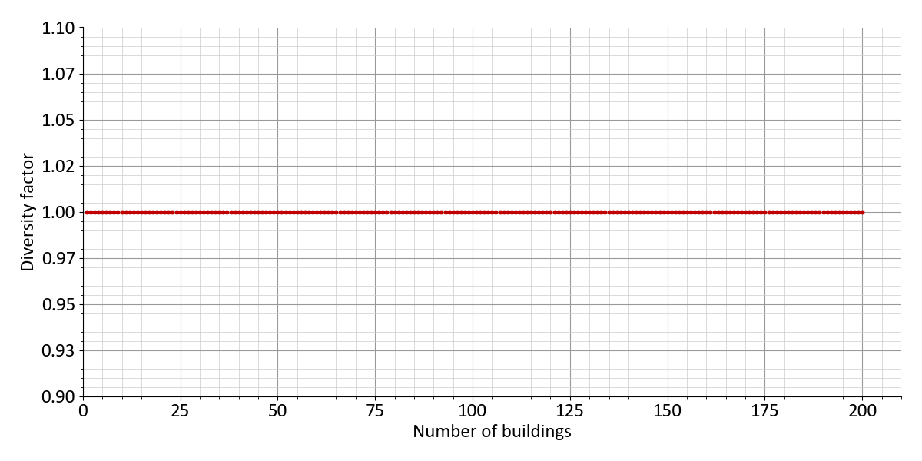
Figure 9: Scenario 1: Diversity factor
Table 10: Scenario 1: Pump work and pressure
Pump work and pressure
Mean pressure gradient | 329 Pa/m
Pressure loss (critical path) | 3.8 bar
Flow rate network pump | 34.3 m³/h
Max. pump power | 3.6 kW
Elec. power demand of pump | 4.8 kW
Power demand pump | 6.7 MWh
Relative power demand pump | 0.94 %
Pressure rating | PN16

Table 11: Scenario 1: Pressure losses (critical path)
Pressure losses (critical path)
Pressure loss energy hub | 0.2 bar
Pressure loss substation | 0.3 bar
Pressure loss pipes | 2.7 bar
Pressure loss fittings / installations | 0.66 bar
Pressure loss (critical path) | 3.8 bar
Building name | Marie-Hüllenkremer-Straße 23

2.1.3 Energy hub
Table 12: Scenario 1: Sizing of the technologies in the energy hub
Technology | Dimensioning | Full load hours/Charging cycles
Biomass CHP 1 | 56 kWₑₗ | 4,766 h
Photovoltaics | 224 kWₚ | 970 h
Solar thermal | 1,000 m² | 76 h
Geothermal probes 1 | 342 kWₜₕ | 930 h

Nominal electric capacity | 56 kWₑₗ
Generated electricity | 267 MWh
Generated heat | 381 MWh
Fuel demand | 763 MWh
Full load hours | 4,766 h

Installed capacity | 224 kWₚ
Collector area | 1,400 m²
Generated electricity | 217 MWh
Full load hours | 970 h
Curtailed generation potential | 0 MWh

Collector area | 0 m²
Generated heat | 76 MWh
Curtailed generation potential | 179 MWh
Yield per collector area | 76 h

Extraction rate | 342 kWₜₕ
Generated heat | 424 MWh
Heat pump capacity | 456 kWₜₕ
Electricity demand | 106 MWh

Table 13: Scenario 1: Energy import
 | Annual sum | Peak power | Share
Electricity import from grid (energy hub) | 221 MWh | 177 kW | 17.3 %
Renewable electricity generation | 217 MWh | --- | 17.0 %
Biomass | 763 MWh | 160 kW | 59.7 %
Heat from solar thermal | 76 MWh | --- | 6.0 %

Table 14: Scenario 1: Energy feed-in
 | Annual energy | Peak power
Electricity feed-in | 68 MWh | 132 kW

Table 15: Scenario 1: Electricity generation and import
Technology | Annual energy | Share
Biomass CHP 1 | 267 MWh | 37.9 %
Renewable electricity generation | 217 MWh | 30.8 %
Share photovoltaics | 217 MWh | 30.8 %
Electricity import from grid (energy hub) | 221 MWh | 31.3 %
 | Self-sufficiency (autarky) rate | 65 %
 | Self-consumption rate | 86 %

Table 16: Scenario 1: Heat generation and import
Technology | Annual energy | Share
Biomass CHP 1 | 381 MWh | 43.2 %
Solar thermal | 76 MWh | 8.6 %
Geothermal probes 1 | 424 MWh | 48.1 %
Solar thermal coverage rate |  | 8.6 %

Emissions and primary energy
Table 17: Scenario 1: Emissions
 | Spec. emissions |  | Annual sum |  | CO₂ emissions
Electricity import (energy hub) | 350 g/kWh | × | 221 MWh | = | 77 t
Electricity feed-in | - 0 g/kWh | × | 68 MWh | = | - 0 t
Biomass | 40 g/kWh | × | 763 MWh | = | 30.5 t
District heating import | 150 g/kWh | × | 0 MWh | = | 0 t
District cooling import | 150 g/kWh | × | 0 MWh | = | 0 t
 |  |  | Sum |  | 108 t

Table 18: Scenario 1: Primary energy factor
 | Primary energy factor |  | Annual sum |  | Primary energy
Electricity import (energy hub) | 1.8 | × | 221 MWh | = | 398 MWh
Electricity feed-in | - 0 | × | 68 MWh | = | - 0 MWh
Biomass | 0.2 | × | 763 MWh | = | 153 MWh
District heating import | 0.6 | × | 0 MWh | = | 0 MWh
District cooling import | 0.8 | × | 0 MWh | = | 0 MWh
 |  |  | Sum |  | 550 MWh

2.1.4 Economic results
Summary
Table 19: Scenario 1: Economic KPIs
Net present value | + 639,921 €
Amortization period | 17 years
Internal rate of return | 7.9 %
Total costs (excl. sales revenues) | 3,924,707.0 €
Levelized costs of energy | 0.244 €/kWh
Annual energy costs per floor area | 46.32 €/m²
Monthly energy costs per floor area | 3.86 €/m²

Table 20: Scenario 1: Subsidies
Initial investment | 3,612,164.0 €
Subsidy on initial investment | 1,203,486.0 €
Subsidy rate for initial investment | 33.3 %
Total costs (excl. all revenues and subsidies) | 5,162,090 €
Total subsidy in observation period | 1,253,335.0 €
Subsidy rate (total) | 24.3 %

Cost and revenue details
Table 21: Scenario 1: Cost breakdown in €
 | Sum | 2027 | 2028 | 2029 | 2030 | ... | 2046 | 2047
Total costs | -639,921 | 2,032,678 | -176,079 | -167,694 | -159,709 | ... | -73,164 | -471,573
Investment cost | 3,243,622 | 3,612,164 | 0 | 0 | 0 | ... | 0 | -401,892
Building energy systems | 492,771 | 563,133 | 0 | 0 | 0 | ... | 0 | -70,362
El. hot water heater | 5,590 | 5,590 | 0 | 0 | 0 | ... | 0 | 0
Air-source heat pump | 82,005 | 82,005 | 0 | 0 | 0 | ... | 0 | 0
Air chiller | 77,242 | 77,242 | 0 | 0 | 0 | ... | 0 | 0
Storage (domestic hot water) | 65,341 | 74,730 | 0 | 0 | 0 | ... | 0 | -9,388
Heat transfer station | 262,590 | 323,564 | 0 | 0 | 0 | ... | 0 | -60,974
Heat network | 1,015,929 | 1,251,830 | 0 | 0 | 0 | ... | 0 | -235,900
Connection pipe | 418,062 | 515,137 | 0 | 0 | 0 | ... | 0 | -97,075
Distribution pipe | 597,866 | 736,692 | 0 | 0 | 0 | ... | 0 | -138,825
Energy hub | 1,454,921 | 1,517,200 | 0 | 0 | 0 | ... | 0 | -95,629
Biomass CHP 1 | 87,858 | 72,800 | 0 | 0 | 0 | ... | 0 | -18,291
Photovoltaics | 246,400 | 246,400 | 0 | 0 | 0 | ... | 0 | 0
Solar thermal | 400,000 | 400,000 | 0 | 0 | 0 | ... | 0 | 0
Geothermal probes 1 | 264,662 | 342,000 | 0 | 0 | 0 | ... | 0 | -77,337
Heat pump (Geothermal probes 1) | 456,000 | 456,000 | 0 | 0 | 0 | ... | 0 | 0
Other costs | 280,000 | 280,000 | 0 | 0 | 0 | ... | 0 | 0
Gebäude Energiezentrale | 150,000 | 150,000 | 0 | 0 | 0 | ... | 0 | 0
Netzpumpe, Druckhaltung, Armaturen | 30,000 | 30,000 | 0 | 0 | 0 | ... | 0 | 0
Planungskosten | 100,000 | 100,000 | 0 | 0 | 0 | ... | 0 | 0
Maintenance costs | 532,171 | 0 | 40,669 | 38,732 | 36,888 | ... | 16,898 | 16,094
Building energy systems | 80,711 | 0 | 6,168 | 5,874 | 5,594 | ... | 2,562 | 2,440
El. hot water heater | 696 | 0 | 53 | 50 | 48 | ... | 22 | 21
Air-source heat pump | 20,439 | 0 | 1,562 | 1,487 | 1,416 | ... | 649 | 618
Air chiller | 19,252 | 0 | 1,471 | 1,401 | 1,334 | ... | 611 | 582
Heat transfer station | 40,323 | 0 | 3,081 | 2,934 | 2,795 | ... | 1,280 | 1,219
Heat network | 156,005 | 0 | 11,922 | 11,354 | 10,813 | ... | 4,953 | 4,718
Connection pipe | 64,197 | 0 | 4,906 | 4,672 | 4,449 | ... | 2,038 | 1,941
Distribution pipe | 91,808 | 0 | 7,016 | 6,682 | 6,363 | ... | 2,915 | 2,776
Energy hub | 291,715 | 0 | 22,293 | 21,231 | 20,220 | ... | 9,263 | 8,822
Biomass CHP 1 | 72,579 | 0 | 5,546 | 5,282 | 5,030 | ... | 2,304 | 2,195
Photovoltaics | 30,706 | 0 | 2,346 | 2,234 | 2,128 | ... | 975 | 928
Solar thermal | 74,773 | 0 | 5,714 | 5,442 | 5,183 | ... | 2,374 | 2,261
Heat pump (Geothermal probes 1) | 113,655 | 0 | 8,685 | 8,272 | 7,878 | ... | 3,609 | 3,437
Other costs | 3,738 | 0 | 285 | 272 | 259 | ... | 118 | 113
Netzpumpe, Druckhaltung, Armaturen | 3,738 | 0 | 285 | 272 | 259 | ... | 118 | 113
Other operation costs | 124,622 | 0 | 9,523 | 9,070 | 8,638 | ... | 3,957 | 3,768
Verwaltung | 124,622 | 0 | 9,523 | 9,070 | 8,638 | ... | 3,957 | 3,768
Energy costs | 1,311,523 | 0 | 100,228 | 95,455 | 90,910 | ... | 41,647 | 39,663
Energy hub | 1,311,523 | 0 | 100,228 | 95,455 | 90,910 | ... | 41,647 | 39,663
Electricity | 550,829 | 0 | 42,095 | 40,090 | 38,181 | ... | 17,491 | 16,658
Energy charge | 550,829 | 0 | 42,095 | 40,090 | 38,181 | ... | 17,491 | 16,658
Biomass | 760,693 | 0 | 58,133 | 55,365 | 52,728 | ... | 24,155 | 23,005
Energy charge | 760,693 | 0 | 58,133 | 55,365 | 52,728 | ... | 24,155 | 23,005
Revenues | -4,598,525 | -376,000 | -322,691 | -307,325 | -292,690 | ... | -134,085 | -127,700
Feed-in | -33,897 | 0 | -2,590 | -2,467 | -2,349 | ... | -1,076 | -1,025
Electricity | -33,897 | 0 | -2,590 | -2,467 | -2,349 | ... | -1,076 | -1,025
Cover energy demands | -4,564,628 | -376,000 | -320,101 | -304,858 | -290,341 | ... | -133,008 | -126,674
Heat demand | -2,096,628 | 0 | -160,227 | -152,597 | -145,331 | ... | -66,577 | -63,407
Energy charge | -1,718,718 | 0 | -131,347 | -125,092 | -119,135 | ... | -54,577 | -51,978
Capacity charge | -377,910 | 0 | -28,880 | -27,505 | -26,195 | ... | -12,000 | -11,428
Cold demand | -82,890 | 0 | -6,334 | -6,032 | -5,745 | ... | -2,632 | -2,506
Energy charge | -41,833 | 0 | -3,197 | -3,044 | -2,899 | ... | -1,328 | -1,265
Capacity charge | -41,056 | 0 | -3,137 | -2,988 | -2,845 | ... | -1,303 | -1,241
Plug loads | -24,206 | 0 | -1,849 | -1,761 | -1,677 | ... | -768 | -732
Energy charge | -22,536 | 0 | -1,722 | -1,640 | -1,562 | ... | -715 | -681
Capacity charge | -1,669 | 0 | -127 | -121 | -115 | ... | -53 | -50
E-mobility | -1,984,902 | 0 | -151,689 | -144,465 | -137,586 | ... | -63,030 | -60,028
Energy charge | -1,860,280 | 0 | -142,165 | -135,395 | -128,948 | ... | -59,072 | -56,259
Capacity charge | -124,622 | 0 | -9,523 | -9,070 | -8,638 | ... | -3,957 | -3,768
One-time connection fees | -376,000 | -376,000 | 0 | 0 | 0 | ... | 0 | 0
Subsidy | -1,253,335 | -1,203,486 | -3,809 | -3,628 | -3,455 | ... | -1,582 | -1,507
Building energy systems | -161,553 | -161,553 | 0 | 0 | 0 | ... | 0 | 0
El. hot water heater | -2,236 | -2,236 | 0 | 0 | 0 | ... | 0 | 0
Storage (domestic hot water) | -29,892 | -29,892 | 0 | 0 | 0 | ... | 0 | 0
Heat transfer station | -129,425 | -129,425 | 0 | 0 | 0 | ... | 0 | 0
Heat network | -500,732 | -500,732 | 0 | 0 | 0 | ... | 0 | 0
Connection pipe | -206,055 | -206,055 | 0 | 0 | 0 | ... | 0 | 0
Distribution pipe | -294,677 | -294,677 | 0 | 0 | 0 | ... | 0 | 0
Energy hub | -479,200 | -479,200 | 0 | 0 | 0 | ... | 0 | 0
Solar thermal | -160,000 | -160,000 | 0 | 0 | 0 | ... | 0 | 0
Geothermal probes 1 | -136,800 | -136,800 | 0 | 0 | 0 | ... | 0 | 0
Heat pump (Geothermal probes 1) | -182,400 | -182,400 | 0 | 0 | 0 | ... | 0 | 0
Other costs | -62,000 | -62,000 | 0 | 0 | 0 | ... | 0 | 0
Netzpumpe, Druckhaltung, Armaturen | -12,000 | -12,000 | 0 | 0 | 0 | ... | 0 | 0
Planungskosten | -50,000 | -50,000 | 0 | 0 | 0 | ... | 0 | 0
Other operation costs | -49,848 | 0 | -3,809 | -3,628 | -3,455 | ... | -1,582 | -1,507
Verwaltung | -49,848 | 0 | -3,809 | -3,628 | -3,455 | ... | -1,582 | -1,507

2.2 Scenario 2: Scenario 2
Fact sheet for the supply scenario
Table 22: Scenario 2: Fact sheet for the supply scenario: Scenario 2
Heat network | yes
Buildings | 38 residential buildings, 12 non-residential buildings
Connected buildings | 47
Installed Heatpumps in buildings | 4
Installed electric hot water heaters in buildings | 1
Heat network type | Conventional district heating network  75 °C (constant) / 55 °C (constant)
Technologies in energy hub | Gas CHP 1, Photovoltaics, Air-source heat pump, Heat storage

2.2.1 Buildings
Table 23: Scenario 2: Heat demands of the buildings
 | Annual energy | Peak power
Space heating | 623 MWh | 563 kW
Domestic hot water | 143 MWh
Total | 766 MWh
Heat generation of air-source heat pumps | – 39.4 MWh
Heat generation of ground-source heat pumps | – 9.7 MWh
Heat generation of heating rods | – 3.2 MWh
Heat generation of decentral hot water heaters | – 9 MWh
Heat import of all buildings | 705 MWh | 504 kW
Heat losses | 253 MWh | 33.3 kW
Heating load at energy hub | 958 MWh | 536 kW

Table 24: Scenario 2: Cooling demands of the buildings
 | Annual energy | Peak power
Space cooling | 22.4 MWh | 66 kW
Process cooling | 0 MWh | 0 kW
Total | 22.4 MWh | 66 kW
Cooling generation of air-cooled chillers | – 22.4 MWh
Waste heat feed-in heat network | 0 MWh | 0 kW

Table 25: Scenario 2: Electricity demands of the buildings
 | Annual energy | Peak power
Plug loads | 6 MWh | 2.7 kW
E-mobility | 498 MWh | 153 kW
Total | 504 MWh | 154 kW
Operating power of all buildings | + 25.6 MWh
Electricity import of all buildings | 529 MWh

Table 26: Scenario 2: Installed building energy systems
 | Count | Installed capacity | Useful energy | Electricity demand | Fuel demand | SCOP
Heat transfer station | 47 | 985 kWₜₕ | 705 MWh | --- | --- | ---
Ground-source heat pump | 1 | 12.8 kWₜₕ | 9.7 MWh | 2 MWh | --- | 4.9
Air-source heat pump | 3 | 52 kWₜₕ | 39.4 MWh | 8.9 MWh | --- | 4.4
Geothermal boreholes | 1 | 10.8 kWₜₕ | 7.7 MWh | --- | --- | ---
Electric heating rod | 1 | 20.9 kWₜₕ | 3.2 MWh | 3.2 MWh | --- | ---
El. hot water heater | 6 | 214 kWₜₕ | 9 MWh | 9 MWh | --- | ---
Storage (domestic hot water) | 47 | 14,100 l | --- | --- | --- | ---
Air chiller | 7 | 66 kWₜₕ | 22.4 MWh | 2.5 MWh | --- | 9

2.2.2 Heat network
Table 27: Scenario 2: Heat balance of the heat network
 | Annual energy | Peak power
Heat import of all buildings | 705 MWh | 504 kW
Heat losses | + 253 MWh | 33.3 kW
Heating load at energy hub | 958 MWh | 536 kW

Table 28: Scenario 2: Cooling balance of the heat network
 | Annual energy | Peak power
Waste heat feed-in heat network | 0 MWh | 0 kW

Table 29: Scenario 2: Electricity balance of the district
 | Annual energy | Peak power
Electricity import of all buildings | 529 MWh
Pump work | + 3.6 MWh | 2.6 kW
Electricity demand district | 533 MWh

Table 30: Scenario 2: Properties of the heat network
Network properties
Route length | 1.4 km
of which distribution pipes | 0.78 km
of which connection pipes | 0.62 km
Supply temperature | 75 °C (constant)
Return temperature | 55 °C (constant)
Water mass | 5.3 t
Water volume | 5.4 m³
Linear heat density | 0.5 MWh/m
District area | 2.7 ha
Heat density | 284 MWh/ha

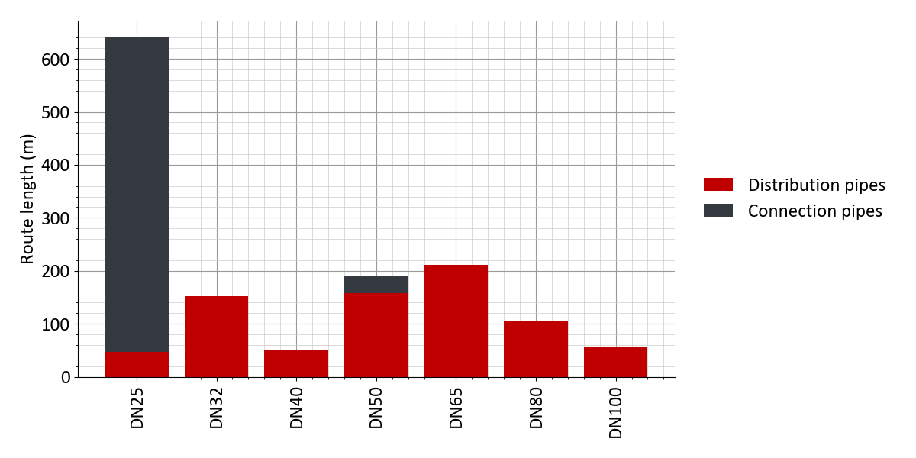
Figure 10: Scenario 2: Distribution of pipe diameters
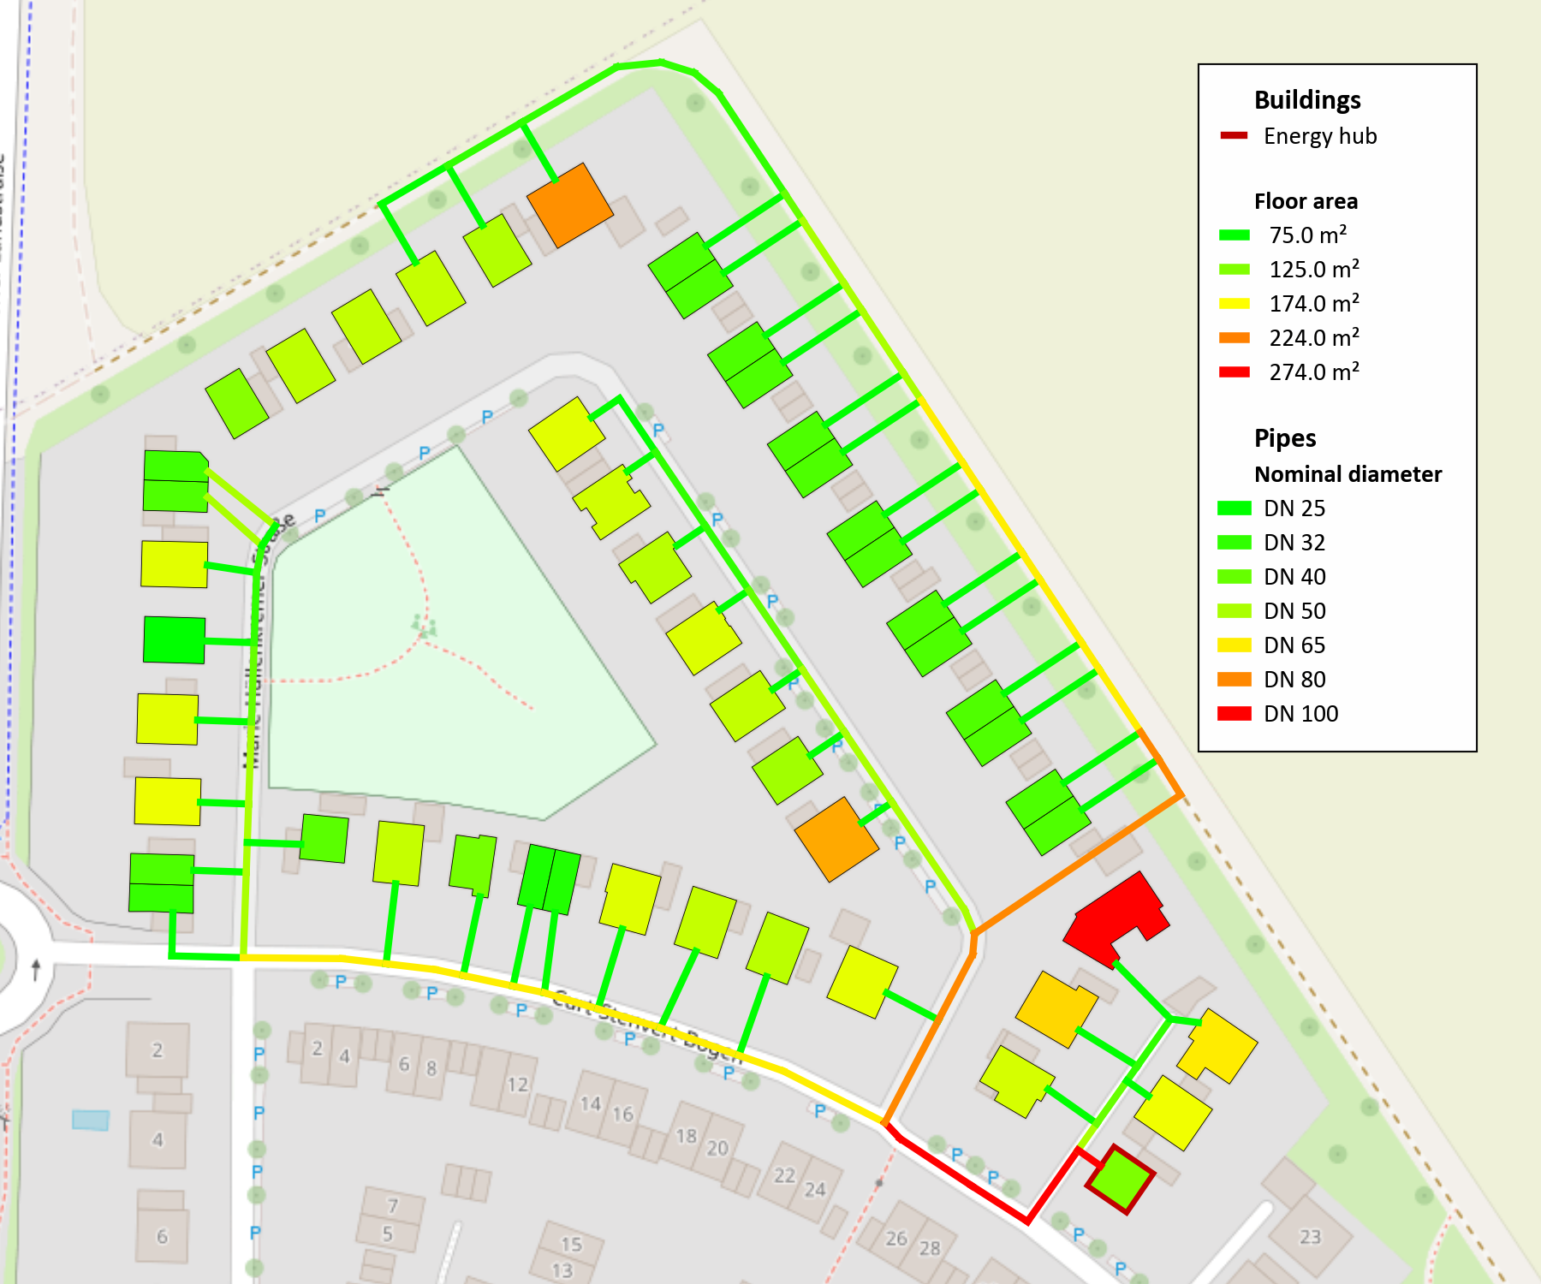
Figure 11: Scenario 2: Design result: Pipe Diameter and floor area of buildings
Figure 12: Scenario 2: Annual profile of supply and return temperature in the heat network
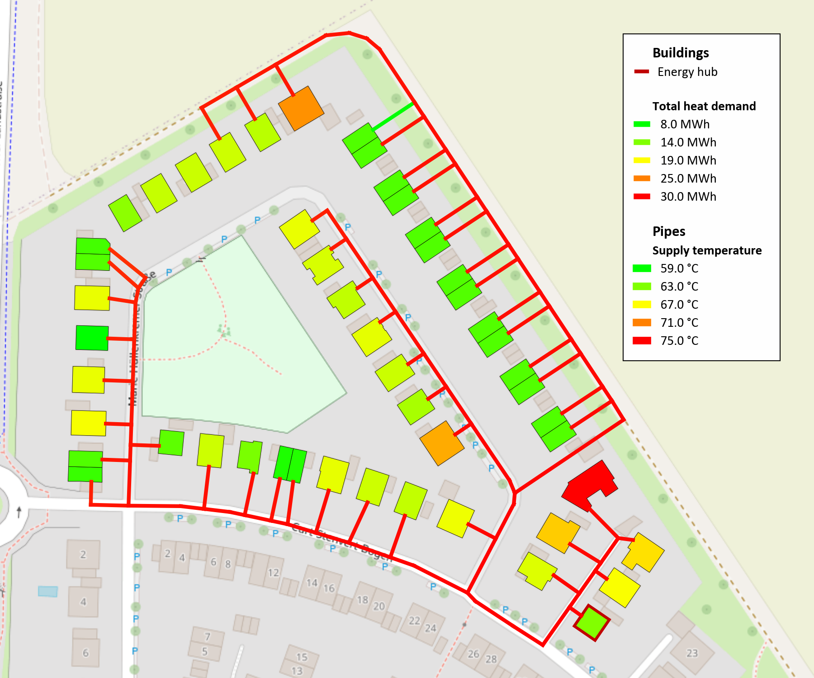
Figure 13: Scenario 2: Design result: Supply temperature and heat demand of buildings
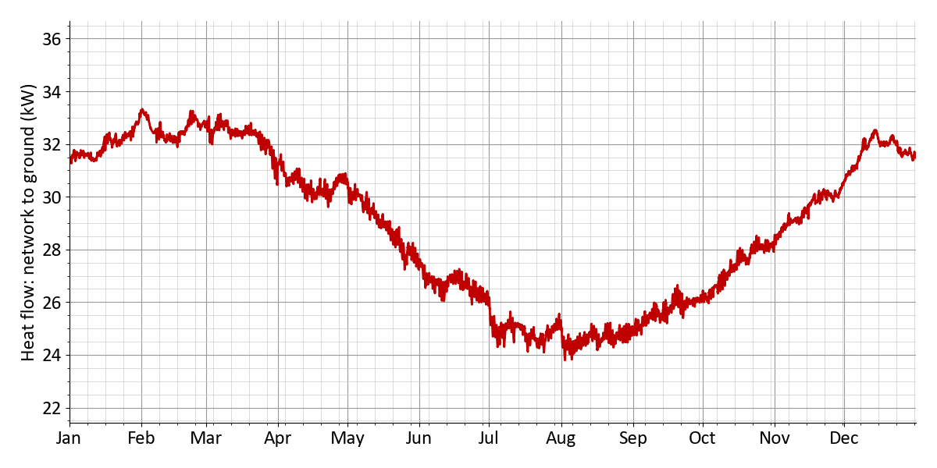
Figure 14: Scenario 2: Heat flow: network to ground
Figure 15: Scenario 2: Diversity factor
Table 31: Scenario 2: Pump work and pressure
Pump work and pressure
Mean pressure gradient | 157 Pa/m
Pressure loss (critical path) | 2.1 bar
Flow rate network pump | 33.5 m³/h
Max. pump power | 1.9 kW
Elec. power demand of pump | 2.6 kW
Power demand pump | 3.6 MWh
Relative power demand pump | 0.51 %
Pressure rating | PN16

Table 32: Scenario 2: Pressure losses (critical path)
Pressure losses (critical path)
Pressure loss energy hub | 0.2 bar
Pressure loss substation | 0.3 bar
Pressure loss pipes | 1.3 bar
Pressure loss fittings / installations | 0.32 bar
Pressure loss (critical path) | 2.1 bar
Building name | Marie-Hüllenkremer-Straße 23

2.2.3 Energy hub
Table 33: Scenario 2: Sizing of the technologies in the energy hub
Technology | Dimensioning | Full load hours/Charging cycles
Gas CHP 1 | 139 kWₑₗ | 2,626 h
Photovoltaics | 251 kWₚ | 970 h
Air-source heat pump | 640 kWₜₕ | 687 h
Heat storage | 23.9 m³ | 425

Nominal electric capacity | 139 kWₑₗ
Generated electricity | 365 MWh
Generated heat | 522 MWh
Fuel demand | 1,043 MWh
Full load hours | 2,626 h

Installed capacity | 251 kWₚ
Collector area | 1,569 m²
Generated electricity | 243 MWh
Full load hours | 970 h
Curtailed generation potential | 0 MWh

Generated heat | 440 MWh
Generated cold | 0 MWh
Electricity demand | 164 MWh
Heat for regeneration | 0 MWh
Full load hours | 687 h
Nominal heating power | 640 kWₜₕ
Nominal electric capacity | 160 kWₑₗ

Storage capacity | 555 kWh
Charging energy | 236 MWh
Discharging energy | 232 MWh
Storage volume | 23.9 m³
Full charging cycles | 425

Table 34: Scenario 2: Energy import
 | Annual sum | Peak power | Share
Electricity import from grid (energy hub) | 114 MWh | 154 kW | 8.1 %
Renewable electricity generation | 243 MWh | --- | 17.4 %
Natural gas | 1,043 MWh | 398 kW | 74.5 %

Table 35: Scenario 2: Energy feed-in
 | Annual energy | Peak power
Electricity feed-in | 25.9 MWh | 131 kW

Table 36: Scenario 2: Electricity generation and import
Technology | Annual energy | Share
Gas CHP 1 | 365 MWh | 50.6 %
Renewable electricity generation | 243 MWh | 33.7 %
Share photovoltaics | 243 MWh | 33.7 %
Electricity import from grid (energy hub) | 114 MWh | 15.8 %
 | Self-sufficiency (autarky) rate | 84 %
 | Self-consumption rate | 96 %

Table 37: Scenario 2: Heat generation and import
Technology | Annual energy | Share
Gas CHP 1 | 522 MWh | 54.3 %
Air-source heat pump | 440 MWh | 45.7 %

Emissions and primary energy
Table 38: Scenario 2: Emissions
 | Spec. emissions |  | Annual sum |  | CO₂ emissions
Electricity import (energy hub) | 350 g/kWh | × | 114 MWh | = | 39.9 t
Electricity feed-in | - 0 g/kWh | × | 25.9 MWh | = | - 0 t
Natural gas | 250 g/kWh | × | 1,043 MWh | = | 261 t
District heating import | 150 g/kWh | × | 0 MWh | = | 0 t
District cooling import | 150 g/kWh | × | 0 MWh | = | 0 t
 |  |  | Sum |  | 301 t

Table 39: Scenario 2: Primary energy factor
 | Primary energy factor |  | Annual sum |  | Primary energy
Electricity import (energy hub) | 1.8 | × | 114 MWh | = | 205 MWh
Electricity feed-in | - 0 | × | 25.9 MWh | = | - 0 MWh
Natural gas | 1.1 | × | 1,043 MWh | = | 1,147 MWh
District heating import | 0.6 | × | 0 MWh | = | 0 MWh
District cooling import | 0.8 | × | 0 MWh | = | 0 MWh
 |  |  | Sum |  | 1,353 MWh

2.2.4 Economic results
Summary
Table 40: Scenario 2: Economic KPIs
Net present value | + 458,831 €
Amortization period | 19 years
Internal rate of return | 7.3 %
Total costs (excl. sales revenues) | 4,105,798.0 €
Levelized costs of energy | 0.255 €/kWh
Annual energy costs per floor area | 48.46 €/m²
Monthly energy costs per floor area | 4.04 €/m²

Table 41: Scenario 2: Subsidies
Initial investment | 3,330,428.0 €
Subsidy on initial investment | 1,020,584.0 €
Subsidy rate for initial investment | 30.6 %
Total costs (excl. all revenues and subsidies) | 5,139,292 €
Total subsidy in observation period | 1,070,433 €
Subsidy rate (total) | 20.8 %

Cost and revenue details
Table 42: Scenario 2: Cost breakdown in €
 | Sum | 2027 | 2028 | 2029 | 2030 | ... | 2046 | 2047
Total costs | -458,830 | 1,933,844 | -161,711 | -154,011 | -146,677 | ... | -67,194 | -423,402
Investment cost | 3,053,801 | 3,330,428 | 0 | 0 | 0 | ... | 0 | -359,407
Building energy systems | 533,111 | 607,830 | 0 | 0 | 0 | ... | 0 | -74,718
Electric heating rod | 1,153 | 1,247 | 0 | 0 | 0 | ... | 0 | -94
El. hot water heater | 5,590 | 5,590 | 0 | 0 | 0 | ... | 0 | 0
Ground-source heat pump | 24,671 | 24,671 | 0 | 0 | 0 | ... | 0 | 0
Air-source heat pump | 82,005 | 82,005 | 0 | 0 | 0 | ... | 0 | 0
Air chiller | 77,242 | 77,242 | 0 | 0 | 0 | ... | 0 | 0
Storage (domestic hot water) | 65,341 | 74,730 | 0 | 0 | 0 | ... | 0 | -9,388
Heat transfer station | 262,256 | 323,152 | 0 | 0 | 0 | ... | 0 | -60,896
Geothermal boreholes | 14,850 | 19,189 | 0 | 0 | 0 | ... | 0 | -4,339
Heat network | 1,030,511 | 1,269,798 | 0 | 0 | 0 | ... | 0 | -239,286
Connection pipe | 418,062 | 515,137 | 0 | 0 | 0 | ... | 0 | -97,075
Distribution pipe | 612,448 | 754,660 | 0 | 0 | 0 | ... | 0 | -142,211
Energy hub | 1,210,178 | 1,172,800 | 0 | 0 | 0 | ... | 0 | -45,402
Gas CHP 1 | 218,078 | 180,700 | 0 | 0 | 0 | ... | 0 | -45,402
Photovoltaics | 276,100 | 276,100 | 0 | 0 | 0 | ... | 0 | 0
Air-source heat pump | 704,000 | 704,000 | 0 | 0 | 0 | ... | 0 | 0
Heat storage | 12,000 | 12,000 | 0 | 0 | 0 | ... | 0 | 0
Other costs | 280,000 | 280,000 | 0 | 0 | 0 | ... | 0 | 0
Gebäude Energiezentrale | 150,000 | 150,000 | 0 | 0 | 0 | ... | 0 | 0
Netzpumpe, Druckhaltung, Armaturen | 30,000 | 30,000 | 0 | 0 | 0 | ... | 0 | 0
Planungskosten | 100,000 | 100,000 | 0 | 0 | 0 | ... | 0 | 0
Maintenance costs | 686,732 | 0 | 52,481 | 49,982 | 47,601 | ... | 21,806 | 20,768
Building energy systems | 89,356 | 0 | 6,828 | 6,503 | 6,193 | ... | 2,837 | 2,702
Electric heating rod | 155 | 0 | 11 | 11 | 10 | ... | 4 | 4
El. hot water heater | 696 | 0 | 53 | 50 | 48 | ... | 22 | 21
Ground-source heat pump | 6,149 | 0 | 469 | 447 | 426 | ... | 195 | 185
Air-source heat pump | 20,439 | 0 | 1,562 | 1,487 | 1,416 | ... | 649 | 618
Air chiller | 19,252 | 0 | 1,471 | 1,401 | 1,334 | ... | 611 | 582
Heat transfer station | 40,271 | 0 | 3,077 | 2,931 | 2,791 | ... | 1,278 | 1,217
Geothermal boreholes | 2,391 | 0 | 182 | 174 | 165 | ... | 75 | 72
Heat network | 158,244 | 0 | 12,093 | 11,517 | 10,968 | ... | 5,025 | 4,785
Connection pipe | 64,197 | 0 | 4,906 | 4,672 | 4,449 | ... | 2,038 | 1,941
Distribution pipe | 94,047 | 0 | 7,187 | 6,844 | 6,519 | ... | 2,986 | 2,844
Energy hub | 435,392 | 0 | 33,273 | 31,688 | 30,179 | ... | 13,825 | 13,167
Gas CHP 1 | 180,153 | 0 | 13,767 | 13,112 | 12,487 | ... | 5,720 | 5,448
Photovoltaics | 34,408 | 0 | 2,629 | 2,504 | 2,385 | ... | 1,092 | 1,040
Air-source heat pump | 219,334 | 0 | 16,761 | 15,963 | 15,203 | ... | 6,964 | 6,633
Heat storage | 1,495 | 0 | 114 | 108 | 103 | ... | 47 | 45
Other costs | 3,738 | 0 | 285 | 272 | 259 | ... | 118 | 113
Netzpumpe, Druckhaltung, Armaturen | 3,738 | 0 | 285 | 272 | 259 | ... | 118 | 113
Other operation costs | 124,622 | 0 | 9,523 | 9,070 | 8,638 | ... | 3,957 | 3,768
Verwaltung | 124,622 | 0 | 9,523 | 9,070 | 8,638 | ... | 3,957 | 3,768
Energy costs | 1,323,985 | 0 | 101,180 | 96,362 | 91,774 | ... | 42,042 | 40,040
Energy hub | 1,323,985 | 0 | 101,180 | 96,362 | 91,774 | ... | 42,042 | 40,040
Electricity | 284,138 | 0 | 21,714 | 20,680 | 19,695 | ... | 9,022 | 8,593
Energy charge | 284,138 | 0 | 21,714 | 20,680 | 19,695 | ... | 9,022 | 8,593
Gas | 1,039,846 | 0 | 79,466 | 75,682 | 72,078 | ... | 33,020 | 31,447
Energy charge | 1,039,846 | 0 | 79,466 | 75,682 | 72,078 | ... | 33,020 | 31,447
Revenues | -4,577,538 | -376,000 | -321,087 | -305,798 | -291,236 | ... | -133,418 | -127,065
Feed-in | -12,910 | 0 | -986 | -939 | -894 | ... | -409 | -390
Electricity | -12,910 | 0 | -986 | -939 | -894 | ... | -409 | -390
Cover energy demands | -4,564,628 | -376,000 | -320,101 | -304,858 | -290,341 | ... | -133,008 | -126,674
Heat demand | -2,096,628 | 0 | -160,227 | -152,597 | -145,331 | ... | -66,577 | -63,407
Energy charge | -1,718,718 | 0 | -131,347 | -125,092 | -119,135 | ... | -54,577 | -51,978
Capacity charge | -377,910 | 0 | -28,880 | -27,505 | -26,195 | ... | -12,000 | -11,428
Cold demand | -82,890 | 0 | -6,334 | -6,032 | -5,745 | ... | -2,632 | -2,506
Energy charge | -41,833 | 0 | -3,197 | -3,044 | -2,899 | ... | -1,328 | -1,265
Capacity charge | -41,056 | 0 | -3,137 | -2,988 | -2,845 | ... | -1,303 | -1,241
Plug loads | -24,206 | 0 | -1,849 | -1,761 | -1,677 | ... | -768 | -732
Energy charge | -22,536 | 0 | -1,722 | -1,640 | -1,562 | ... | -715 | -681
Capacity charge | -1,669 | 0 | -127 | -121 | -115 | ... | -53 | -50
E-mobility | -1,984,902 | 0 | -151,689 | -144,465 | -137,586 | ... | -63,030 | -60,028
Energy charge | -1,860,280 | 0 | -142,165 | -135,395 | -128,948 | ... | -59,072 | -56,259
Capacity charge | -124,622 | 0 | -9,523 | -9,070 | -8,638 | ... | -3,957 | -3,768
One-time connection fees | -376,000 | -376,000 | 0 | 0 | 0 | ... | 0 | 0
Subsidy | -1,070,433 | -1,020,584 | -3,809 | -3,628 | -3,455 | ... | -1,582 | -1,507
Building energy systems | -169,064 | -169,064 | 0 | 0 | 0 | ... | 0 | 0
El. hot water heater | -2,236 | -2,236 | 0 | 0 | 0 | ... | 0 | 0
Storage (domestic hot water) | -29,892 | -29,892 | 0 | 0 | 0 | ... | 0 | 0
Heat transfer station | -129,261 | -129,261 | 0 | 0 | 0 | ... | 0 | 0
Geothermal boreholes | -7,675 | -7,675 | 0 | 0 | 0 | ... | 0 | 0
Heat network | -507,919 | -507,919 | 0 | 0 | 0 | ... | 0 | 0
Connection pipe | -206,055 | -206,055 | 0 | 0 | 0 | ... | 0 | 0
Distribution pipe | -301,864 | -301,864 | 0 | 0 | 0 | ... | 0 | 0
Energy hub | -281,600 | -281,600 | 0 | 0 | 0 | ... | 0 | 0
Air-source heat pump | -281,600 | -281,600 | 0 | 0 | 0 | ... | 0 | 0
Other costs | -62,000 | -62,000 | 0 | 0 | 0 | ... | 0 | 0
Netzpumpe, Druckhaltung, Armaturen | -12,000 | -12,000 | 0 | 0 | 0 | ... | 0 | 0
Planungskosten | -50,000 | -50,000 | 0 | 0 | 0 | ... | 0 | 0
Other operation costs | -49,848 | 0 | -3,809 | -3,628 | -3,455 | ... | -1,582 | -1,507
Verwaltung | -49,848 | 0 | -3,809 | -3,628 | -3,455 | ... | -1,582 | -1,507

3 Scenario comparison
Table 43: Optimization of the energy hub
 | Scenario 1 | Scenario 2
CHP 1 | 56 kWₑₗ | 139 kWₑₗ
Photovoltaics | 224 kWₚ | 251 kWₚ
Solar thermal | 1,000 m² | ---
Geothermal energy 1 | 342 kWₜₕ | ---
Air-source heat pump | --- | 160 kWₑₗ
Heat storage | --- | 555 kWh

Table 44: Economic KPIs
 | Scenario 1 | Scenario 2
Net present value | 639,921 € | 458,831 €
Amortization period | 17 years | 19 years
Internal rate of return | 7.9 % | 7.3 %
Levelized costs of heat | 0.411 €/kWh | 0.43 €/kWh
Levelized costs of energy | 0.244 €/kWh | 0.255 €/kWh
Annual energy costs per floor area | 46.3 €/m² | 48.5 €/m²
Monthly energy costs per floor area | 3.9 €/m² | 4 €/m²

Table 45: Cost breakdown in €
 | Scenario 1 | Scenario 2
Total costs | 639,921 | 458,831
Investment cost | -3,243,622 | -3,053,802
Building energy systems | -492,771 | -533,112
Electric heating rod | --- | -1,154
El. hot water heater | -5,590 | -5,590
Ground-source heat pump | --- | -24,671
Air-source heat pump | -82,006 | -82,006
Air chiller | -77,243 | -77,243
Storage (domestic hot water) | -65,342 | -65,342
Heat transfer station | -262,591 | -262,256
Geothermal boreholes | --- | -14,850
Heat network | -1,015,930 | -1,030,511
Connection pipe | -418,063 | -418,063
Distribution pipe | -597,867 | -612,449
Energy hub | -1,454,921 | -1,210,178
Biomass CHP 1 | -87,859 | -218,078
Photovoltaics | -246,400 | -276,100
Solar thermal | -400,000 | ---
Geothermal probes 1 | -264,662 | ---
Air-source heat pump | --- | -704,000
Heat storage | --- | -12,000
Heat pump (Geothermal probes 1) | -456,000 | ---
Other costs | -280,000 | -280,000
Maintenance costs | -532,172 | -686,732
Building energy systems | -80,712 | -89,357
Electric heating rod | --- | -155
El. hot water heater | -697 | -697
Ground-source heat pump | --- | -6,149
Air-source heat pump | -20,440 | -20,440
Air chiller | -19,252 | -19,252
Heat transfer station | -40,323 | -40,272
Geothermal boreholes | --- | -2,391
Heat network | -156,006 | -158,245
Connection pipe | -64,198 | -64,198
Distribution pipe | -91,808 | -94,047
Energy hub | -291,715 | -435,392
Biomass CHP 1 | -72,580 | -180,154
Photovoltaics | -30,707 | -34,408
Solar thermal | -74,773 | ---
Air-source heat pump | --- | -219,335
Heat storage | --- | -1,495
Heat pump (Geothermal probes 1) | -113,655 | ---
Other costs | -3,739 | -3,739
Other operation costs | -124,622 | -124,622
Energy costs | -1,311,523 | -1,323,985
Energy hub | -1,311,523 | -1,323,985
Electricity | -550,830 | -284,138
Energy charge | -550,830 | -284,138
Gas | --- | -1,039,847
Energy charge | --- | -1,039,847
Biomass | -760,693 | ---
Energy charge | -760,693 | ---
Revenues | 4,598,525 | 4,577,538
Feed-in | 33,897 | 12,911
Electricity | 33,897 | 12,911
Cover energy demands | 4,564,628 | 4,564,628
Heat demand | 2,096,628 | 2,096,628
Energy charge | 1,718,718 | 1,718,718
Capacity charge | 377,910 | 377,910
Cold demand | 82,891 | 82,891
Energy charge | 41,834 | 41,834
Capacity charge | 41,057 | 41,057
Plug loads | 24,207 | 24,207
Energy charge | 22,537 | 22,537
Capacity charge | 1,670 | 1,670
E-mobility | 1,984,902 | 1,984,902
Energy charge | 1,860,280 | 1,860,280
Capacity charge | 124,622 | 124,622
One-time connection fees | 376,000 | 376,000
Subsidy | 1,253,335 | 1,070,433
Building energy systems | 161,554 | 169,065
El. hot water heater | 2,236 | 2,236
Storage (domestic hot water) | 29,892 | 29,892
Heat transfer station | 129,426 | 129,261
Geothermal boreholes | --- | 7,676
Heat network | 500,732 | 507,919
Connection pipe | 206,055 | 206,055
Distribution pipe | 294,677 | 301,864
Energy hub | 479,200 | 281,600
Solar thermal | 160,000 | ---
Geothermal probes 1 | 136,800 | ---
Air-source heat pump | --- | 281,600
Heat pump (Geothermal probes 1) | 182,400 | ---
Other costs | 62,000 | 62,000
Other operation costs | 49,849 | 49,849

Figure 16: Specific costs and emissions
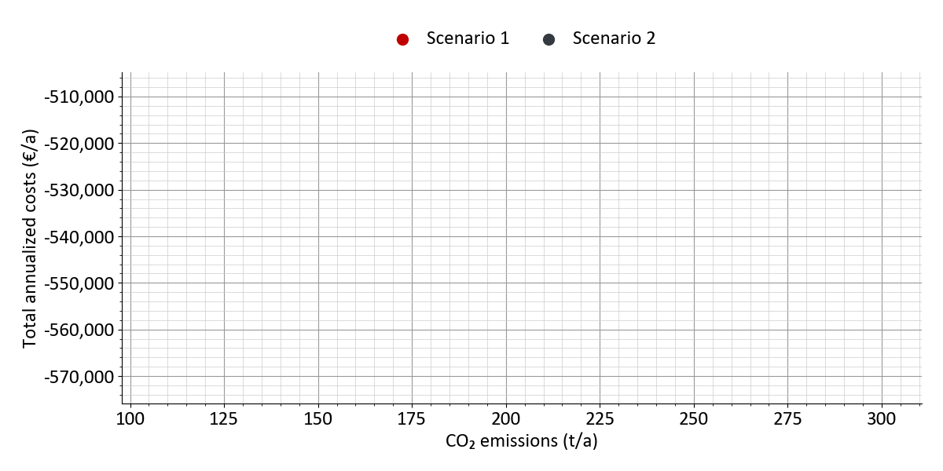
Figure 17: Total costs and emissions
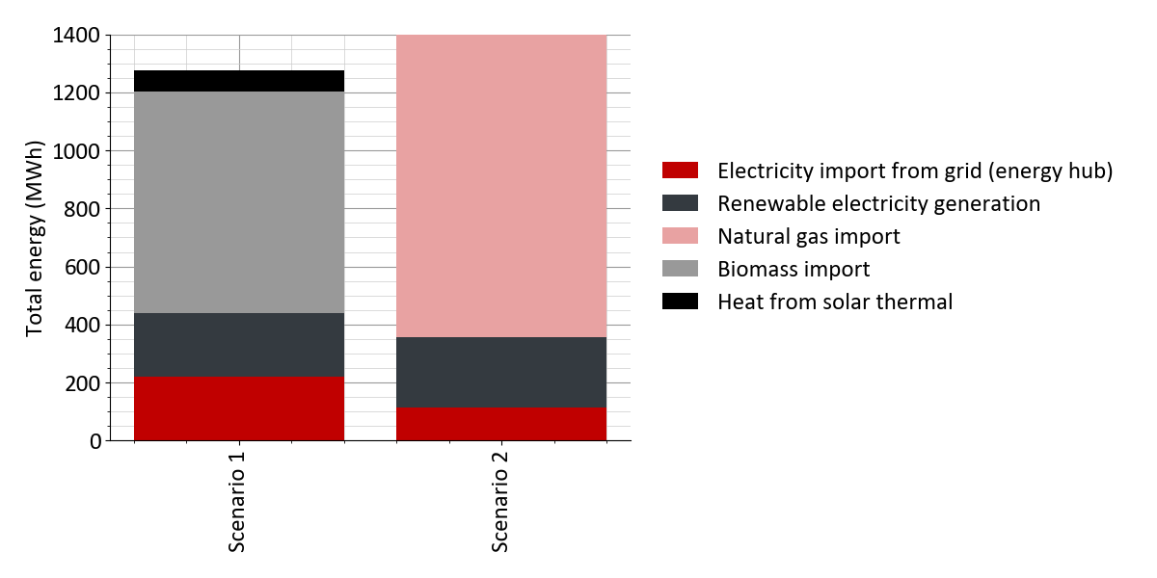
Figure 18: Energy import and feed-in
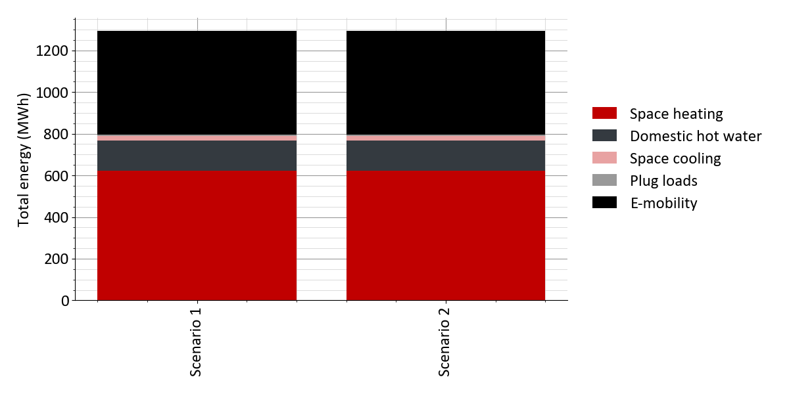
Figure 19: Energy demands
Table 46: Emissions and primary energy
 | Scenario 1 | Scenario 2
CO₂ emissions | 108 t | 301 t
CO₂ emissions per heat demand | 141 g/kWh | 392 g/kWh
CO₂ emissions per energy demand | 83 g/kWh | 233 g/kWh
CO₂ emissions per floor area | 15.9 kg/m² | 44.2 kg/m²
Primary energy | 550 MWh | 1,353 MWh
Primary energy per heat demand | 0.72 kWh/kWh | 1.8 kWh/kWh
Primary energy per energy demand | 0.43 kWh/kWh | 1 kWh/kWh
Primary energy per floor area | 81 kWh/m² | 199 kWh/m²

4 Appendix
Economic evaluation and scenario comparison

4.1 Buildings

4.1.1 Buildings: Economic parameters
Table 47: Cost parameters decentral technologies for scenario 'Scenario 1'
 | Specific investment costs (cost data points) | Lifetime | Annual maintenance costs | Subsidy
Electric heating rod (domestic hot water) | 5 kW: 80 €/kW  10 kW: 50 €/kW  20 kW: 35 €/kW  50 kW: 18 €/kW | 20 years | 1 % of investment | 40 %
Air-source heat pump | 5 kW: 2300 €/kW  10 kW: 1800 €/kW  20 kW: 1500 €/kW  30 kW: 1400 €/kW  40 kW: 1300 €/kW  50 kW: 1200 €/kW  60 kW: 1200 €/kW  80 kW: 1200 €/kW  110 kW: 1200 €/kW | 20 years | 2 % of investment | 0 %
Air chiller | 5 kW: 1300 €/kW  20 kW: 900 €/kW  100 kW: 700 €/kW  250 kW: 600 €/kW  500 kW: 450 €/kW | 20 years | 2 % of investment | 0 %
Storage (domestic hot water) | 130 l: 8 €/l  150 l: 7 €/l  300 l: 5.3 €/l  500 l: 4.8 €/l  1000 l: 4.5 €/l | 30 years | 0 % of investment | 40 %
Heat transfer station | 15 kW: 380 €/kW  30 kW: 250 €/kW  100 kW: 150 €/kW  500 kW: 85 €/kW  2000 kW: 55 €/kW  10000 kW: 34 €/kW | 40 years | 1 % of investment | 40 %

Table 48: Cost parameters decentral technologies for scenario 'Scenario 2'
 | Specific investment costs (cost data points) | Lifetime | Annual maintenance costs | Subsidy
Electric heating rod | 2 kW: 200 €/kW  5 kW: 100 €/kW  10 kW: 75 €/kW  20 kW: 60 €/kW  50 kW: 50 €/kW  100 kW: 40 €/kW | 25 years | 1 % of investment | 0 %
Electric heating rod (domestic hot water) | 5 kW: 80 €/kW  10 kW: 50 €/kW  20 kW: 35 €/kW  50 kW: 18 €/kW | 20 years | 1 % of investment | 40 %
Ground-source heat pump | 5 kW: 3000 €/kW  10 kW: 2100 €/kW  20 kW: 1500 €/kW  30 kW: 1200 €/kW  40 kW: 1100 €/kW  50 kW: 1000 €/kW  60 kW: 900 €/kW  80 kW: 800 €/kW  110 kW: 700 €/kW | 20 years | 2 % of investment | 0 %
Air-source heat pump | 5 kW: 2300 €/kW  10 kW: 1800 €/kW  20 kW: 1500 €/kW  30 kW: 1400 €/kW  40 kW: 1300 €/kW  50 kW: 1200 €/kW  60 kW: 1200 €/kW  80 kW: 1200 €/kW  110 kW: 1200 €/kW | 20 years | 2 % of investment | 0 %
Air chiller | 5 kW: 1300 €/kW  20 kW: 900 €/kW  100 kW: 700 €/kW  250 kW: 600 €/kW  500 kW: 450 €/kW | 20 years | 2 % of investment | 0 %
Storage (domestic hot water) | 130 l: 8 €/l  150 l: 7 €/l  300 l: 5.3 €/l  500 l: 4.8 €/l  1000 l: 4.5 €/l | 30 years | 0 % of investment | 40 %
Heat transfer station | 15 kW: 380 €/kW  30 kW: 250 €/kW  100 kW: 150 €/kW  500 kW: 85 €/kW  2000 kW: 55 €/kW  10000 kW: 34 €/kW | 40 years | 1 % of investment | 40 %
Geothermal boreholes | 5 kW: 2500 €/kW  10 kW: 1800 €/kW  20 kW: 1500 €/kW  40 kW: 1400 €/kW  60 kW: 1300 €/kW  80 kW: 1300 €/kW  110 kW: 1200 €/kW | 50 years | 1 % of investment | 40 %

4.2 Heat network

4.2.1 Heat network: General parameters
Table 49: Heat network settings
 | All scenarios
Consider heat losses | yes
Surcharge (fittings, etc.) | 20 %
Network temperature | constant
Design criteria | Pressure gradient and flow velocity
Diversity factor (method) | Neglect diversity (f=1)
Diversity factor only for residential buildings | no
Diversity factor DHW: calculation method | TU Dresden
Heat carrier fluid | Water
Thermal conductivity | 1.5 W/mK
Ground temperature: Option | calculated
Depth | 1 m

Table 50: Hydraulic settings
 | All scenarios
Circulation pump | Central pump
Pressure in pressure maintenance | 3 bar
Pressure loss fittings | 25 %
Pressure loss substations | 0.3 bar
Pressure loss energy hub: Option | fixed
Pressure loss energy hub | 0.2 bar
Waste heat feed-in | Return to supply
Temperature difference | 20 K

4.2.2 Heat network: Pipe parameters
Table 51: Pipe parameters: Kunststoff (Doppelrohr): BruggPipes: CALPEX DUO (normal) for scenario 'Scenario 1'
Nominal diameter | Outer diameter (pipe) | Thickness (pipe) | Outer diameter (case) | Thickness (case) | Installation depth | Pipe distance | Thermal conductivity (insulation) | Roughness
DN | mm | mm | mm | mm | m | mm | W/mK | mm
20 | 25 | 2.3 | 93 | 2.1 | 1.2 | 33 | 0.02 | 0.007
25 | 32 | 2.9 | 113 | 2.3 | 1.2 | 40 | 0.02 | 0.007
32 | 40 | 3.7 | 128 | 2.7 | 1.2 | 50 | 0.02 | 0.007
40 | 50 | 4.6 | 163 | 3.2 | 1.2 | 60 | 0.02 | 0.007
50 | 63 | 5.8 | 183 | 3.3 | 1.2 | 73 | 0.02 | 0.007
65 | 75 | 6.8 | 202 | 3.3 | 1.2 | 85 | 0.02 | 0.007

Table 52: Pipe parameters: Kunststoff (Doppelrohr): BruggPipes: CALPEX DUO (normal) for scenario 'Scenario 2'
Nominal diameter | Outer diameter (pipe) | Thickness (pipe) | Outer diameter (case) | Thickness (case) | Installation depth | Pipe distance | Thermal conductivity (insulation) | Roughness
DN | mm | mm | mm | mm | m | mm | W/mK | mm
20 | 25 | 2.3 | 78 | 1.9 | 1.2 | 228 | 0.02 | 0.007
25 | 32 | 2.9 | 78 | 1.9 | 1.2 | 228 | 0.02 | 0.007
32 | 40 | 3.7 | 93 | 2.1 | 1.2 | 243 | 0.02 | 0.007
40 | 50 | 4.6 | 113 | 2.3 | 1.2 | 263 | 0.02 | 0.007
50 | 63 | 5.8 | 128 | 2.7 | 1.2 | 278 | 0.02 | 0.007
65 | 75 | 6.8 | 143 | 2.9 | 1.2 | 293 | 0.02 | 0.007
80 | 90 | 8.2 | 163 | 3.2 | 1.2 | 313 | 0.02 | 0.007
100 | 110 | 10 | 183 | 3.3 | 1.2 | 333 | 0.02 | 0.007
125 | 140 | 12.7 | 202 | 3.3 | 1.2 | 352 | 0.02 | 0.007
150 | 160 | 14.6 | 250 | 3.9 | 1.2 | 500 | 0.02 | 0.007

Table 53: Pipe costs for all scenarios
Nominal diameter | Pipe cost | Installation | Total
mm | €/m | €/m | €/m
32 | 79 | 740 | 819
50 | 96 | 830 | 926
80 | 130 | 970 | 1,100
100 | 160 | 1,100 | 1,260
150 | 230 | 1,300 | 1,530
200 | 320 | 1,500 | 1,820
300 | 560 | 1,800 | 2,360
400 | 860 | 2,100 | 2,960
500 | 1,200 | 2,300 | 3,500
600 | 1,600 | 2,500 | 4,100
800 | 2,700 | 2,600 | 5,300

4.2.3 Heat network: Design criteria
Table 54: Sizing criteria: Kunststoff (Doppelrohr): BruggPipes: CALPEX DUO (normal) for scenario 'Scenario 1'
Nominal diameter | Max. pressure gradient | Max. flow velocity
DN | Pa/m | m/s
20 | 200 | 0.9
25 | 200 | 0.9
32 | 200 | 0.93
40 | 200 | 0.98
50 | 200 | 1
65 | 200 | 1.1

Table 55: Sizing criteria: Kunststoff (Doppelrohr): BruggPipes: CALPEX DUO (normal) for scenario 'Scenario 2'
Nominal diameter | Max. pressure gradient | Max. flow velocity
DN | Pa/m | m/s
20 | 200 | 0.9
25 | 200 | 0.9
32 | 200 | 0.93
40 | 200 | 0.98
50 | 200 | 1
65 | 200 | 1.1
80 | 200 | 1.2
100 | 200 | 1.4
125 | 200 | 1.6
150 | 200 | 1.9

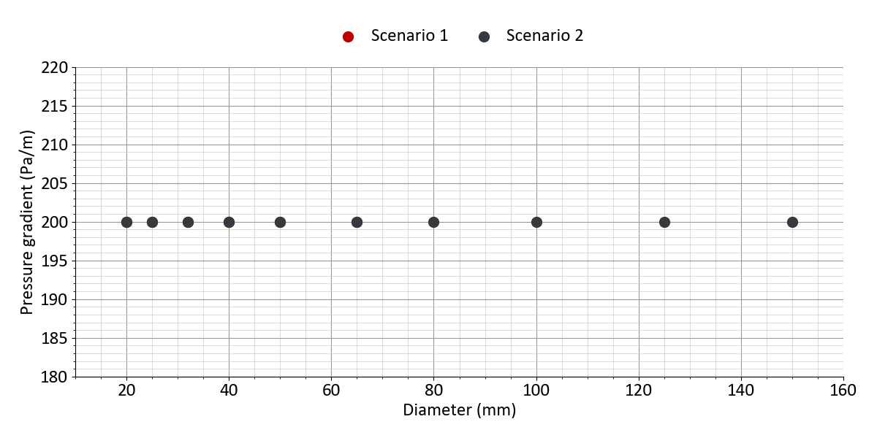
Figure 20: Design criteria: pressure gradient (Kunststoff (Doppelrohr): BruggPipes: CALPEX DUO (normal))
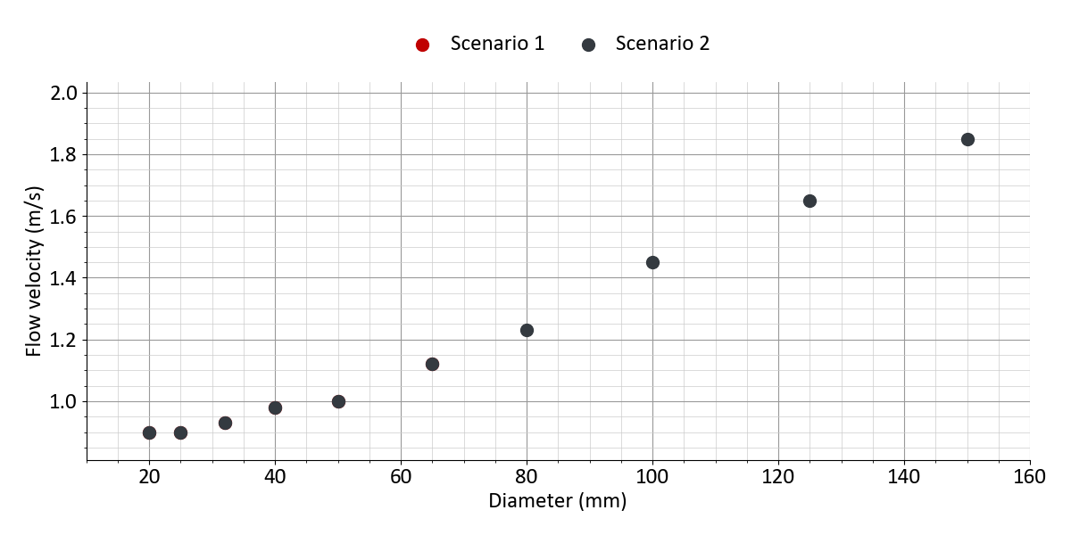
Figure 21: Design criteria: flow velocity (Kunststoff (Doppelrohr): BruggPipes: CALPEX DUO (normal))

4.2.4 Heat network: Fluid parameters
Table 56: Fluid parameters
 | All scenarios
Heat carrier fluid | Water
Density | 981 kg/m³
Viscosity | 0.0004 Pa/s
Specific heat capacity | 4.187 kJ/kgK

4.3 Energy hub

4.3.1 Energy hub: General parameters
Table 57: Settings of the design optimization
 | All scenarios
Optimization objective | Net present value / total annualized costs
Consider renewables to cover peak loads | yes
Conservative system design | yes
Set number of design days | no
Set time limit for calculation | no

Table 58: Settings of energy demands
 | All scenarios
Split into high- and low-temperature heat demand | no
Plug loads demand covered by energy hub | yes
Electricity for e-mobility covered by energy hub | yes
Electricity for building energy systems covered by energy hub | yes
Electricity for pumps covered by energy hub | yes
Hydrogen demand profile uploaded | no

Table 59: Ecologic parameters
 | All scenarios
Limit CO₂ emissions | no
Limit primary energy consumption | no

Table 60: Emission and primary energy factors for scenario 'Scenario 1'
 | CO₂ emissions | Primary energy factor
Electricity import | 350 g/kWh | 1.8
Electricity feed-in | 0 g/kWh | 0
Biomass import | 40 g/kWh | 0.2

Table 61: Emission and primary energy factors for scenario 'Scenario 2'
 | CO₂ emissions | Primary energy factor
Electricity import | 350 g/kWh | 1.8
Electricity feed-in | 0 g/kWh | 0
Natural gas import | 250 g/kWh | 1.1

4.3.2 Energy hub: Technology settings
Table 62: Biomass CHP 1: Settings
 | Scenario 1 | Scenario 2
Enabled | yes | yes
Define optimization interval | no | no
Generates high-temp. heat | no | no
Generates low-temp. heat | yes | yes
Electrical efficiency | 35 % | 35 %
Thermal efficiency | 50 % | 50 %
Fuel type | Biomass | Natural Gas
Direct electricity feed-in | no | no

Table 63: Photovoltaics: Settings
 | All scenarios
Enabled | yes
Lower area capacity limit | 0 m²
Upper area capacity limit | 62,500 m²
Lower power capacity limit | 0 kWₚ
Upper power capacity limit | 10,000 kWₚ
Area concurrence with solar thermal | no
Tilt angle | 30 °
East-west orientation (azimuth) | 0 °
Inverter efficiency | 96 %
System losses | 14 %
PV module type | Polycrystalline
Module efficiency | 16 %
Temperature coefficient | 0.42 %/°C
Set electricity price | no
Electricity generation constraint | no

Table 64: Solar thermal: Settings
 | Scenario 1 | Scenario 2
Enabled | yes | no
Lower limit | 1,000 m² | ---
Upper limit | 10,000 m² | ---
Area concurrence with PV | no | ---
Tilt angle | 30 ° | ---
East-west orientation (azimuth) | 0 ° | ---
Mean collector temperature | 80 °C | ---
Collector type | Flat-plate collector | ---

Table 65: Geothermal probes 1: Settings
 | Scenario 1 | Scenario 2
Enabled | yes | no
Geothermal technology | Geothermal probes | ---
Extraction temperature | 10 °C | ---
Define optimization interval | no | ---
Can generate heat | yes | ---
Can generate cold | no | ---
Generates high-temp. heat | no | ---
Generates low-temp. heat | yes | ---
Limit heat extraction | no | ---
Install heat pump (High temp.) | no | ---
Install heat pump | yes | ---
Heat: COP settings | Constant value | ---
Heat: Constant COP value | 4 | ---
Define heat pump capacity | no | ---
Limit cool extraction | no | ---
Install chiller | no | ---
Enforce regeneration | no | ---

Table 66: Air-source heat pump: Settings
 | Scenario 1 | Scenario 2
Enabled | no | yes
Define optimization interval | --- | no
Nominal COP | --- | 4
Can generate heat | --- | yes
Can generate cold | --- | yes
Generates high-temp. heat | --- | no
Generates low-temp. heat | --- | yes
Use heat for regeneration | --- | no
HT heat: COP settings | --- | Calculate COP (Carnot)
HT heat: Carnot efficiency | --- | Medium efficiency (50 %)
HT heat: Maximum COP | --- | 6
Heat: COP settings | --- | Calculate COP (Carnot)
Heat: Carnot efficiency | --- | Medium efficiency (50 %)
Heat: Maximum COP | --- | 6
Cooling: COP settings | --- | Calculate COP (Carnot)
Cooling: Carnot efficiency | --- | Medium efficiency (50 %)
Cooling: Maximum COP | --- | 6

Table 67: Heat storage: Settings
 | Scenario 1 | Scenario 2
Enabled | no | yes
Define optimization interval | --- | no
Long term storage possible | --- | no
Stand-by-losses | --- | 20 % per 5days
Temperature range | --- | 20 K
Limit state of charge | --- | no
Limit charging time/power | --- | no

4.3.3 Energy hub: Economic parameters
Table 68: Cost parameters for scenario 'Scenario 1'
 | Specific investment costs | Lifetime | Annual maintenance costs | Subsidy | Existing with remaining lifetime
Biomass CHP 1 | 1,300 €/kWₑₗ | 15 years | 8 % of investment | 0 % | ---
Photovoltaics | 1,100 €/kWₚ | 20 years | 1 % of investment | 0 % | ---
Solar thermal | 400 €/m² | 20 years | 1.5 % of investment | 40 % | ---
Geothermal probes 1 | 1,000 €/kWₜₕ | 50 years | 0 % of investment | 40 % | ---
Heat pump (Geothermal probes 1) | 1,000 €/kWₜₕ | 20 years | 2 % of investment | 40 % | ---

Table 69: Cost parameters for scenario 'Scenario 2'
 | Specific investment costs | Lifetime | Annual maintenance costs | Subsidy | Existing with remaining lifetime
Gas CHP 1 | 1,300 €/kWₑₗ | 15 years | 8 % of investment | 0 % | ---
Photovoltaics | 1,100 €/kWₚ | 20 years | 1 % of investment | 0 % | ---
Air-source heat pump | 1,100 €/kWₜₕ | 20 years | 2.5 % of investment | 40 % | ---
Heat storage | 500 €/m³ | 20 years | 1 % of investment | 0 % | ---

4.3.4 Energy hub: Import and feed-in
Table 70: Electricity grid
 | All scenarios
Electricity import (energy hub) | yes
Supply price | 0.2 €/kWh
Limit annual import | no
Annual price increase (option) | No change
Electricity feed-in | yes
Feed-in tariff | 0.04 €/kWh
Limit annual feed-in | no
Limit grid capacity | no
Grid capacity | no

Table 71: Natural gas
 | Scenario 1 | Scenario 2
Natural gas import | no | yes
Supply price | --- | 0.08 €/kWh
Limit annual import | --- | no
Annual price increase (option) | --- | No change
Limit grid capacity | --- | no
Grid capacity | --- | no

Table 72: Biomass
 | Scenario 1 | Scenario 2
Biomass import | yes | no
Supply price | 0.08 €/kWh | ---
Limit annual import | no | ---
Annual price increase (option) | No change | ---

4.4 Economic parameters
Table 73: Economic parameters
 | All scenarios
Imputed interest | 5 %
Observation period | 20 years
Year 1 of observation period | 2027
Inflation rate | 0 %
Operating cost subsidy (BEW) of large-scale heat pumps | no
Operating cost subsidy (BEW) of solar thermal collectors | no
CO₂ price option | No pricing

Table 74: Other costs: One-time costs for all scenarios
 | Specific investment costs | Lifetime | Maintenance costs | Subsidy
Gebäude Energiezentrale | 150,000 € | 20 years | 0 % | 0 %
Netzpumpe, Druckhaltung, Armaturen | 30,000 € | 20 years | 1 % | 40 %
Planungskosten | 100,000 € | 20 years | 0 % | 50 %

Table 75: Other costs: Annual costs for all scenarios
 | Annual costs | Subsidy
Verwaltung | 10,000 € | 40 %

Table 76: Revenue settings: Components
 | All scenarios
Energy price | yes
Capacity price | yes
Base price | no
One-time connection fee | yes

Table 77: Revenue settings: Prices for all scenarios
 | Supply price | Capacity price | Heat network connection
One-time connection fees | --- | --- | 8,000 €
Heat demand | 0.18 €/kWh | 50 €/kW | ---
Cooling demand | 0.15 €/kWh | 50 €/kW | ---
Plug loads | 0.3 €/kWh | 50 €/kW | ---
E-mobility | 0.3 €/kWh | 50 €/kW | ---

4.5 Project and weather data

4.5.1 General project data
Table 78: Project settings
 | All scenarios
Min. temp. diff. water/water | 2
Public holidays | yes
Time change | no
First day of year | Monday
Version of simulation core | 4.6

Table 79: Geographical location (weather data)
 | All scenarios
City | Düsseldorf
Country | Germany

4.5.2 Weather data
Table 80: Customization of weather data
 | All scenarios
Air temperature increase/decrease | no
Specify minimum temperature | no
Specify maximum temperature | no
GHI profile increase/decrease | no
DNI profile increase/decrease | no
Wind speed increase/decrease | no

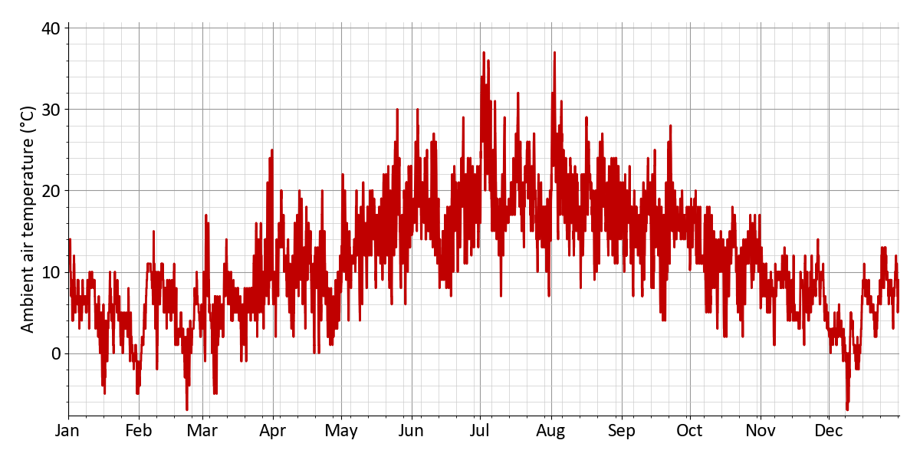
Figure 22: Ambient air temperature (Annual profile)
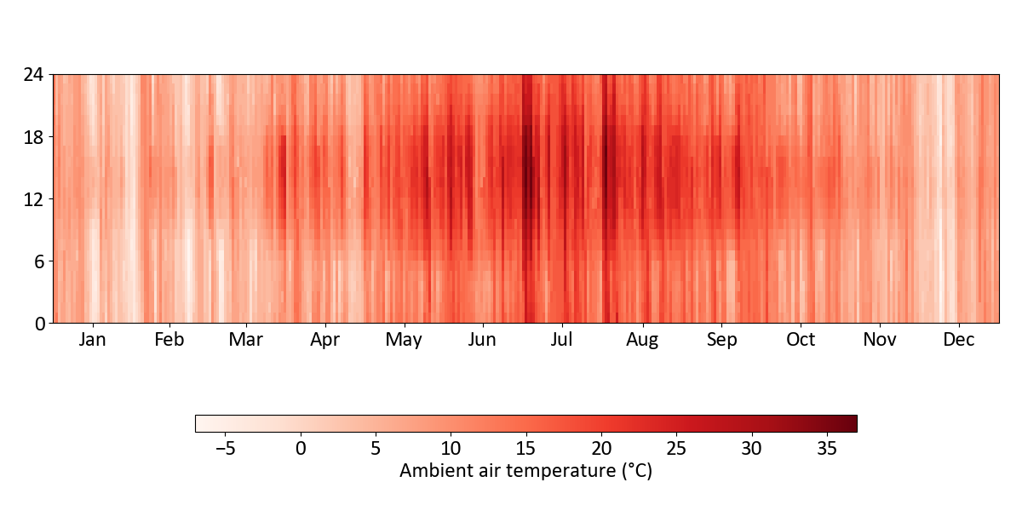
Figure 23: Ambient air temperature (Heatmap)
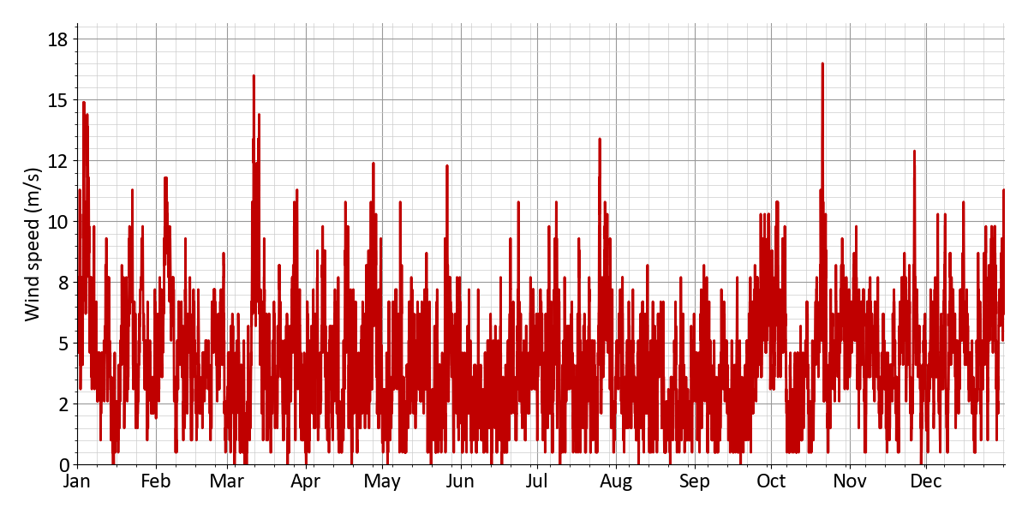
Figure 24: Wind speed (Annual profile)
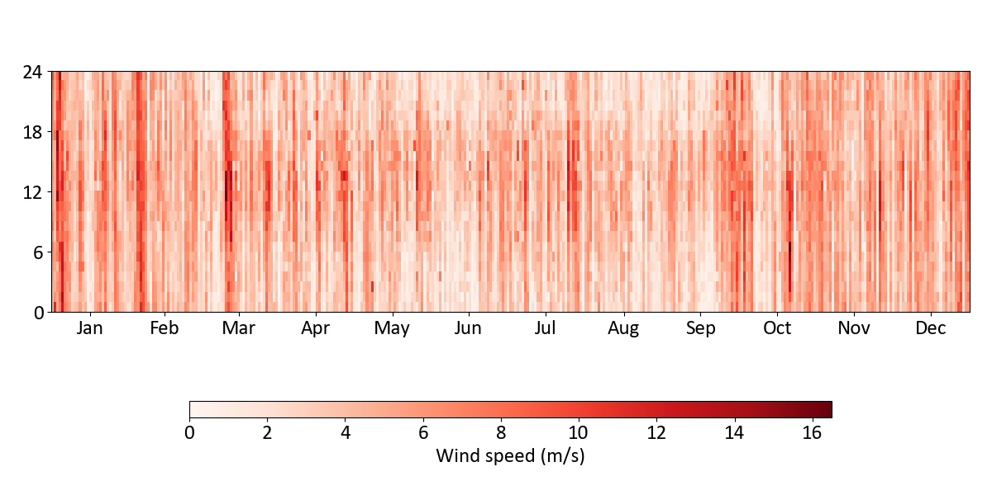
Figure 25: Wind speed (Heatmap)
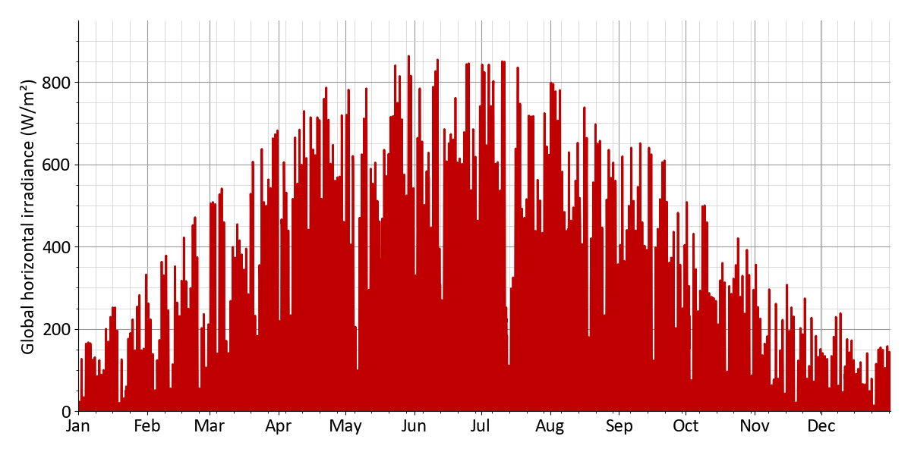
Figure 26: Global horizontal irradiance (annual profile)
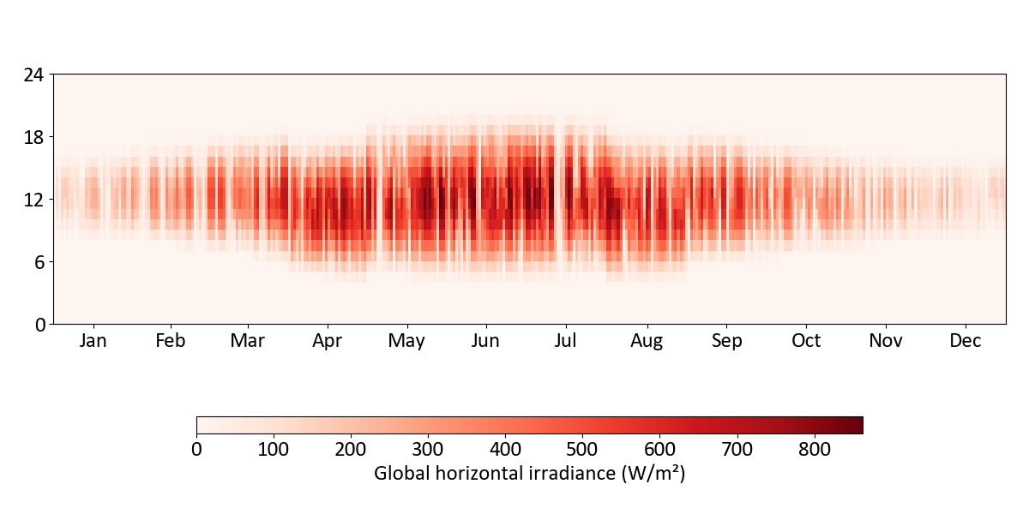
Figure 27: Global horizontal irradiance (Heatmap)
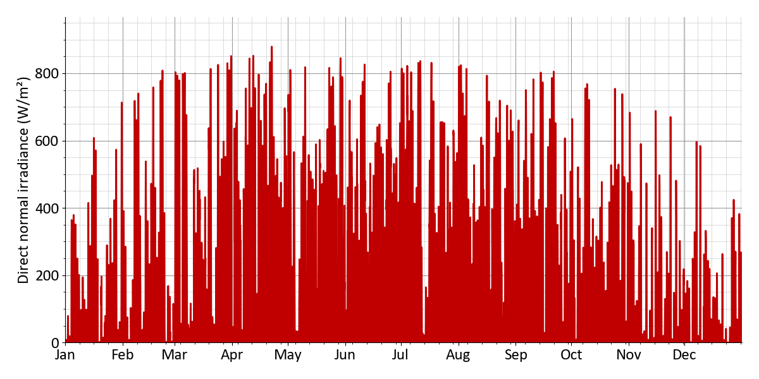
Figure 28: Direct normal irradiance (Annual profile)
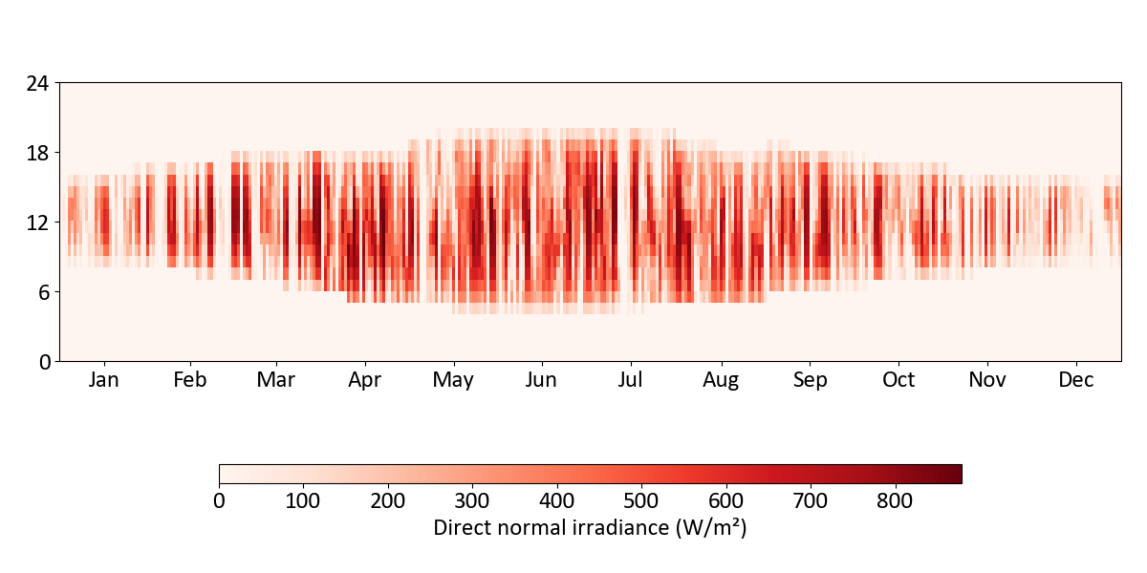
Figure 29: Direct normal irradiance (Heatmap)
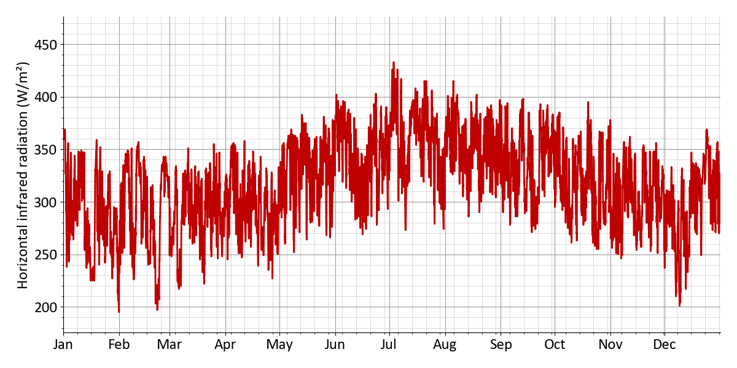
Figure 30: Horizontal infrared radiation (Annual profile)
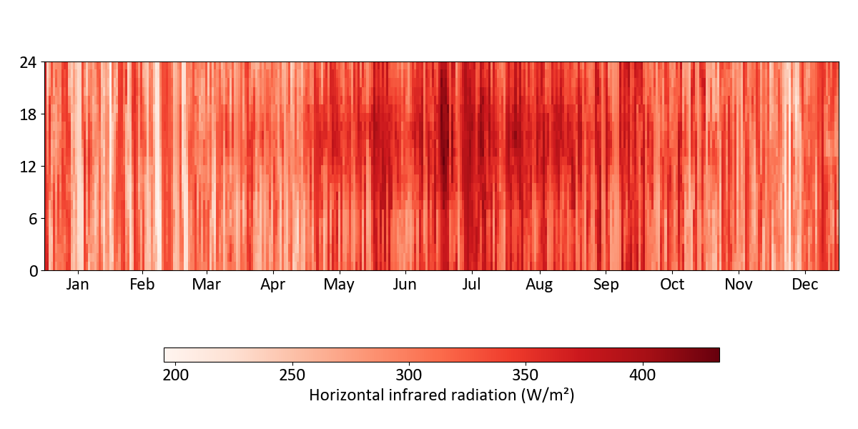
Figure 31: Horizontal infrared radiation (Heatmap)

4.6 Additional information and data sources
This report includes map data © OpenStreetMap contributors, licensed under the Open Database License (ODbL).

