Result Report
Project: Project 1
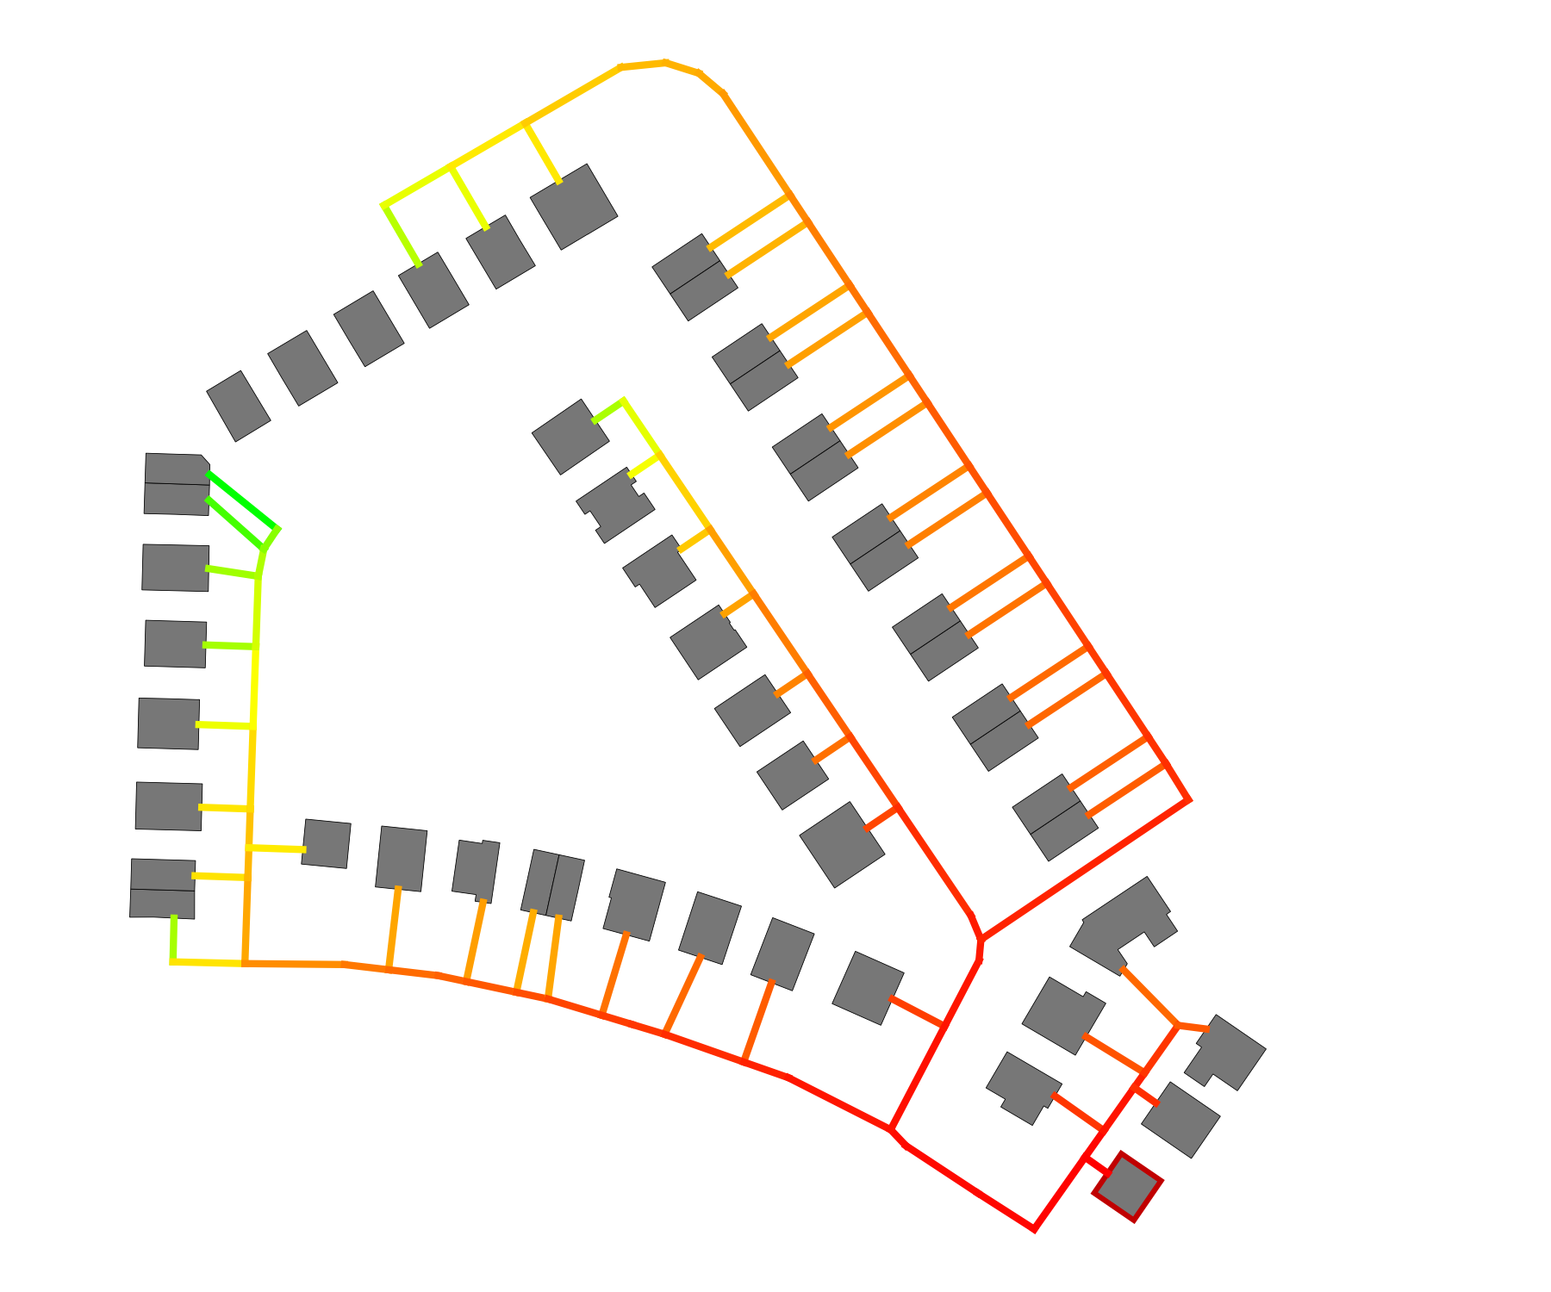
Client: | Example Company
 | Example street 1
 | 12345 Example city
Created by: | Engineering office Example company
 | Example street 2
 | 12345 Example city

Report created by: Test
Creation date: 09.09.2026 (13:46)

Table of contents
1 Introduction 1
1.1 Project area 1
1.2 Starting situation 1
1.3 Objective 1
2 Summary 2
2.1 General information 2
2.2 Scenario comparison 2
3 Potential analysis 4
3.1 Land use 4
3.2 Natural heat sources 4
3.2.1 Surface water bodies 4
3.2.2 Solar thermal energy 5
3.2.3 Shallow geothermal energy 6
3.2.4 Deep geothermal energy 6
3.3 Anthropogenic heat sources 7
3.3.1 Waste heat 7
3.3.2 Wastewater treatment plants 7
3.3.3 Existing heat networks 7
3.4 Biogenic fuels 8
3.4.1 Biogas 8
3.4.2 Biomass 8
3.5 Renewable power generation 9
4 Supply scenarios 11
4.1 Scenario 1: Scenario 1 12
4.1.1 Buildings 12
4.1.2 Heat network 16
4.1.3 Energy hub 21
4.1.4 Economic results 24
4.2 Scenario 2: Scenario 2 28
4.2.1 Buildings 28
4.2.2 Heat network 31
4.2.3 Energy hub 37
4.2.4 Economic results 40
5 Scenario comparison 44
6 Appendix 49
6.1 Methodology 49
6.2 Buildings 51
6.2.1 Buildings: Economic parameters 51
6.3 Heat network 53
6.3.1 Heat network: General parameters 53
6.3.2 Heat network: Pipe parameters 54
6.3.3 Heat network: Design criteria 55
6.3.4 Heat network: Fluid parameters 57
6.4 Energy hub 57
6.4.1 Energy hub: General parameters 57
6.4.2 Energy hub: Technology settings 58
6.4.3 Energy hub: Economic parameters 60
6.4.4 Energy hub: Import and feed-in 61
6.5 Economic parameters 62
6.6 Project and weather data 63
6.6.1 General project data 63
6.6.2 Weather data 63
6.7 Additional information and data sources 68

Tables
Table 1: Potential analysis: Land use 4
Table 2: Potential analysis: Surface water bodies 5
Table 3: Potential analysis: Solar thermal energy 6
Table 4: Potential analysis: Shallow geothermal energy 6
Table 5: Potential analysis: Existing heat networks 8
Table 6: Potential analysis: Biomass 9
Table 7: Potential analysis: Areas suitable for biomass provision 9
Table 8: Potential analysis: Renewable power generation 9
Table 9: Scenario 1: Fact sheet for the supply scenario: Scenario 1 12
Table 10: Scenario 1: Heat demands of the buildings 14
Table 11: Scenario 1: Cooling demands of the buildings 14
Table 12: Scenario 1: Electricity demands of the buildings 15
Table 13: Scenario 1: Installed building energy systems 15
Table 14: Scenario 1: Heat balance of the heat network 16
Table 15: Scenario 1: Cooling balance of the heat network 16
Table 16: Scenario 1: Electricity balance of the district 16
Table 17: Scenario 1: Properties of the heat network 17
Table 18: Scenario 1: Pump work and pressure 20
Table 19: Scenario 1: Pressure losses (critical path) 21
Table 20: Scenario 1: Sizing of the technologies in the energy hub 21
Table 25: Scenario 1: Energy import 22
Table 26: Scenario 1: Energy feed-in 23
Table 27: Scenario 1: Electricity generation and import 23
Table 28: Scenario 1: Heat generation and import 23
Table 29: Scenario 1: Emissions 23
Table 30: Scenario 1: Primary energy factor 24
Table 31: Scenario 1: Economic KPIs 24
Table 32: Scenario 1: Subsidies 24
Table 33: Scenario 1: Cost breakdown in € 24
Table 34: Scenario 2: Fact sheet for the supply scenario: Scenario 2 28
Table 35: Scenario 2: Heat demands of the buildings 29
Table 36: Scenario 2: Cooling demands of the buildings 30
Table 37: Scenario 2: Electricity demands of the buildings 30
Table 38: Scenario 2: Installed building energy systems 31
Table 39: Scenario 2: Heat balance of the heat network 32
Table 40: Scenario 2: Cooling balance of the heat network 32
Table 41: Scenario 2: Electricity balance of the district 32
Table 42: Scenario 2: Properties of the heat network 33
Table 43: Scenario 2: Pump work and pressure 36
Table 44: Scenario 2: Pressure losses (critical path) 37
Table 45: Scenario 2: Sizing of the technologies in the energy hub 37
Table 50: Scenario 2: Energy import 38
Table 51: Scenario 2: Energy feed-in 38
Table 52: Scenario 2: Electricity generation and import 38
Table 53: Scenario 2: Heat generation and import 39
Table 54: Scenario 2: Emissions 39
Table 55: Scenario 2: Primary energy factor 39
Table 56: Scenario 2: Economic KPIs 40
Table 57: Scenario 2: Subsidies 40
Table 58: Scenario 2: Cost breakdown in € 40
Table 59: Optimization of the energy hub 44
Table 60: Economic KPIs 44
Table 61: Cost breakdown in € 44
Table 62: Emissions and primary energy 48
Table 63: Cost parameters decentral technologies for scenario 'Scenario 1' 51
Table 64: Cost parameters decentral technologies for scenario 'Scenario 2' 52
Table 65: Heat network settings 53
Table 66: Hydraulic settings 54
Table 67: Pipe parameters: Kunststoff (Doppelrohr): BruggPipes: CALPEX DUO (normal) for scenario 'Scenario 1' 54
Table 68: Pipe parameters: Kunststoff (Doppelrohr): BruggPipes: CALPEX DUO (normal) for scenario 'Scenario 2' 54
Table 69: Pipe costs for all scenarios 55
Table 70: Sizing criteria: Kunststoff (Doppelrohr): BruggPipes: CALPEX DUO (normal) for scenario 'Scenario 1' 55
Table 71: Sizing criteria: Kunststoff (Doppelrohr): BruggPipes: CALPEX DUO (normal) for scenario 'Scenario 2' 56
Table 72: Fluid parameters 57
Table 73: Settings of the design optimization 57
Table 74: Settings of energy demands 57
Table 75: Ecologic parameters 58
Table 76: Emission and primary energy factors for scenario 'Scenario 1' 58
Table 77: Emission and primary energy factors for scenario 'Scenario 2' 58
Table 78: Biomass CHP 1: Settings 58
Table 79: Photovoltaics: Settings 58
Table 80: Solar thermal: Settings 59
Table 81: Geothermal probes 1: Settings 59
Table 82: Air-source heat pump: Settings 60
Table 83: Heat storage: Settings 60
Table 84: Cost parameters for scenario 'Scenario 1' 60
Table 85: Cost parameters for scenario 'Scenario 2' 61
Table 86: Electricity grid 61
Table 87: Natural gas 61
Table 88: Biomass 62
Table 89: Economic parameters 62
Table 90: Other costs: One-time costs for all scenarios 62
Table 91: Other costs: Annual costs for all scenarios 62
Table 92: Revenue settings: Components 62
Table 93: Revenue settings: Prices for all scenarios 63
Table 94: Project settings 63
Table 95: Geographical location (weather data) 63
Table 96: Customization of weather data 63

Figures
Figure 1: Specific costs and emissions 3
Figure 2: Scenario 1: Hourly total heat demand of all buildings 13
Figure 3: Scenario 1: Hourly total cooling demand of all buildings 13
Figure 4: Scenario 1: Distribution of pipe diameters 18
Figure 5: Scenario 1: Design result: Pipe Diameter and floor area of buildings 18
Figure 6: Scenario 1: Annual profile of supply and return temperature in the heat network 19
Figure 7: Scenario 1: Design result: Supply temperature and heat demand of buildings 19
Figure 8: Scenario 1: Heat flow: network to ground 20
Figure 9: Scenario 1: Diversity factor 20
Figure 10: Scenario 2: Distribution of pipe diameters 33
Figure 11: Scenario 2: Design result: Pipe Diameter and floor area of buildings 34
Figure 12: Scenario 2: Annual profile of supply and return temperature in the heat network 34
Figure 13: Scenario 2: Design result: Supply temperature and heat demand of buildings 35
Figure 14: Scenario 2: Heat flow: network to ground 35
Figure 15: Scenario 2: Diversity factor 36
Figure 16: Specific costs and emissions 47
Figure 17: Total costs and emissions 47
Figure 18: Energy import and feed-in 47
Figure 19: Energy demands 48
Figure 20: Design criteria: pressure gradient (Kunststoff (Doppelrohr): BruggPipes: CALPEX DUO (normal)) 56
Figure 21: Design criteria: flow velocity (Kunststoff (Doppelrohr): BruggPipes: CALPEX DUO (normal)) 57
Figure 22: Ambient air temperature (Annual profile) 64
Figure 23: Ambient air temperature (Heatmap) 64
Figure 24: Wind speed (Annual profile) 65
Figure 25: Wind speed (Heatmap) 65
Figure 26: Global horizontal irradiance (annual profile) 66
Figure 27: Global horizontal irradiance (Heatmap) 66
Figure 28: Direct normal irradiance (Annual profile) 67
Figure 29: Direct normal irradiance (Heatmap) 67
Figure 30: Horizontal infrared radiation (Annual profile) 68
Figure 31: Horizontal infrared radiation (Heatmap) 68

1 Introduction

1.1 Project area
For a district in Düsseldorf, a suitable, cost-effective, and climate-friendly energy concept is to be developed to supply heat to 50 buildings. As part of this study, a total of 2 different options were analyzed and compared. The results presented in this report are based on simulations of the buildings, the district heating network, and the energy hub.

1.2 Starting situation

1.3 Objective
The goal of the future-oriented energy concept for heating supply in the supply area is to be both environmentally friendly and price-stable. Environmental sustainability is ensured by the climate neutrality of the concept, which aligns with the Climate Protection Act 2045 and contributes to climate protection. Heat price stability is to be achieved through high independence from global energy markets and CO₂ taxes.

2 Summary

2.1 General information
This report summarizes the results of the analysis for the project 'Project 1'. The aim of the project is to develop a sustainable and efficient energy supply concept, taking into account the specific requirements of the district. The project area comprises a total of 50 buildings, including 38 residential and 12 non-residential buildings, which together have a total heating demand of 766 MWh and a total cooling demand of 22.4 MWh. Heat supply in the district is provided via a district heating network.
The components of the energy system are designed to achieve maximum technical and economic efficiency as well as the highest level of supply security. As part of the evaluation, a total of 2 different scenarios are analyzed. The results of these scenarios are assessed and compared with respect to their technical, economic, and environmental impacts. The project places particular emphasis on the optimization of ecological and economic objectives. By integrating modern generation and storage technologies and utilizing renewable energy sources, the goal is to achieve the lowest possible CO₂ emissions. At the same time, economic aspects are analyzed, including investment costs, operating costs, and long-term financial indicators such as net present value (NPV), payback period, and levelized cost of energy (LCOE). This report provides an overview of the investigated scenarios, their technical and economic implementation, and their potential contributions to a sustainable energy supply. The report is structured as follows: The design and simulation results, as well as the economic results for each variant, are presented individually in Chapter 2. In Chapter 4, the different supply options are compared from a technical and economic perspective. A detailed list of all input parameters used for the calculations, along with additional information on the applied calculation methodology, can be found in the appendix.

2.2 Scenario comparison
One of the key evaluation metrics is cost-effectiveness, which is measured using the levelized cost of heat. These are calculated based on the annualized total costs and the covered heat demand. To assess the environmental impacts, specific CO₂ emissions are used. These indicate how many emissions are generated per kilowatt hour of heat supplied. Figure 1 visualizes the results of the scenario analysis by comparing specific CO₂ emissions (g/kWh) with levelized heat costs (€/kWh). Each scenario is represented by a point in the diagram, showing the respective combination of ecological and economic outcomes. The position of the points illustrates the trade-off between low heat generation costs and low CO₂ emissions. Scenarios with higher costs may offer advantages in terms of reduced emissions, whereas more cost-effective variants often come with a higher environmental footprint. The spread of the points also indicates the range of possible solution approaches. Particular attention is given to scenarios located in the area of low costs and low emissions, as these potentially offer an optimal balance between cost-effectiveness and sustainability. Such scenarios may, for example, rely on a combination of renewable energy sources, efficient storage technologies, and modern supply system design. Chapter 5 provides a detailed comparison of the individual scenarios and examines both technical and economic aspects to support the selection of a specific supply concept.
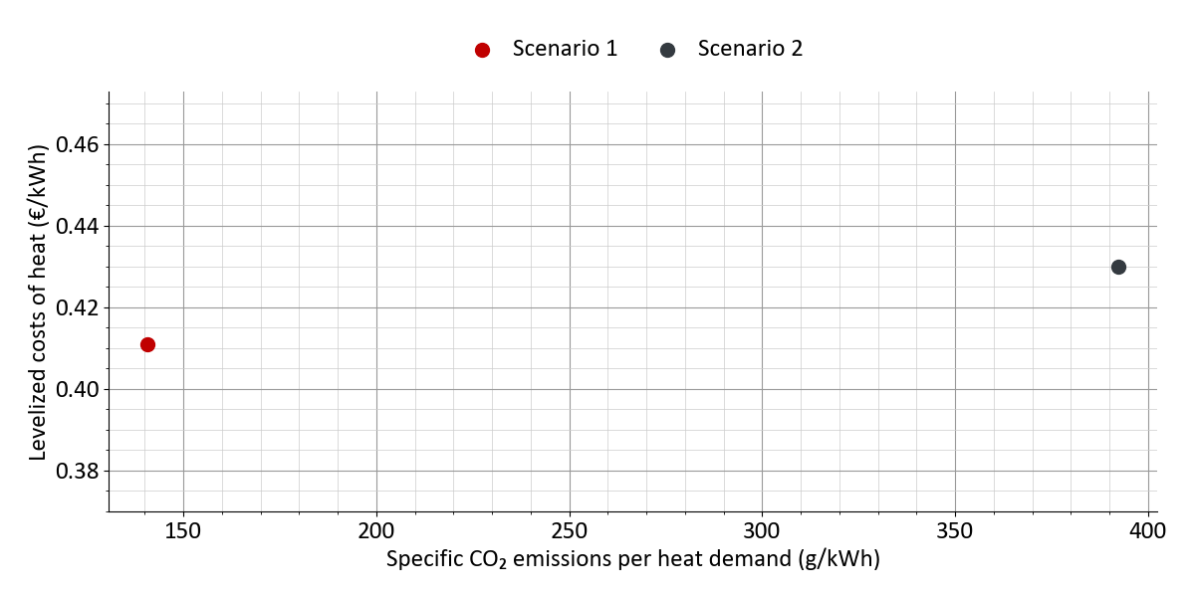
Figure 1: Specific costs and emissions

3 Potential analysis

3.1 Land use
The use of renewable energy sources is often land-dependent, which makes the available areas surrounding the district a key boundary condition of the potential analysis. An evaluation of the land use classes therefore provides an initial overview of the spatial structure of the analysis area. The distribution of built-up, vegetation, agricultural and water areas allows conclusions to be drawn regarding generally suitable locations for the individual technologies, for example unsealed areas for borehole heat exchangers and horizontal ground collectors, open spaces for solar thermal and photovoltaic systems, or forest and agricultural areas for the supply of biomass.
Within the analysis radius of 5,000 m around the district, 100.0 % of the area is described by land cover data. A total of 12 land use classes occur. The dominant class is 211 - Non-irrigated arable land with a share of 35.9 %. The largest classes are listed in the following table.
Table 1: Potential analysis: Land use
Land use class | Area | Share of analysis area
211 - Non-irrigated arable land | 2,817 ha | 35.9 %
112 - Discontinuous urban fabric | 2,375 ha | 30.3 %
121 - Industrial or commercial units | 1,175 ha | 15.0 %
311 - Broad-leaved forest | 411 ha | 5.2 %
142 - Sport and leisure facilities | 369 ha | 4.7 %
141 - Green urban areas | 238 ha | 3.0 %
231 - Pastures | 157 ha | 2.0 %
512 - Water bodies | 80 ha | 1.0 %
111 - Continuous urban fabric | 80 ha | 1.0 %
131 - Mineral extraction sites | 68 ha | 0.9 %
Other classes (2) | 72 ha | 0.9 %

3.2 Natural heat sources

3.2.1 Surface water bodies
Surface water bodies can be used as a heat source for large-scale heat pumps or for direct cooling. Compared to ambient air, they offer a higher heat capacity and a more stable temperature level, which increases the seasonal performance factor and reduces the peak load. Rivers and lakes close to the district are therefore of particular interest for thermal use. Key boundary conditions are the water rights permit, the permissible temperature difference of the return flow and the ecological requirements of the respective water body.
Within the analysis radius of 2,000 m around the district, 20 surface water bodies with a total area of 37,838 m² were identified. The water body closest to the district is located at a distance of 166 m. 17 of the water bodies are located within water protection areas. The identified potentials are listed in the following table.
Table 2: Potential analysis: Surface water bodies
Water body (name) | Area (river width if applicable) | Distance to district | in drinking water protection area
Pond | 205 m² | 166 m | Weiler (within)
Basin | 127 m² | 812 m | Weiler (within)
Basin | 91 m² | 830 m | Weiler (within)
Pond | 3,941 m² | 1,053 m | Weiler (within)
Pond | 1,942 m² | 1,075 m | Weiler (within)
Pond | 1,840 m² | 1,094 m | Weiler (within)
Reservoir | 1,273 m² | 1,183 m | Weiler (within)
Basin | 475 m² | 1,198 m | ---
Pond | 5,478 m² | 1,213 m | Weiler (within)
Pond | 3,525 m² | 1,225 m | Weiler (within)
Pond | 2,189 m² | 1,325 m | Weiler (within)
Basin | 234 m² | 1,367 m | Weiler (within)
Rückhaltebecken, Basin | 4,162 m² | 1,424 m | ---
Absetzbecken, Basin | 404 m² | 1,526 m | ---
Pond | 1,532 m² | 1,579 m | Weiler (within)
Pond | 2,611 m² | 1,599 m | Weiler (within)
Pond | 3,111 m² | 1,653 m | Weiler (within)
Basin | 2,020 m² | 1,656 m | Weiler (within)
Basin | 2,090 m² | 1,742 m | Weiler (within)
Reservoir | 590 m² | 1,887 m | Weiler (intersects)

3.2.2 Solar thermal energy
Solar thermal systems allow solar-generated heat to be fed into heat networks. A relevant design parameter is the global horizontal irradiation at the site, which together with the network supply temperature and the collector type influences the area-specific heat yield.
The annual global horizontal irradiation at the site amounts to 1,088 kWh/(m²·a). On this basis, the annual area-specific heat yields were calculated for standard flat plate collectors with southern orientation and a tilt angle of 30° for three exemplary collector temperatures. The yields for the individual temperature levels are listed in the following table.
Table 3: Potential analysis: Solar thermal energy
Collector temperature | Heat yield
50 °C | 2,044 MWh/(ha·a)
70 °C | 1,322 MWh/(ha·a)
90 °C | 759 MWh/(ha·a)

3.2.3 Shallow geothermal energy
By means of horizontal ground collectors or borehole heat exchangers, the subsurface can be used down to a depth of approximately 400 m for heating and cooling supply through shallow geothermal energy. A relevant design parameter is the thermal conductivity of the subsurface, which determines the specific heat extraction rate per metre and thus the required collector area or borehole depth. In the case of drilling, the geological and hydrogeological conditions (for example the location of water protection areas) must be taken into account.
Relevant areas for shallow geothermal energy could be identified within the district. The largest share of the district area is accounted for by the soil type Luvisol with an area of 100.0 %. Water protection areas are present within the district. The characteristic values of the identified potentials for shallow geothermal energy are listed in the following table.
Table 4: Potential analysis: Shallow geothermal energy
Soil type | District area share | Soil texture class (ESDAC) | Average thermal conductivity | Thermal conductivity range | Humidity class
Luvisol | 100.0 % | medium fine | 1 W/mK | 0.3 W/mK | humid

3.2.4 Deep geothermal energy
From a depth of approximately 400 m, the subsurface can be used for heat supply through deep geothermal energy. In hydrothermal systems, thermal water is extracted from water-bearing layers and returned to the subsurface after the heat has been withdrawn. Petrothermal systems, in contrast, develop the heat from low-permeability rock via artificially created flow paths. In the case of drilling, the geological and hydrogeological conditions (for example the location of water protection areas) must be taken into account.
No potential for the thermal use of deep geothermal energy could be found within the district.

3.3 Anthropogenic heat sources

3.3.1 Waste heat
Waste heat arises as an unused by-product of technical processes and can be integrated into heat networks directly or via heat pumps, provided the temperature is suitable and the supply is sufficiently continuous. As no additional primary energy has to be expended, the use of waste heat is a particularly efficient and, in terms of development, often economical option. Potential sources include industrial and commercial processes, data centres and waste treatment plants. Key design parameters are the temperature level, the available capacity and the temporal profile of the waste heat supply, which ideally coincides with the heat demand of the district. Aspects to be considered are the distance between the source and the supply area, the dependence on the operating mode and continued operation of the waste-heat-supplying process, as well as the contractual safeguarding of the long-term supply.
No waste heat potentials could be found in the analysis area with a radius of 2,000 m around the district.

3.3.2 Wastewater treatment plants
Wastewater exhibits a comparatively constant temperature level throughout the year and can be used, for example, as a heat source for large-scale heat pumps. Wastewater treatment plants are of particular interest in this respect. The heat quantity that can actually be extracted must be coordinated with the plant operator, as the minimum discharge temperature stipulated by water law limits the usable temperature difference.
No wastewater treatment plants could be found in the analysis area with a radius of 2,000 m around the district.

3.3.3 Existing heat networks
Existing heat networks are relevant both as a possible connection option for the district and as a starting point for a joint expansion of the supply area. In this context, the available capacities, the temperature level and the current generation mix of the network operator must be taken into account.
Within the analysis radius of 2,000 m, 2 existing heat networks with an estimated total supply area of approx. 690,000 ha were identified. The network closest to the district is located at a distance of 428 m. The heat networks found are listed in the following table.
Table 5: Potential analysis: Existing heat networks
Heat network | Distance to district | Estimated supply area
Heat network 1 | 428 m | 330,000 ha
Heat network 2 | 1,577 m | 360,000 ha

3.4 Biogenic fuels

3.4.1 Biogas
In biogas plants, a methane-rich gas is produced from the anaerobic digestion of substrates, which can be converted into electricity in a combined heat and power unit whose waste heat can be fed into heat networks. Alternatively, the biogas can be upgraded to biomethane and utilised via the natural gas grid at any location within the supply area, for example in a peak load boiler. Relevant design parameters are the substrate availability in the surrounding area as well as the installed thermal input capacity, from which the usable heat potential is derived. Aspects to be considered are the distance of existing plants from the supply area and the resulting connection pipeline, as well as the competition with existing heat consumers and the regulatory framework conditions for funding.
No biogas plants could be found in the analysis area with a radius of 2,000 m around the district.

3.4.2 Biomass
Biomass in the form of wood chips, log wood, pellets or residual and waste wood can be combusted in heating plants and combined heat and power plants, with the heat being fed into heat networks. Owing to the good storability of the fuel and the high achievable supply temperatures, biomass plants are suitable both for base load operation and for covering the peak load. Aspects to be considered are the sustainability and price stability of the fuel supply, the competing use by existing consumers and material recovery pathways, the emission control requirements regarding dust and nitrogen oxide emissions, as well as the regulatory limitation of the biomass share under the funding scheme.
Within the analysis radius of 30,000 m, 1 biomass plants with a total installed capacity of 3,100 kW were identified. The nearest plant is located at a distance of 21,750 m. The following table lists the biomass plants found.
Table 6: Potential analysis: Biomass
Biomass plant | Installed capacity | Year of commissioning | Type | Distance to district
Biomass plant 1 | 3,100 kW | 2007 | Firewood | 21,750 m

63.4 % of the analysis area is accounted for by land use classes in the categories of forest and woodland areas as well as agricultural areas. The area figures describe land use classes that could theoretically offer raw material potentials for the use of biomass. The share actually available depends on ownership structures, existing use, nature conservation requirements and the competition with material recovery. The following table shows the distribution of the suitable areas.
Table 7: Potential analysis: Areas suitable for biomass provision
Area category | Area | Share of analysis area
Agricultural land | 134,574 ha | 47.7 %
Forest and woodland | 44,516 ha | 15.8 %

3.5 Renewable power generation
Renewably generated electricity from wind power, photovoltaic and hydropower plants contributes to heat supply through sector coupling by providing the drive power for large-scale heat pumps, electrode boilers or power-to-heat applications. Since the greenhouse gas balance of heat pumps, for example, depends significantly on the emission factor of the electricity purchased, the availability of green electricity can make an important contribution to the decarbonisation of heat networks.
Within the analysis radius of 20,000 m, 62 plants for renewable electricity generation with a total installed capacity of 120,408 kW were identified. The technologies Wind energy, Photovoltaic, Hydropower were examined. The results for each technology are listed in the following table.
Table 8: Potential analysis: Renewable power generation
Technology | Number of plants | Installed capacity | Distance to nearest plant
Wind energy | 50 | 109,662 kW | 5,603 m
Photovoltaic | 6 | 10,094 kW | 2,226 m
Hydropower | 6 | 651 kW | 3,931 m

4 Supply scenarios
This chapter presents the results of the analyzed supply variants for the district in detail. Results that are identical across all variants are first summarized collectively. The results that differ between the variants are described in separate sections for each supply option. For each supply variant, the outcomes of the energy demand assessment, the network design, the energy hub design, and the economic evaluation are presented.
The relevant forms of energy demand generally include heating, cooling, and electricity demand. The determined useful energy demand refers to the actual amount of energy required and directly delivered to the users of the buildings in the district, such as space heating at radiators or domestic hot water at tapping points. In contrast to final energy demand, useful energy demand also includes losses from energy conversion and distribution (e.g., within the buildings).
The energy demands of the district are analyzed with temporal resolution for the design of the system components and the simulation of the energy system. This high-resolution approach offers a key advantage over using annual values, as it accounts for the temporal correlation between the availability of renewable energy on the one hand and the likewise time-varying energy demand on the other. An hourly resolution (8,760 values per year) is generally sufficient to capture the essential temporal dependencies. Heat demands at the district level may include space heating and domestic hot water demands. Cooling demands primarily consist of space cooling needs and, where applicable, process cooling requirements (e.g., for cold storage or IT infrastructure). In addition to thermal demands, electricity demands may also be considered: this includes, on the one hand, electricity needed to operate building system technologies (e.g., for water-to-water or air-to-water heat pumps), referred to here as auxiliary electricity. On the other hand, final energy demands for user electricity (lighting, household appliances, etc.) or electromobility (electricity for charging stations for electric vehicles) may also occur. Seasonal profiles for space heating and cooling are generated using the degree-day method. To calculate the hourly load profile, these are then overlaid with standard load profiles for different day types (weekday, Saturday, and Sunday) in order to approximate typical behavior-based consumption patterns in buildings.
In the following section of this chapter, the relevant energy flows within the heating network are presented (e.g., heat losses), along with an overview of the key results from the network design and simulation (e.g., heat line density or auxiliary electricity demand for pumping). For each supply variant, the results of the energy hub design are also presented. Finally, the economic and environmental performance indicators of the supply variants are evaluated. These include the net present values over the evaluation period, the levelized cost of heat, and the resulting CO₂ emissions associated with meeting the heating, cooling, and electricity demands of the district.

4.1 Scenario 1: Scenario 1
Description of the supply concept
The following section presents the key characteristics and calculation results for the supply variant 'Scenario 1'. This supply variant includes 50 buildings, of which 38 are residential and 12 are non-residential. 47 buildings are connected to a heating network operated with supply temperatures of 75 °C (constant) and return temperatures of 55 °C (constant). Based on these network temperatures, the heating network can be classified as 'Conventional district heating network'. The systems planned for the energy hub are listed in the following table.
Fact sheet for the supply scenario
Table 9: Scenario 1: Fact sheet for the supply scenario: Scenario 1
Heat network | yes
Buildings | 38 residential buildings, 12 non-residential buildings
Connected buildings | 47
Installed Heatpumps in buildings | 3
Heat network type | Conventional district heating network  75 °C (constant) / 55 °C (constant)
Technologies in energy hub | Biomass CHP 1, Photovoltaics, Solar thermal, Geothermal probes 1

4.1.1 Buildings
The analyzed supply area comprises 50 buildings. Of these, 38 are residential buildings with a total of 76 dwelling units. The total heating demand of all buildings amounts to 766 MWh, of which 623 MWh is for space heating (81 %) and 143 MWh is for domestic hot water (18.6 %). The total usable floor area of all supplied buildings is 6,799 m². The supply temperatures for space heating are in the range of 35 °C. For domestic hot water, supply temperatures of 60 °C are assumed.
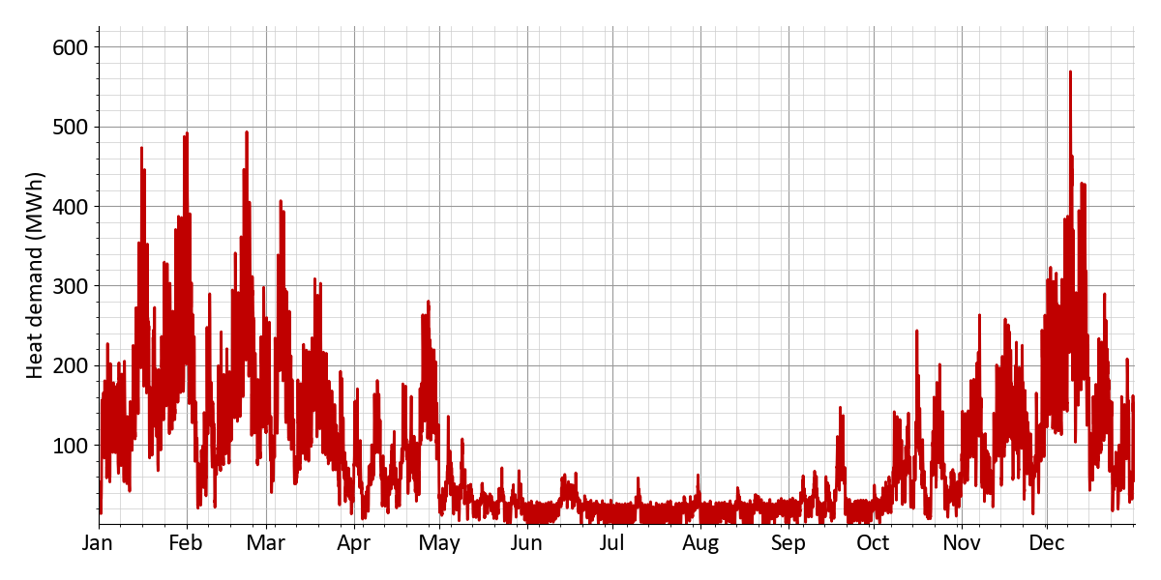
Figure 2: Scenario 1: Hourly total heat demand of all buildings
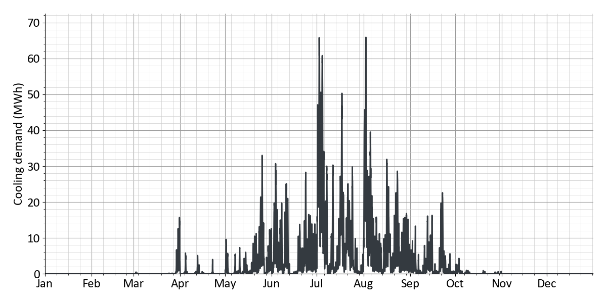
Figure 3: Scenario 1: Hourly total cooling demand of all buildings
Table 10 shows the annual heating demands of the buildings along with the corresponding peak loads. The space heating demand amounts to 623 MWh, with a peak demand of 563 kW. The domestic hot water demand amounts to 143 MWh. The total heating demand, resulting from the sum of space heating and domestic hot water demands of all buildings in the district, amounts to 766 MWh with a peak load of 569 kW. A total of 3 air-source heat pumps are installed in the buildings, generating 39.4 MWh of heat in total and achieving a seasonal performance factor (SCOP) of 4.4. Decentralized electric domestic hot water heating generates a total of 9 MWh heat. The buildings draw a total of 718 MWh of heat from the district heating network, with an annual peak load of 516 kW. An overview of the systems installed in the buildings can be found in a subsequent table on the installed building energy systems.
Table 10: Scenario 1: Heat demands of the buildings
 | Annual energy | Peak power
Space heating | 623 MWh | 563 kW
Domestic hot water | 143 MWh
Total | 766 MWh
Heat generation of air-source heat pumps | – 39.4 MWh
Heat generation of decentral hot water heaters | – 9 MWh
Heat import of all buildings | 718 MWh | 516 kW
Heat losses | 164 MWh | 21.4 kW
Heating load at energy hub | 881 MWh | 537 kW

Table 11 shows the total cooling demands of all buildings and the corresponding peak cooling loads. The annual cooling demand for space conditioning amounts to 22.4 MWh, with a maximum peak cooling load of 66 kW over the year. The annual cooling demand for process cooling amounts to 0 MWh, with a maximum cooling load of 0 kW. The total cooling demand for all buildings amounts to 22.4 MWh, with a peak cooling load of 66 kW required to meet the demand. Air-cooled chillers cover parts of the cooling demand decentrally within the buildings and release the waste heat to the ambient air. The cooling generated by the air-cooled chillers amounts to 22.4 MWh. By providing cooling within the buildings, a certain amount of waste heat is fed into the heating network. The total amount of waste heat injected over the year amounts to 0 MWh, with a maximum injection capacity of 0 kW.
Table 11: Scenario 1: Cooling demands of the buildings
 | Annual energy | Peak power
Space cooling | 22.4 MWh | 66 kW
Process cooling | 0 MWh | 0 kW
Total | 22.4 MWh | 66 kW
Cooling generation of air-cooled chillers | – 22.4 MWh
Waste heat feed-in heat network | 0 MWh | 0 kW

The electrical demands of the buildings are shown in Table 12. The annual electricity demand for user electricity (e.g., for lighting and other general loads) amounts to 6 MWh. For electromobility, the annual electricity demand is determined to be 498 MWh, with a maximum power demand of 153 kW. The total annual electricity demand for all buildings amounts to 504 MWh. The annual auxiliary electricity demand for all buildings amounts to 20.4 MWh. Auxiliary electricity refers to the electricity required for heating and cooling systems within the buildings. This includes, for example, the electricity consumption of decentralized heat pumps or instantaneous water heaters. A detailed breakdown of the auxiliary electricity demand by technology at the building level can be found in the table of installed building energy systems. The total electricity consumption of the buildings results from the sum of user electricity, electromobility, and auxiliary electricity demands. This amounts to 524 MWh per year.
Table 12: Scenario 1: Electricity demands of the buildings
 | Annual energy | Peak power
Plug loads | 6 MWh | 2.7 kW
E-mobility | 498 MWh | 153 kW
Total | 504 MWh | 154 kW
Operating power of all buildings | + 20.4 MWh
Electricity import of all buildings | 524 MWh

Table 13 provides an overview of the systems installed in the buildings. A total of 47 district heating connections with a combined capacity of 987 kWₜₕ are planned for supplying heat from the district heating network, through which a total of 718 MWh of heat is delivered to the buildings. A total of 3 decentralized air-source heat pumps are planned for the buildings. With a total thermal capacity of 52 kWₜₕ, they generate 39.4 MWh of heat. The electricity demand of the air-source heat pumps amounts to 8.9 MWh, resulting in an average seasonal performance factor (SCOP) of 4.4. A total of 6 systems for decentralized electric domestic hot water heating with a total capacity of 214 kWₜₕ are installed in the buildings. These contribute 9 MWh of heat for domestic hot water generation. A total of 7 air-cooled chillers with a combined capacity of 66 kWₜₕ contribute 22.4 MWh annually to the decentralized cooling supply of the buildings. The electricity demand of the air-cooled chillers amounts to 2.5 MWh, resulting in a seasonal performance factor (SCOP) of 9.
Table 13: Scenario 1: Installed building energy systems
 | Count | Installed capacity | Useful energy | Electricity demand | Fuel demand | SCOP
Heat transfer station | 47 | 987 kWₜₕ | 718 MWh | --- | --- | ---
Air-source heat pump | 3 | 52 kWₜₕ | 39.4 MWh | 8.9 MWh | --- | 4.4
El. hot water heater | 6 | 214 kWₜₕ | 9 MWh | 9 MWh | --- | ---
Storage (domestic hot water) | 47 | 14,100 l | --- | --- | --- | ---
Air chiller | 7 | 66 kWₜₕ | 22.4 MWh | 2.5 MWh | --- | 9

4.1.2 Heat network
The heat balance for the district heating network is shown in Table 14. The first row of the table shows the heat demand of the buildings supplied by the district heating network (718 MWh, peak load: 516 kW). The buildings' heat demand serves as the starting point for calculating the heat supply at the energy hub (last row). Heat losses from the network to the ground increase the required heat generation at the energy hub. The heat losses of the district heating network amount to 164 MWh, with a maximum loss rate over the year of 21.4 kW. The resulting annual heat supply from the energy hub amounts to 881 MWh, with a peak load of 537 kW.
Table 14: Scenario 1: Heat balance of the heat network
 | Annual energy | Peak power
Heat import of all buildings | 718 MWh | 516 kW
Heat losses | + 164 MWh | 21.4 kW
Heating load at energy hub | 881 MWh | 537 kW

The cooling balance for the district heating network is shown in Table 15.
Table 15: Scenario 1: Cooling balance of the heat network
 | Annual energy | Peak power
Waste heat feed-in heat network | 0 MWh | 0 kW

As shown in Table 16, the total electricity demand of the district consists of the electricity demand of the buildings and the electricity demand for the circulation pumps of the district heating network. The electricity consumption for the circulation pumps amounts to 6.7 MWh, with a maximum power demand of 4.9 kW. The total electricity demand of the district energy system amounts to 531 MWh.
Table 16: Scenario 1: Electricity balance of the district
 | Annual energy | Peak power
Electricity import of all buildings | 524 MWh
Pump work | + 6.7 MWh | 4.9 kW
Electricity demand district | 531 MWh

Key performance indicators for the district heating network are shown in Table 17. The total route length of the district heating network is 1.4 km, of which 0.78 km accounts for distribution lines and 0.62 km for building connections. The smallest pipe diameter is DN25 and the largest is DN65. The supply temperature in the district heating network is assumed to be 75 °C (constant), and the return temperature is assumed to be 55 °C (constant). The heat transfer fluid in the network contributes to the thermal inertia of the overall system, which increases proportionally with the water volume. Based on the network lengths and pipe diameters, the total water volume of the district heating network amounts to 4.2 m³ (sum of supply and return), corresponding to a water mass of 4.1 t. For an initial economic assessment of whether a district heating network is economically viable, the heat line density can be used as an indicator. The heat line density is calculated as the ratio of the heat fed into the heating network to the total route length of the district heating network (1.4 km). For conventional district heating networks, heat line densities above 1.5 MWh/m indicate that the construction of a district heating network may be economically viable. Lower reference values apply to low-temperature district heating networks. For the area under consideration, the heat line density amounts to 0.51 MWh/m.
Table 17: Scenario 1: Properties of the heat network
Network properties
Route length | 1.4 km
of which distribution pipes | 0.78 km
of which connection pipes | 0.62 km
Supply temperature | 75 °C (constant)
Return temperature | 55 °C (constant)
Water mass | 4.1 t
Water volume | 4.2 m³
Linear heat density | 0.51 MWh/m
District area | 2.7 ha
Heat density | 284 MWh/ha

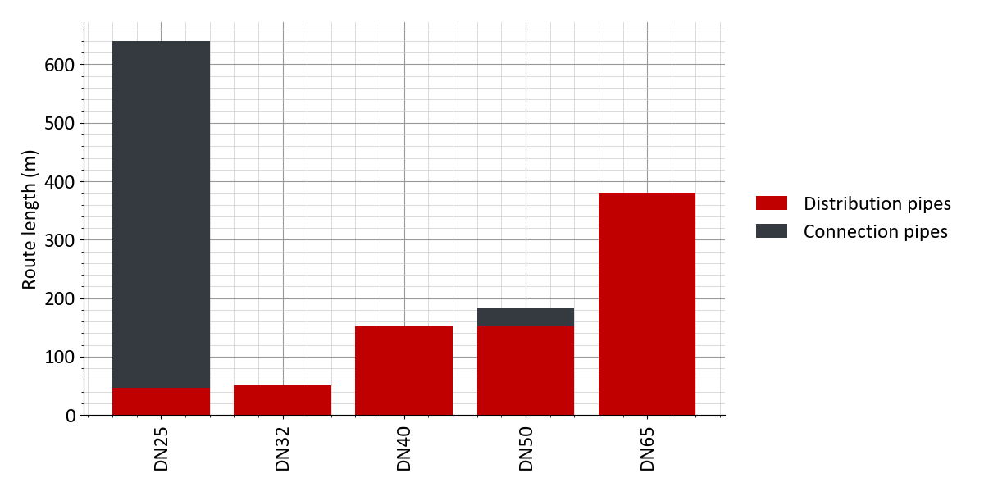
Figure 4: Scenario 1: Distribution of pipe diameters
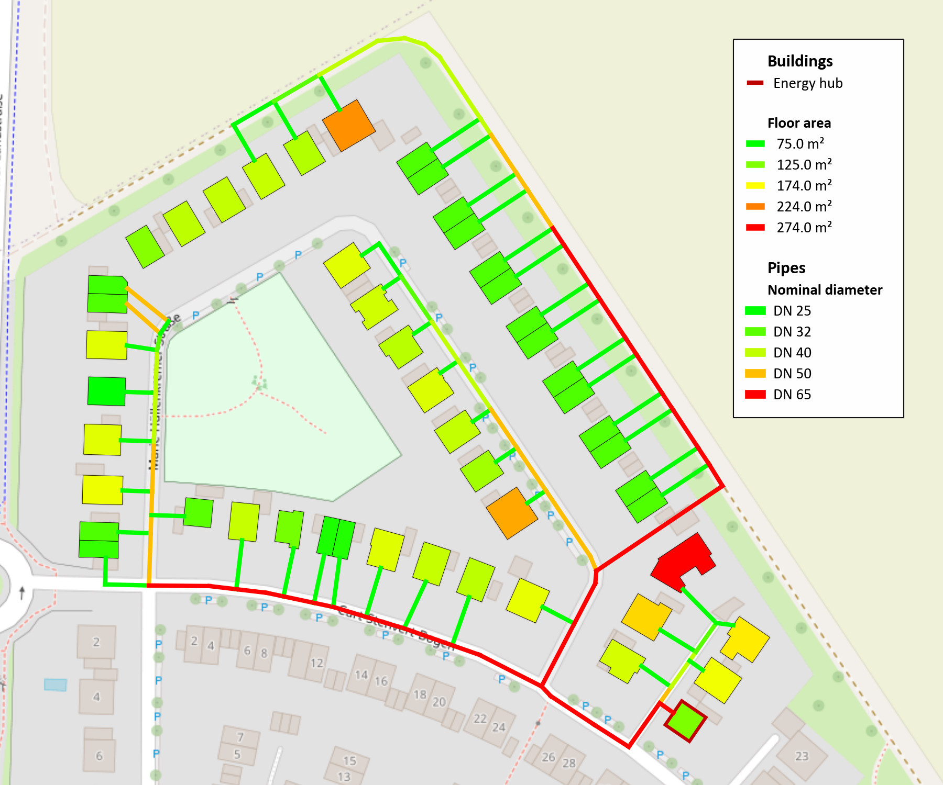
Figure 5: Scenario 1: Design result: Pipe Diameter and floor area of buildings
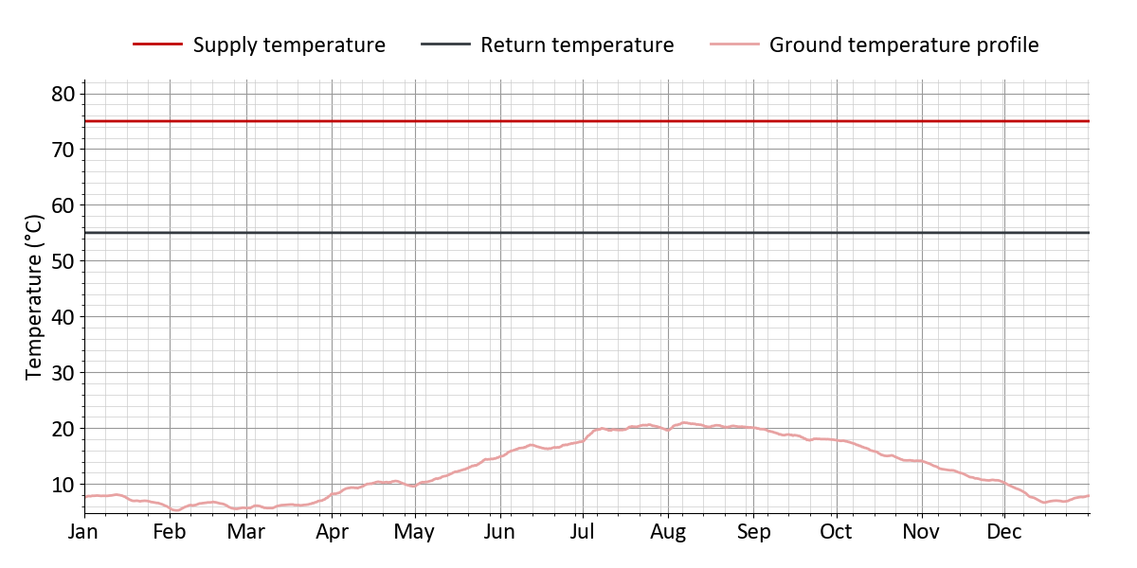
Figure 6: Scenario 1: Annual profile of supply and return temperature in the heat network
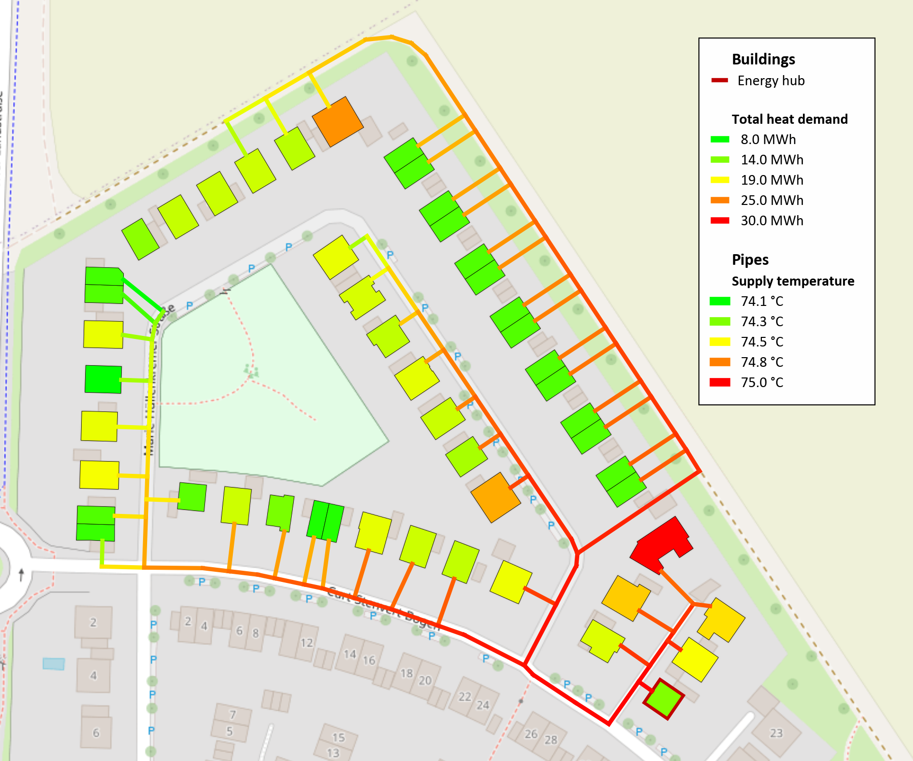
Figure 7: Scenario 1: Design result: Supply temperature and heat demand of buildings
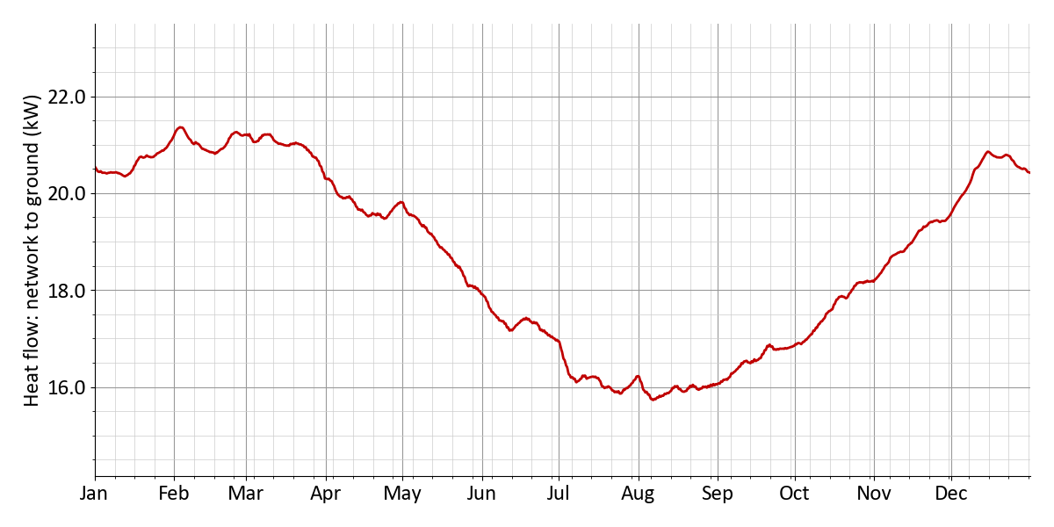
Figure 8: Scenario 1: Heat flow: network to ground
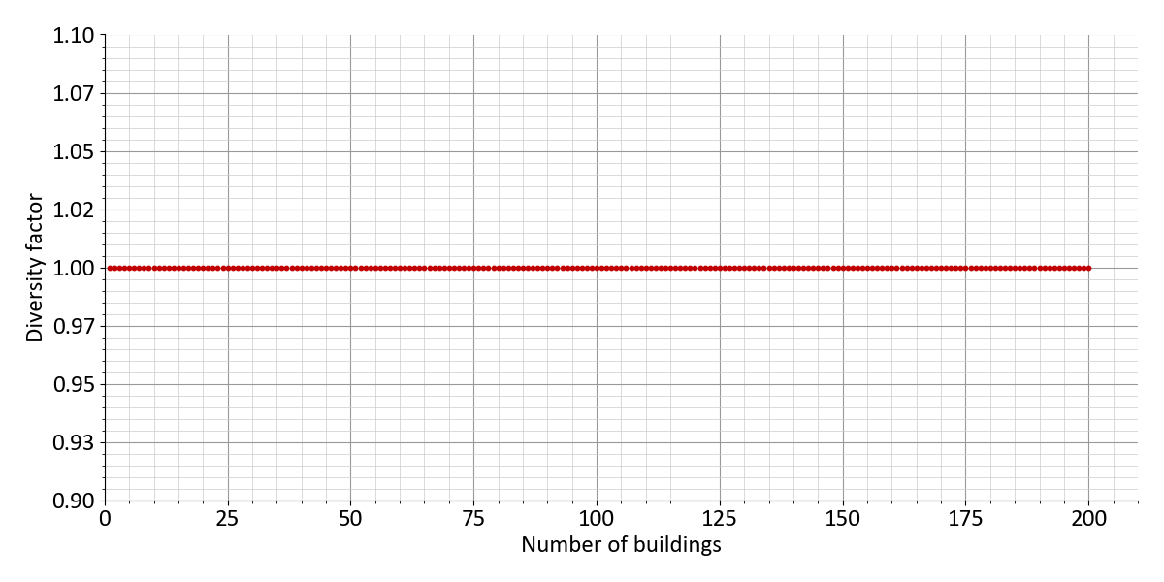
Figure 9: Scenario 1: Diversity factor
The results of the hydraulic calculation are shown in Table 18. The average pressure gradient in the network is 329 Pa/m. The pressure loss at the network's critical point is 3.8 bar. The maximum pump power is 3.6 kW. The electrical power consumption of the pump is 4.8 kW. The electricity demand of the network pump amounts to 6.7 MWh. The relative electricity demand of the network pump is 0.94 %. The pressure stage of the network is designed for PN16.
Table 18: Scenario 1: Pump work and pressure
Pump work and pressure
Mean pressure gradient | 329 Pa/m
Pressure loss (critical path) | 3.8 bar
Flow rate network pump | 34.3 m³/h
Max. pump power | 3.6 kW
Elec. power demand of pump | 4.8 kW
Power demand pump | 6.7 MWh
Relative power demand pump | 0.94 %
Pressure rating | PN16

The total pressure losses for the district heating pipeline with the network's critical point, along with the corresponding individual pressure losses, are shown in Table 19. The pressure loss at the energy hub is assumed to be 0.2 bar, and at the heat transfer stations 0.3 bar. The pipelines cause a pressure loss of 2.7 bar along the hydraulically critical path. In addition, pressure losses due to pipe fittings, such as valves and bends, are estimated at 0.66 bar (assumption: 25 % of the pipe pressure losses). This results in a total pressure loss of 3.8 bar, which must be overcome by the network pump.
Table 19: Scenario 1: Pressure losses (critical path)
Pressure losses (critical path)
Pressure loss energy hub | 0.2 bar
Pressure loss substation | 0.3 bar
Pressure loss pipes | 2.7 bar
Pressure loss fittings / installations | 0.66 bar
Pressure loss (critical path) | 3.8 bar
Building name | Marie-Hüllenkremer-Straße 23

4.1.3 Energy hub
The system design of the energy hub is shown in Table 20. Detailed information on the energy generation systems can be found in the following tables. Biomass CHP 1 has an electrical rated power of 56 kWₑₗ and achieves full load hours of 4,766 h. Table Fehler! Verweisquelle konnte nicht gefunden werden. provides details such as the fuel consumption of 763 MWh, as well as the generated 267 MWh of electricity and 381 MWh of heat. The module capacity of the PV system is 224 kWₚ. As shown in Table Fehler! Verweisquelle konnte nicht gefunden werden., the collector area amounts to 1,400 m², with an electricity generation of 217 MWh. Solar thermal has a collector area of 1,000 m². Table Fehler! Verweisquelle konnte nicht gefunden werden. contains additional data, including a collector area of 1,000 m² and a heat yield of 76 MWh. Geothermal probes 1 has a capacity of 342 kWₜₕ. Table Fehler! Verweisquelle konnte nicht gefunden werden. contains the data on the generation of 424 MWh of heat and 0 MWh of cooling, as well as the electricity demand of 106 MWh.
Table 20: Scenario 1: Sizing of the technologies in the energy hub
Technology | Dimensioning | Full load hours/Charging cycles
Biomass CHP 1 | 56 kWₑₗ | 4,766 h
Photovoltaics | 224 kWₚ | 970 h
Solar thermal | 1,000 m² | 76 h
Geothermal probes 1 | 342 kWₜₕ | 930 h

Nominal electric capacity | 56 kWₑₗ
Generated electricity | 267 MWh
Generated heat | 381 MWh
Fuel demand | 763 MWh
Full load hours | 4,766 h

Installed capacity | 224 kWₚ
Collector area | 1,400 m²
Generated electricity | 217 MWh
Full load hours | 970 h
Curtailed generation potential | 0 MWh

Collector area | 0 m²
Generated heat | 76 MWh
Curtailed generation potential | 179 MWh
Yield per collector area | 76 h

Extraction rate | 342 kWₜₕ
Generated heat | 424 MWh
Heat pump capacity | 456 kWₜₕ
Electricity demand | 106 MWh

Table 21: Scenario 1: Energy import
 | Annual sum | Peak power | Share
Electricity import from grid (energy hub) | 221 MWh | 177 kW | 17.3 %
Renewable electricity generation | 217 MWh | --- | 17.0 %
Biomass | 763 MWh | 160 kW | 59.7 %
Heat from solar thermal | 76 MWh | --- | 6.0 %

Table 22: Scenario 1: Energy feed-in
 | Annual energy | Peak power
Electricity feed-in | 68 MWh | 132 kW

Table 23: Scenario 1: Electricity generation and import
Technology | Annual energy | Share
Biomass CHP 1 | 267 MWh | 37.9 %
Renewable electricity generation | 217 MWh | 30.8 %
Share photovoltaics | 217 MWh | 30.8 %
Electricity import from grid (energy hub) | 221 MWh | 31.3 %
 | Self-sufficiency (autarky) rate | 65 %
 | Self-consumption rate | 86 %

Table 24: Scenario 1: Heat generation and import
Technology | Annual energy | Share
Biomass CHP 1 | 381 MWh | 43.2 %
Solar thermal | 76 MWh | 8.6 %
Geothermal probes 1 | 424 MWh | 48.1 %
Solar thermal coverage rate |  | 8.6 %

Emissions and primary energy
Table 25: Scenario 1: Emissions
 | Spec. emissions |  | Annual sum |  | CO₂ emissions
Electricity import (energy hub) | 350 g/kWh | × | 221 MWh | = | 77 t
Electricity feed-in | - 0 g/kWh | × | 68 MWh | = | - 0 t
Biomass | 40 g/kWh | × | 763 MWh | = | 30.5 t
District heating import | 150 g/kWh | × | 0 MWh | = | 0 t
District cooling import | 150 g/kWh | × | 0 MWh | = | 0 t
 |  |  | Sum |  | 108 t

Table 26: Scenario 1: Primary energy factor
 | Primary energy factor |  | Annual sum |  | Primary energy
Electricity import (energy hub) | 1.8 | × | 221 MWh | = | 398 MWh
Electricity feed-in | - 0 | × | 68 MWh | = | - 0 MWh
Biomass | 0.2 | × | 763 MWh | = | 153 MWh
District heating import | 0.6 | × | 0 MWh | = | 0 MWh
District cooling import | 0.8 | × | 0 MWh | = | 0 MWh
 |  |  | Sum |  | 550 MWh

4.1.4 Economic results
Summary
Table 27: Scenario 1: Economic KPIs
Net present value | + 639,921 €
Amortization period | 17 years
Internal rate of return | 7.9 %
Total costs (excl. sales revenues) | 3,924,707.0 €
Levelized costs of energy | 0.244 €/kWh
Annual energy costs per floor area | 46.32 €/m²
Monthly energy costs per floor area | 3.86 €/m²

Table 28: Scenario 1: Subsidies
Initial investment | 3,612,164.0 €
Subsidy on initial investment | 1,203,486.0 €
Subsidy rate for initial investment | 33.3 %
Total costs (excl. all revenues and subsidies) | 5,162,090 €
Total subsidy in observation period | 1,253,335.0 €
Subsidy rate (total) | 24.3 %

Cost and revenue details
Table 29: Scenario 1: Cost breakdown in €
 | Sum | 2027 | 2028 | 2029 | 2030 | ... | 2046 | 2047
Total costs | -639,921 | 2,032,678 | -176,079 | -167,694 | -159,709 | ... | -73,164 | -471,573
Investment cost | 3,243,622 | 3,612,164 | 0 | 0 | 0 | ... | 0 | -401,892
Building energy systems | 492,771 | 563,133 | 0 | 0 | 0 | ... | 0 | -70,362
El. hot water heater | 5,590 | 5,590 | 0 | 0 | 0 | ... | 0 | 0
Air-source heat pump | 82,005 | 82,005 | 0 | 0 | 0 | ... | 0 | 0
Air chiller | 77,242 | 77,242 | 0 | 0 | 0 | ... | 0 | 0
Storage (domestic hot water) | 65,341 | 74,730 | 0 | 0 | 0 | ... | 0 | -9,388
Heat transfer station | 262,590 | 323,564 | 0 | 0 | 0 | ... | 0 | -60,974
Heat network | 1,015,929 | 1,251,830 | 0 | 0 | 0 | ... | 0 | -235,900
Connection pipe | 418,062 | 515,137 | 0 | 0 | 0 | ... | 0 | -97,075
Distribution pipe | 597,866 | 736,692 | 0 | 0 | 0 | ... | 0 | -138,825
Energy hub | 1,454,921 | 1,517,200 | 0 | 0 | 0 | ... | 0 | -95,629
Biomass CHP 1 | 87,858 | 72,800 | 0 | 0 | 0 | ... | 0 | -18,291
Photovoltaics | 246,400 | 246,400 | 0 | 0 | 0 | ... | 0 | 0
Solar thermal | 400,000 | 400,000 | 0 | 0 | 0 | ... | 0 | 0
Geothermal probes 1 | 264,662 | 342,000 | 0 | 0 | 0 | ... | 0 | -77,337
Heat pump (Geothermal probes 1) | 456,000 | 456,000 | 0 | 0 | 0 | ... | 0 | 0
Other costs | 280,000 | 280,000 | 0 | 0 | 0 | ... | 0 | 0
Gebäude Energiezentrale | 150,000 | 150,000 | 0 | 0 | 0 | ... | 0 | 0
Netzpumpe, Druckhaltung, Armaturen | 30,000 | 30,000 | 0 | 0 | 0 | ... | 0 | 0
Planungskosten | 100,000 | 100,000 | 0 | 0 | 0 | ... | 0 | 0
Maintenance costs | 532,171 | 0 | 40,669 | 38,732 | 36,888 | ... | 16,898 | 16,094
Building energy systems | 80,711 | 0 | 6,168 | 5,874 | 5,594 | ... | 2,562 | 2,440
El. hot water heater | 696 | 0 | 53 | 50 | 48 | ... | 22 | 21
Air-source heat pump | 20,439 | 0 | 1,562 | 1,487 | 1,416 | ... | 649 | 618
Air chiller | 19,252 | 0 | 1,471 | 1,401 | 1,334 | ... | 611 | 582
Heat transfer station | 40,323 | 0 | 3,081 | 2,934 | 2,795 | ... | 1,280 | 1,219
Heat network | 156,005 | 0 | 11,922 | 11,354 | 10,813 | ... | 4,953 | 4,718
Connection pipe | 64,197 | 0 | 4,906 | 4,672 | 4,449 | ... | 2,038 | 1,941
Distribution pipe | 91,808 | 0 | 7,016 | 6,682 | 6,363 | ... | 2,915 | 2,776
Energy hub | 291,715 | 0 | 22,293 | 21,231 | 20,220 | ... | 9,263 | 8,822
Biomass CHP 1 | 72,579 | 0 | 5,546 | 5,282 | 5,030 | ... | 2,304 | 2,195
Photovoltaics | 30,706 | 0 | 2,346 | 2,234 | 2,128 | ... | 975 | 928
Solar thermal | 74,773 | 0 | 5,714 | 5,442 | 5,183 | ... | 2,374 | 2,261
Heat pump (Geothermal probes 1) | 113,655 | 0 | 8,685 | 8,272 | 7,878 | ... | 3,609 | 3,437
Other costs | 3,738 | 0 | 285 | 272 | 259 | ... | 118 | 113
Netzpumpe, Druckhaltung, Armaturen | 3,738 | 0 | 285 | 272 | 259 | ... | 118 | 113
Other operation costs | 124,622 | 0 | 9,523 | 9,070 | 8,638 | ... | 3,957 | 3,768
Verwaltung | 124,622 | 0 | 9,523 | 9,070 | 8,638 | ... | 3,957 | 3,768
Energy costs | 1,311,523 | 0 | 100,228 | 95,455 | 90,910 | ... | 41,647 | 39,663
Energy hub | 1,311,523 | 0 | 100,228 | 95,455 | 90,910 | ... | 41,647 | 39,663
Electricity | 550,829 | 0 | 42,095 | 40,090 | 38,181 | ... | 17,491 | 16,658
Energy charge | 550,829 | 0 | 42,095 | 40,090 | 38,181 | ... | 17,491 | 16,658
Biomass | 760,693 | 0 | 58,133 | 55,365 | 52,728 | ... | 24,155 | 23,005
Energy charge | 760,693 | 0 | 58,133 | 55,365 | 52,728 | ... | 24,155 | 23,005
Revenues | -4,598,525 | -376,000 | -322,691 | -307,325 | -292,690 | ... | -134,085 | -127,700
Feed-in | -33,897 | 0 | -2,590 | -2,467 | -2,349 | ... | -1,076 | -1,025
Electricity | -33,897 | 0 | -2,590 | -2,467 | -2,349 | ... | -1,076 | -1,025
Cover energy demands | -4,564,628 | -376,000 | -320,101 | -304,858 | -290,341 | ... | -133,008 | -126,674
Heat demand | -2,096,628 | 0 | -160,227 | -152,597 | -145,331 | ... | -66,577 | -63,407
Energy charge | -1,718,718 | 0 | -131,347 | -125,092 | -119,135 | ... | -54,577 | -51,978
Capacity charge | -377,910 | 0 | -28,880 | -27,505 | -26,195 | ... | -12,000 | -11,428
Cold demand | -82,890 | 0 | -6,334 | -6,032 | -5,745 | ... | -2,632 | -2,506
Energy charge | -41,833 | 0 | -3,197 | -3,044 | -2,899 | ... | -1,328 | -1,265
Capacity charge | -41,056 | 0 | -3,137 | -2,988 | -2,845 | ... | -1,303 | -1,241
Plug loads | -24,206 | 0 | -1,849 | -1,761 | -1,677 | ... | -768 | -732
Energy charge | -22,536 | 0 | -1,722 | -1,640 | -1,562 | ... | -715 | -681
Capacity charge | -1,669 | 0 | -127 | -121 | -115 | ... | -53 | -50
E-mobility | -1,984,902 | 0 | -151,689 | -144,465 | -137,586 | ... | -63,030 | -60,028
Energy charge | -1,860,280 | 0 | -142,165 | -135,395 | -128,948 | ... | -59,072 | -56,259
Capacity charge | -124,622 | 0 | -9,523 | -9,070 | -8,638 | ... | -3,957 | -3,768
One-time connection fees | -376,000 | -376,000 | 0 | 0 | 0 | ... | 0 | 0
Subsidy | -1,253,335 | -1,203,486 | -3,809 | -3,628 | -3,455 | ... | -1,582 | -1,507
Building energy systems | -161,553 | -161,553 | 0 | 0 | 0 | ... | 0 | 0
El. hot water heater | -2,236 | -2,236 | 0 | 0 | 0 | ... | 0 | 0
Storage (domestic hot water) | -29,892 | -29,892 | 0 | 0 | 0 | ... | 0 | 0
Heat transfer station | -129,425 | -129,425 | 0 | 0 | 0 | ... | 0 | 0
Heat network | -500,732 | -500,732 | 0 | 0 | 0 | ... | 0 | 0
Connection pipe | -206,055 | -206,055 | 0 | 0 | 0 | ... | 0 | 0
Distribution pipe | -294,677 | -294,677 | 0 | 0 | 0 | ... | 0 | 0
Energy hub | -479,200 | -479,200 | 0 | 0 | 0 | ... | 0 | 0
Solar thermal | -160,000 | -160,000 | 0 | 0 | 0 | ... | 0 | 0
Geothermal probes 1 | -136,800 | -136,800 | 0 | 0 | 0 | ... | 0 | 0
Heat pump (Geothermal probes 1) | -182,400 | -182,400 | 0 | 0 | 0 | ... | 0 | 0
Other costs | -62,000 | -62,000 | 0 | 0 | 0 | ... | 0 | 0
Netzpumpe, Druckhaltung, Armaturen | -12,000 | -12,000 | 0 | 0 | 0 | ... | 0 | 0
Planungskosten | -50,000 | -50,000 | 0 | 0 | 0 | ... | 0 | 0
Other operation costs | -49,848 | 0 | -3,809 | -3,628 | -3,455 | ... | -1,582 | -1,507
Verwaltung | -49,848 | 0 | -3,809 | -3,628 | -3,455 | ... | -1,582 | -1,507

4.2 Scenario 2: Scenario 2
Description of the supply concept
The following section presents the key characteristics and calculation results for the supply variant 'Scenario 2'. This supply variant includes 50 buildings, of which 38 are residential and 12 are non-residential. 47 buildings are connected to a heating network operated with supply temperatures of 75 °C (constant) and return temperatures of 55 °C (constant). Based on these network temperatures, the heating network can be classified as 'Conventional district heating network'. The systems planned for the energy hub are listed in the following table.
Fact sheet for the supply scenario
Table 30: Scenario 2: Fact sheet for the supply scenario: Scenario 2
Heat network | yes
Buildings | 38 residential buildings, 12 non-residential buildings
Connected buildings | 47
Installed Heatpumps in buildings | 4
Installed electric hot water heaters in buildings | 1
Heat network type | Conventional district heating network  75 °C (constant) / 55 °C (constant)
Technologies in energy hub | Gas CHP 1, Photovoltaics, Air-source heat pump, Heat storage

4.2.1 Buildings
The analyzed supply area comprises 50 buildings. Of these, 38 are residential buildings with a total of 76 dwelling units. The total heating demand of all buildings amounts to 766 MWh, of which 623 MWh is for space heating (81 %) and 143 MWh is for domestic hot water (18.6 %). The total usable floor area of all supplied buildings is 6,799 m². The supply temperatures for space heating are in the range of 35 °C. For domestic hot water, supply temperatures of 60 °C are assumed.
Table 31 shows the annual heating demands of the buildings along with the corresponding peak loads. The space heating demand amounts to 623 MWh, with a peak demand of 563 kW. The domestic hot water demand amounts to 143 MWh. The total heating demand, resulting from the sum of space heating and domestic hot water demands of all buildings in the district, amounts to 766 MWh with a peak load of 569 kW. A total of 3 air-source heat pumps are installed in the buildings, generating 39.4 MWh of heat in total and achieving a seasonal performance factor (SCOP) of 4.4. A ground-source heat pump is planned for one of the buildings, contributing 9.7 MWh to heat generation and achieving a seasonal performance factor (SCOP) of 4.9. Direct electric heat generation (electric heating rods or instantaneous water heaters) contributes 3.2 MWh to heat generation in the district. Decentralized electric domestic hot water heating generates a total of 9 MWh heat. The buildings draw a total of 705 MWh of heat from the district heating network, with an annual peak load of 504 kW. An overview of the systems installed in the buildings can be found in a subsequent table on the installed building energy systems.
Table 31: Scenario 2: Heat demands of the buildings
 | Annual energy | Peak power
Space heating | 623 MWh | 563 kW
Domestic hot water | 143 MWh
Total | 766 MWh
Heat generation of air-source heat pumps | – 39.4 MWh
Heat generation of ground-source heat pumps | – 9.7 MWh
Heat generation of heating rods | – 3.2 MWh
Heat generation of decentral hot water heaters | – 9 MWh
Heat import of all buildings | 705 MWh | 504 kW
Heat losses | 253 MWh | 33.3 kW
Heating load at energy hub | 958 MWh | 536 kW

Table 32 shows the total cooling demands of all buildings and the corresponding peak cooling loads. The annual cooling demand for space conditioning amounts to 22.4 MWh, with a maximum peak cooling load of 66 kW over the year. The annual cooling demand for process cooling amounts to 0 MWh, with a maximum cooling load of 0 kW. The total cooling demand for all buildings amounts to 22.4 MWh, with a peak cooling load of 66 kW required to meet the demand. Air-cooled chillers cover parts of the cooling demand decentrally within the buildings and release the waste heat to the ambient air. The cooling generated by the air-cooled chillers amounts to 22.4 MWh. By providing cooling within the buildings, a certain amount of waste heat is fed into the heating network. The total amount of waste heat injected over the year amounts to 0 MWh, with a maximum injection capacity of 0 kW.
Table 32: Scenario 2: Cooling demands of the buildings
 | Annual energy | Peak power
Space cooling | 22.4 MWh | 66 kW
Process cooling | 0 MWh | 0 kW
Total | 22.4 MWh | 66 kW
Cooling generation of air-cooled chillers | – 22.4 MWh
Waste heat feed-in heat network | 0 MWh | 0 kW

The electrical demands of the buildings are shown in Table 33. The annual electricity demand for user electricity (e.g., for lighting and other general loads) amounts to 6 MWh. For electromobility, the annual electricity demand is determined to be 498 MWh, with a maximum power demand of 153 kW. The total annual electricity demand for all buildings amounts to 504 MWh. The annual auxiliary electricity demand for all buildings amounts to 25.6 MWh. Auxiliary electricity refers to the electricity required for heating and cooling systems within the buildings. This includes, for example, the electricity consumption of decentralized heat pumps or instantaneous water heaters. A detailed breakdown of the auxiliary electricity demand by technology at the building level can be found in the table of installed building energy systems. The total electricity consumption of the buildings results from the sum of user electricity, electromobility, and auxiliary electricity demands. This amounts to 529 MWh per year.
Table 33: Scenario 2: Electricity demands of the buildings
 | Annual energy | Peak power
Plug loads | 6 MWh | 2.7 kW
E-mobility | 498 MWh | 153 kW
Total | 504 MWh | 154 kW
Operating power of all buildings | + 25.6 MWh
Electricity import of all buildings | 529 MWh

Table 34 provides an overview of the systems installed in the buildings. A total of 47 district heating connections with a combined capacity of 985 kWₜₕ are planned for supplying heat from the district heating network, through which a total of 705 MWh of heat is delivered to the buildings. 1 ground-source heat pump with a capacity of 12.8 kWₜₕ generates 9.7 MWh of heat decentrally within a building. The electricity demand amounts to 2 MWh, resulting in a seasonal performance factor (SCOP) of 4.9. A total of 3 decentralized air-source heat pumps are planned for the buildings. With a total thermal capacity of 52 kWₜₕ, they generate 39.4 MWh of heat. The electricity demand of the air-source heat pumps amounts to 8.9 MWh, resulting in an average seasonal performance factor (SCOP) of 4.4. 1 geothermal borehole system with an extraction capacity of 10.8 kWₜₕ is planned for a building. The borehole provides a decentralized supply of 7.7 MWh of heat and 0 MWh of cooling. 1 direct electric heating system (electric heating rod) is installed. With an installed capacity of 20.9 kWₜₕ, it generates 3.2 MWh of heat (electricity demand: 3.2 MWh, assuming an efficiency of 100%). A total of 6 systems for decentralized electric domestic hot water heating with a total capacity of 214 kWₜₕ are installed in the buildings. These contribute 9 MWh of heat for domestic hot water generation. A total of 7 air-cooled chillers with a combined capacity of 66 kWₜₕ contribute 22.4 MWh annually to the decentralized cooling supply of the buildings. The electricity demand of the air-cooled chillers amounts to 2.5 MWh, resulting in a seasonal performance factor (SCOP) of 9.
Table 34: Scenario 2: Installed building energy systems
 | Count | Installed capacity | Useful energy | Electricity demand | Fuel demand | SCOP
Heat transfer station | 47 | 985 kWₜₕ | 705 MWh | --- | --- | ---
Ground-source heat pump | 1 | 12.8 kWₜₕ | 9.7 MWh | 2 MWh | --- | 4.9
Air-source heat pump | 3 | 52 kWₜₕ | 39.4 MWh | 8.9 MWh | --- | 4.4
Geothermal boreholes | 1 | 10.8 kWₜₕ | 7.7 MWh | --- | --- | ---
Electric heating rod | 1 | 20.9 kWₜₕ | 3.2 MWh | 3.2 MWh | --- | ---
El. hot water heater | 6 | 214 kWₜₕ | 9 MWh | 9 MWh | --- | ---
Storage (domestic hot water) | 47 | 14,100 l | --- | --- | --- | ---
Air chiller | 7 | 66 kWₜₕ | 22.4 MWh | 2.5 MWh | --- | 9

4.2.2 Heat network
The heat balance for the district heating network is shown in Table 35. The first row of the table shows the heat demand of the buildings supplied by the district heating network (705 MWh, peak load: 504 kW). The buildings' heat demand serves as the starting point for calculating the heat supply at the energy hub (last row). Heat losses from the network to the ground increase the required heat generation at the energy hub. The heat losses of the district heating network amount to 253 MWh, with a maximum loss rate over the year of 33.3 kW. The resulting annual heat supply from the energy hub amounts to 958 MWh, with a peak load of 536 kW.
Table 35: Scenario 2: Heat balance of the heat network
 | Annual energy | Peak power
Heat import of all buildings | 705 MWh | 504 kW
Heat losses | + 253 MWh | 33.3 kW
Heating load at energy hub | 958 MWh | 536 kW

The cooling balance for the district heating network is shown in Table 36.
Table 36: Scenario 2: Cooling balance of the heat network
 | Annual energy | Peak power
Waste heat feed-in heat network | 0 MWh | 0 kW

As shown in Table 37, the total electricity demand of the district consists of the electricity demand of the buildings and the electricity demand for the circulation pumps of the district heating network. The electricity consumption for the circulation pumps amounts to 3.6 MWh, with a maximum power demand of 2.6 kW. The total electricity demand of the district energy system amounts to 533 MWh.
Table 37: Scenario 2: Electricity balance of the district
 | Annual energy | Peak power
Electricity import of all buildings | 529 MWh
Pump work | + 3.6 MWh | 2.6 kW
Electricity demand district | 533 MWh

Key performance indicators for the district heating network are shown in Table 38. The total route length of the district heating network is 1.4 km, of which 0.78 km accounts for distribution lines and 0.62 km for building connections. The smallest pipe diameter is DN25 and the largest is DN100. The supply temperature in the district heating network is assumed to be 75 °C (constant), and the return temperature is assumed to be 55 °C (constant). The heat transfer fluid in the network contributes to the thermal inertia of the overall system, which increases proportionally with the water volume. Based on the network lengths and pipe diameters, the total water volume of the district heating network amounts to 5.4 m³ (sum of supply and return), corresponding to a water mass of 5.3 t. For an initial economic assessment of whether a district heating network is economically viable, the heat line density can be used as an indicator. The heat line density is calculated as the ratio of the heat fed into the heating network to the total route length of the district heating network (1.4 km). For conventional district heating networks, heat line densities above 1.5 MWh/m indicate that the construction of a district heating network may be economically viable. Lower reference values apply to low-temperature district heating networks. For the area under consideration, the heat line density amounts to 0.5 MWh/m.
Table 38: Scenario 2: Properties of the heat network
Network properties
Route length | 1.4 km
of which distribution pipes | 0.78 km
of which connection pipes | 0.62 km
Supply temperature | 75 °C (constant)
Return temperature | 55 °C (constant)
Water mass | 5.3 t
Water volume | 5.4 m³
Linear heat density | 0.5 MWh/m
District area | 2.7 ha
Heat density | 284 MWh/ha

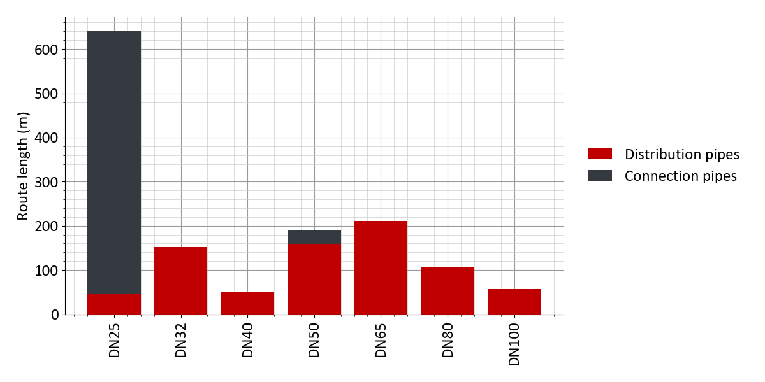
Figure 10: Scenario 2: Distribution of pipe diameters
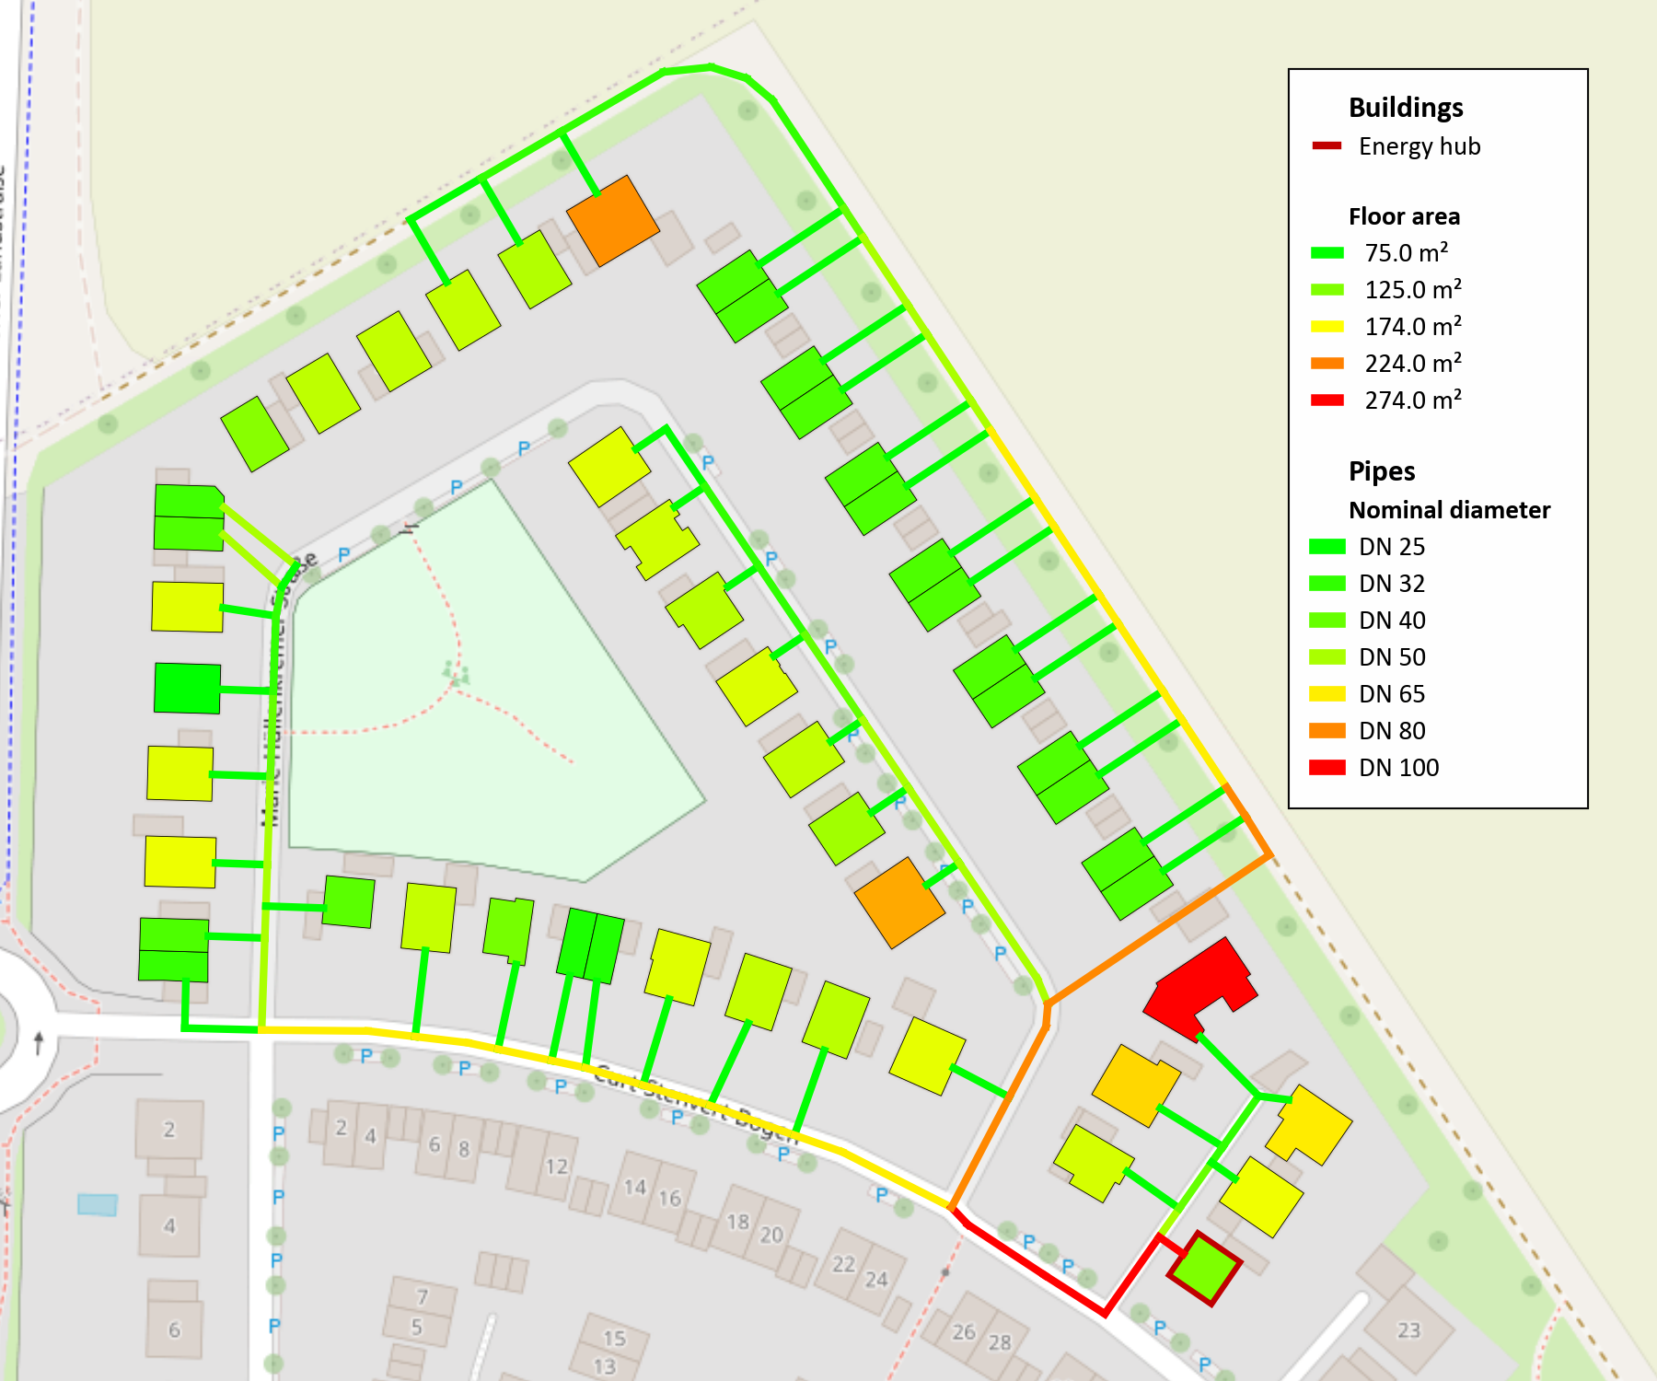
Figure 11: Scenario 2: Design result: Pipe Diameter and floor area of buildings
Figure 12: Scenario 2: Annual profile of supply and return temperature in the heat network
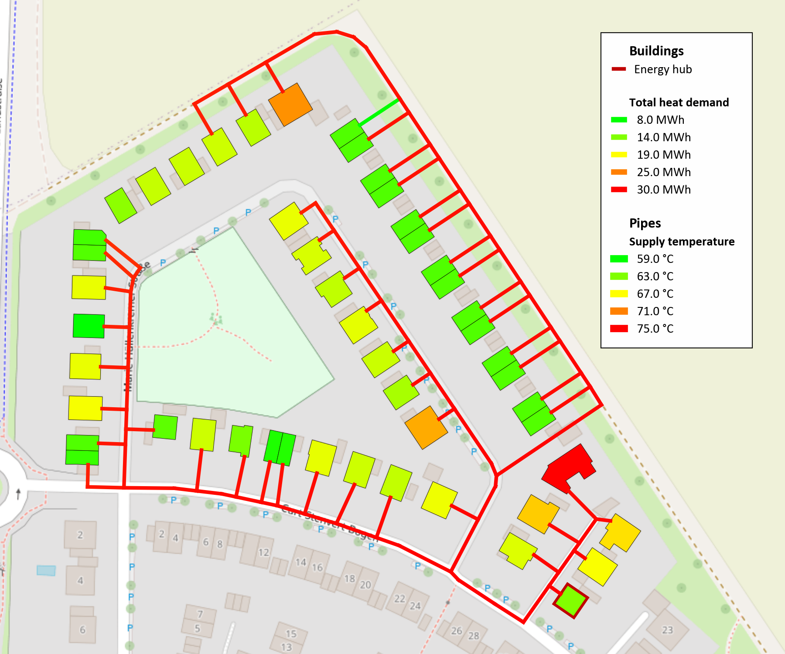
Figure 13: Scenario 2: Design result: Supply temperature and heat demand of buildings
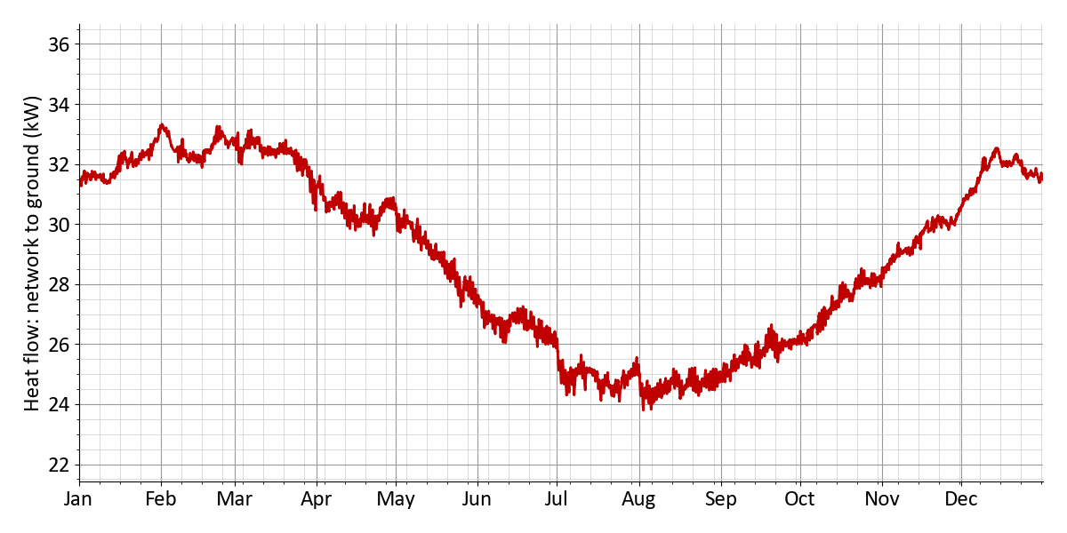
Figure 14: Scenario 2: Heat flow: network to ground
Figure 15: Scenario 2: Diversity factor
The results of the hydraulic calculation are shown in Table 39. The average pressure gradient in the network is 157 Pa/m. The pressure loss at the network's critical point is 2.1 bar. The maximum pump power is 1.9 kW. The electrical power consumption of the pump is 2.6 kW. The electricity demand of the network pump amounts to 3.6 MWh. The relative electricity demand of the network pump is 0.51 %. The pressure stage of the network is designed for PN16.
Table 39: Scenario 2: Pump work and pressure
Pump work and pressure
Mean pressure gradient | 157 Pa/m
Pressure loss (critical path) | 2.1 bar
Flow rate network pump | 33.5 m³/h
Max. pump power | 1.9 kW
Elec. power demand of pump | 2.6 kW
Power demand pump | 3.6 MWh
Relative power demand pump | 0.51 %
Pressure rating | PN16

The total pressure losses for the district heating pipeline with the network's critical point, along with the corresponding individual pressure losses, are shown in Table 40. The pressure loss at the energy hub is assumed to be 0.2 bar, and at the heat transfer stations 0.3 bar. The pipelines cause a pressure loss of 1.3 bar along the hydraulically critical path. In addition, pressure losses due to pipe fittings, such as valves and bends, are estimated at 0.32 bar (assumption: 25 % of the pipe pressure losses). This results in a total pressure loss of 2.1 bar, which must be overcome by the network pump.
Table 40: Scenario 2: Pressure losses (critical path)
Pressure losses (critical path)
Pressure loss energy hub | 0.2 bar
Pressure loss substation | 0.3 bar
Pressure loss pipes | 1.3 bar
Pressure loss fittings / installations | 0.32 bar
Pressure loss (critical path) | 2.1 bar
Building name | Marie-Hüllenkremer-Straße 23

4.2.3 Energy hub
The system design of the energy hub is shown in Table 41. Detailed information on the energy generation systems can be found in the following tables. Gas CHP 1 has an electrical rated power of 139 kWₑₗ and achieves full load hours of 2,626 h. Table Fehler! Verweisquelle konnte nicht gefunden werden. provides details such as the fuel consumption of 1,043 MWh, as well as the generated 365 MWh of electricity and 522 MWh of heat. The module capacity of the PV system is 251 kWₚ. As shown in Table Fehler! Verweisquelle konnte nicht gefunden werden., the collector area amounts to 1,569 m², with an electricity generation of 243 MWh. The Air-source heat pump has an electrical rated power of 160 kWₑₗ (full load hours: 687 h). Table Fehler! Verweisquelle konnte nicht gefunden werden. includes details such as the electricity demand of 164 MWh and the generation of 440 MWh of heat. The heat storage unit has a storage capacity of 555 kWh. Detailed information on the heat storage unit can be found in Table Fehler! Verweisquelle konnte nicht gefunden werden..
Table 41: Scenario 2: Sizing of the technologies in the energy hub
Technology | Dimensioning | Full load hours/Charging cycles
Gas CHP 1 | 139 kWₑₗ | 2,626 h
Photovoltaics | 251 kWₚ | 970 h
Air-source heat pump | 640 kWₜₕ | 687 h
Heat storage | 23.9 m³ | 425

Nominal electric capacity | 139 kWₑₗ
Generated electricity | 365 MWh
Generated heat | 522 MWh
Fuel demand | 1,043 MWh
Full load hours | 2,626 h

Installed capacity | 251 kWₚ
Collector area | 1,569 m²
Generated electricity | 243 MWh
Full load hours | 970 h
Curtailed generation potential | 0 MWh

Generated heat | 440 MWh
Generated cold | 0 MWh
Electricity demand | 164 MWh
Heat for regeneration | 0 MWh
Full load hours | 687 h
Nominal heating power | 640 kWₜₕ
Nominal electric capacity | 160 kWₑₗ

Storage capacity | 555 kWh
Charging energy | 236 MWh
Discharging energy | 232 MWh
Storage volume | 23.9 m³
Full charging cycles | 425

Table 42: Scenario 2: Energy import
 | Annual sum | Peak power | Share
Electricity import from grid (energy hub) | 114 MWh | 154 kW | 8.1 %
Renewable electricity generation | 243 MWh | --- | 17.4 %
Natural gas | 1,043 MWh | 398 kW | 74.5 %

Table 43: Scenario 2: Energy feed-in
 | Annual energy | Peak power
Electricity feed-in | 25.9 MWh | 131 kW

Table 44: Scenario 2: Electricity generation and import
Technology | Annual energy | Share
Gas CHP 1 | 365 MWh | 50.6 %
Renewable electricity generation | 243 MWh | 33.7 %
Share photovoltaics | 243 MWh | 33.7 %
Electricity import from grid (energy hub) | 114 MWh | 15.8 %
 | Self-sufficiency (autarky) rate | 84 %
 | Self-consumption rate | 96 %

Table 45: Scenario 2: Heat generation and import
Technology | Annual energy | Share
Gas CHP 1 | 522 MWh | 54.3 %
Air-source heat pump | 440 MWh | 45.7 %

Emissions and primary energy
Table 46: Scenario 2: Emissions
 | Spec. emissions |  | Annual sum |  | CO₂ emissions
Electricity import (energy hub) | 350 g/kWh | × | 114 MWh | = | 39.9 t
Electricity feed-in | - 0 g/kWh | × | 25.9 MWh | = | - 0 t
Natural gas | 250 g/kWh | × | 1,043 MWh | = | 261 t
District heating import | 150 g/kWh | × | 0 MWh | = | 0 t
District cooling import | 150 g/kWh | × | 0 MWh | = | 0 t
 |  |  | Sum |  | 301 t

Table 47: Scenario 2: Primary energy factor
 | Primary energy factor |  | Annual sum |  | Primary energy
Electricity import (energy hub) | 1.8 | × | 114 MWh | = | 205 MWh
Electricity feed-in | - 0 | × | 25.9 MWh | = | - 0 MWh
Natural gas | 1.1 | × | 1,043 MWh | = | 1,147 MWh
District heating import | 0.6 | × | 0 MWh | = | 0 MWh
District cooling import | 0.8 | × | 0 MWh | = | 0 MWh
 |  |  | Sum |  | 1,353 MWh

4.2.4 Economic results
Summary
Table 48: Scenario 2: Economic KPIs
Net present value | + 458,831 €
Amortization period | 19 years
Internal rate of return | 7.3 %
Total costs (excl. sales revenues) | 4,105,798.0 €
Levelized costs of energy | 0.255 €/kWh
Annual energy costs per floor area | 48.46 €/m²
Monthly energy costs per floor area | 4.04 €/m²

Table 49: Scenario 2: Subsidies
Initial investment | 3,330,428.0 €
Subsidy on initial investment | 1,020,584.0 €
Subsidy rate for initial investment | 30.6 %
Total costs (excl. all revenues and subsidies) | 5,139,292 €
Total subsidy in observation period | 1,070,433 €
Subsidy rate (total) | 20.8 %

Cost and revenue details
Table 50: Scenario 2: Cost breakdown in €
 | Sum | 2027 | 2028 | 2029 | 2030 | ... | 2046 | 2047
Total costs | -458,830 | 1,933,844 | -161,711 | -154,011 | -146,677 | ... | -67,194 | -423,402
Investment cost | 3,053,801 | 3,330,428 | 0 | 0 | 0 | ... | 0 | -359,407
Building energy systems | 533,111 | 607,830 | 0 | 0 | 0 | ... | 0 | -74,718
Electric heating rod | 1,153 | 1,247 | 0 | 0 | 0 | ... | 0 | -94
El. hot water heater | 5,590 | 5,590 | 0 | 0 | 0 | ... | 0 | 0
Ground-source heat pump | 24,671 | 24,671 | 0 | 0 | 0 | ... | 0 | 0
Air-source heat pump | 82,005 | 82,005 | 0 | 0 | 0 | ... | 0 | 0
Air chiller | 77,242 | 77,242 | 0 | 0 | 0 | ... | 0 | 0
Storage (domestic hot water) | 65,341 | 74,730 | 0 | 0 | 0 | ... | 0 | -9,388
Heat transfer station | 262,256 | 323,152 | 0 | 0 | 0 | ... | 0 | -60,896
Geothermal boreholes | 14,850 | 19,189 | 0 | 0 | 0 | ... | 0 | -4,339
Heat network | 1,030,511 | 1,269,798 | 0 | 0 | 0 | ... | 0 | -239,286
Connection pipe | 418,062 | 515,137 | 0 | 0 | 0 | ... | 0 | -97,075
Distribution pipe | 612,448 | 754,660 | 0 | 0 | 0 | ... | 0 | -142,211
Energy hub | 1,210,178 | 1,172,800 | 0 | 0 | 0 | ... | 0 | -45,402
Gas CHP 1 | 218,078 | 180,700 | 0 | 0 | 0 | ... | 0 | -45,402
Photovoltaics | 276,100 | 276,100 | 0 | 0 | 0 | ... | 0 | 0
Air-source heat pump | 704,000 | 704,000 | 0 | 0 | 0 | ... | 0 | 0
Heat storage | 12,000 | 12,000 | 0 | 0 | 0 | ... | 0 | 0
Other costs | 280,000 | 280,000 | 0 | 0 | 0 | ... | 0 | 0
Gebäude Energiezentrale | 150,000 | 150,000 | 0 | 0 | 0 | ... | 0 | 0
Netzpumpe, Druckhaltung, Armaturen | 30,000 | 30,000 | 0 | 0 | 0 | ... | 0 | 0
Planungskosten | 100,000 | 100,000 | 0 | 0 | 0 | ... | 0 | 0
Maintenance costs | 686,732 | 0 | 52,481 | 49,982 | 47,601 | ... | 21,806 | 20,768
Building energy systems | 89,356 | 0 | 6,828 | 6,503 | 6,193 | ... | 2,837 | 2,702
Electric heating rod | 155 | 0 | 11 | 11 | 10 | ... | 4 | 4
El. hot water heater | 696 | 0 | 53 | 50 | 48 | ... | 22 | 21
Ground-source heat pump | 6,149 | 0 | 469 | 447 | 426 | ... | 195 | 185
Air-source heat pump | 20,439 | 0 | 1,562 | 1,487 | 1,416 | ... | 649 | 618
Air chiller | 19,252 | 0 | 1,471 | 1,401 | 1,334 | ... | 611 | 582
Heat transfer station | 40,271 | 0 | 3,077 | 2,931 | 2,791 | ... | 1,278 | 1,217
Geothermal boreholes | 2,391 | 0 | 182 | 174 | 165 | ... | 75 | 72
Heat network | 158,244 | 0 | 12,093 | 11,517 | 10,968 | ... | 5,025 | 4,785
Connection pipe | 64,197 | 0 | 4,906 | 4,672 | 4,449 | ... | 2,038 | 1,941
Distribution pipe | 94,047 | 0 | 7,187 | 6,844 | 6,519 | ... | 2,986 | 2,844
Energy hub | 435,392 | 0 | 33,273 | 31,688 | 30,179 | ... | 13,825 | 13,167
Gas CHP 1 | 180,153 | 0 | 13,767 | 13,112 | 12,487 | ... | 5,720 | 5,448
Photovoltaics | 34,408 | 0 | 2,629 | 2,504 | 2,385 | ... | 1,092 | 1,040
Air-source heat pump | 219,334 | 0 | 16,761 | 15,963 | 15,203 | ... | 6,964 | 6,633
Heat storage | 1,495 | 0 | 114 | 108 | 103 | ... | 47 | 45
Other costs | 3,738 | 0 | 285 | 272 | 259 | ... | 118 | 113
Netzpumpe, Druckhaltung, Armaturen | 3,738 | 0 | 285 | 272 | 259 | ... | 118 | 113
Other operation costs | 124,622 | 0 | 9,523 | 9,070 | 8,638 | ... | 3,957 | 3,768
Verwaltung | 124,622 | 0 | 9,523 | 9,070 | 8,638 | ... | 3,957 | 3,768
Energy costs | 1,323,985 | 0 | 101,180 | 96,362 | 91,774 | ... | 42,042 | 40,040
Energy hub | 1,323,985 | 0 | 101,180 | 96,362 | 91,774 | ... | 42,042 | 40,040
Electricity | 284,138 | 0 | 21,714 | 20,680 | 19,695 | ... | 9,022 | 8,593
Energy charge | 284,138 | 0 | 21,714 | 20,680 | 19,695 | ... | 9,022 | 8,593
Gas | 1,039,846 | 0 | 79,466 | 75,682 | 72,078 | ... | 33,020 | 31,447
Energy charge | 1,039,846 | 0 | 79,466 | 75,682 | 72,078 | ... | 33,020 | 31,447
Revenues | -4,577,538 | -376,000 | -321,087 | -305,798 | -291,236 | ... | -133,418 | -127,065
Feed-in | -12,910 | 0 | -986 | -939 | -894 | ... | -409 | -390
Electricity | -12,910 | 0 | -986 | -939 | -894 | ... | -409 | -390
Cover energy demands | -4,564,628 | -376,000 | -320,101 | -304,858 | -290,341 | ... | -133,008 | -126,674
Heat demand | -2,096,628 | 0 | -160,227 | -152,597 | -145,331 | ... | -66,577 | -63,407
Energy charge | -1,718,718 | 0 | -131,347 | -125,092 | -119,135 | ... | -54,577 | -51,978
Capacity charge | -377,910 | 0 | -28,880 | -27,505 | -26,195 | ... | -12,000 | -11,428
Cold demand | -82,890 | 0 | -6,334 | -6,032 | -5,745 | ... | -2,632 | -2,506
Energy charge | -41,833 | 0 | -3,197 | -3,044 | -2,899 | ... | -1,328 | -1,265
Capacity charge | -41,056 | 0 | -3,137 | -2,988 | -2,845 | ... | -1,303 | -1,241
Plug loads | -24,206 | 0 | -1,849 | -1,761 | -1,677 | ... | -768 | -732
Energy charge | -22,536 | 0 | -1,722 | -1,640 | -1,562 | ... | -715 | -681
Capacity charge | -1,669 | 0 | -127 | -121 | -115 | ... | -53 | -50
E-mobility | -1,984,902 | 0 | -151,689 | -144,465 | -137,586 | ... | -63,030 | -60,028
Energy charge | -1,860,280 | 0 | -142,165 | -135,395 | -128,948 | ... | -59,072 | -56,259
Capacity charge | -124,622 | 0 | -9,523 | -9,070 | -8,638 | ... | -3,957 | -3,768
One-time connection fees | -376,000 | -376,000 | 0 | 0 | 0 | ... | 0 | 0
Subsidy | -1,070,433 | -1,020,584 | -3,809 | -3,628 | -3,455 | ... | -1,582 | -1,507
Building energy systems | -169,064 | -169,064 | 0 | 0 | 0 | ... | 0 | 0
El. hot water heater | -2,236 | -2,236 | 0 | 0 | 0 | ... | 0 | 0
Storage (domestic hot water) | -29,892 | -29,892 | 0 | 0 | 0 | ... | 0 | 0
Heat transfer station | -129,261 | -129,261 | 0 | 0 | 0 | ... | 0 | 0
Geothermal boreholes | -7,675 | -7,675 | 0 | 0 | 0 | ... | 0 | 0
Heat network | -507,919 | -507,919 | 0 | 0 | 0 | ... | 0 | 0
Connection pipe | -206,055 | -206,055 | 0 | 0 | 0 | ... | 0 | 0
Distribution pipe | -301,864 | -301,864 | 0 | 0 | 0 | ... | 0 | 0
Energy hub | -281,600 | -281,600 | 0 | 0 | 0 | ... | 0 | 0
Air-source heat pump | -281,600 | -281,600 | 0 | 0 | 0 | ... | 0 | 0
Other costs | -62,000 | -62,000 | 0 | 0 | 0 | ... | 0 | 0
Netzpumpe, Druckhaltung, Armaturen | -12,000 | -12,000 | 0 | 0 | 0 | ... | 0 | 0
Planungskosten | -50,000 | -50,000 | 0 | 0 | 0 | ... | 0 | 0
Other operation costs | -49,848 | 0 | -3,809 | -3,628 | -3,455 | ... | -1,582 | -1,507
Verwaltung | -49,848 | 0 | -3,809 | -3,628 | -3,455 | ... | -1,582 | -1,507

5 Scenario comparison
Table 51: Optimization of the energy hub
 | Scenario 1 | Scenario 2
CHP 1 | 56 kWₑₗ | 139 kWₑₗ
Photovoltaics | 224 kWₚ | 251 kWₚ
Solar thermal | 1,000 m² | ---
Geothermal energy 1 | 342 kWₜₕ | ---
Air-source heat pump | --- | 160 kWₑₗ
Heat storage | --- | 555 kWh

Table 52: Economic KPIs
 | Scenario 1 | Scenario 2
Net present value | 639,921 € | 458,831 €
Amortization period | 17 years | 19 years
Internal rate of return | 7.9 % | 7.3 %
Levelized costs of heat | 0.411 €/kWh | 0.43 €/kWh
Levelized costs of energy | 0.244 €/kWh | 0.255 €/kWh
Annual energy costs per floor area | 46.3 €/m² | 48.5 €/m²
Monthly energy costs per floor area | 3.9 €/m² | 4 €/m²

Table 53: Cost breakdown in €
 | Scenario 1 | Scenario 2
Total costs | 639,921 | 458,831
Investment cost | -3,243,622 | -3,053,802
Building energy systems | -492,771 | -533,112
Electric heating rod | --- | -1,154
El. hot water heater | -5,590 | -5,590
Ground-source heat pump | --- | -24,671
Air-source heat pump | -82,006 | -82,006
Air chiller | -77,243 | -77,243
Storage (domestic hot water) | -65,342 | -65,342
Heat transfer station | -262,591 | -262,256
Geothermal boreholes | --- | -14,850
Heat network | -1,015,930 | -1,030,511
Connection pipe | -418,063 | -418,063
Distribution pipe | -597,867 | -612,449
Energy hub | -1,454,921 | -1,210,178
Biomass CHP 1 | -87,859 | -218,078
Photovoltaics | -246,400 | -276,100
Solar thermal | -400,000 | ---
Geothermal probes 1 | -264,662 | ---
Air-source heat pump | --- | -704,000
Heat storage | --- | -12,000
Heat pump (Geothermal probes 1) | -456,000 | ---
Other costs | -280,000 | -280,000
Maintenance costs | -532,172 | -686,732
Building energy systems | -80,712 | -89,357
Electric heating rod | --- | -155
El. hot water heater | -697 | -697
Ground-source heat pump | --- | -6,149
Air-source heat pump | -20,440 | -20,440
Air chiller | -19,252 | -19,252
Heat transfer station | -40,323 | -40,272
Geothermal boreholes | --- | -2,391
Heat network | -156,006 | -158,245
Connection pipe | -64,198 | -64,198
Distribution pipe | -91,808 | -94,047
Energy hub | -291,715 | -435,392
Biomass CHP 1 | -72,580 | -180,154
Photovoltaics | -30,707 | -34,408
Solar thermal | -74,773 | ---
Air-source heat pump | --- | -219,335
Heat storage | --- | -1,495
Heat pump (Geothermal probes 1) | -113,655 | ---
Other costs | -3,739 | -3,739
Other operation costs | -124,622 | -124,622
Energy costs | -1,311,523 | -1,323,985
Energy hub | -1,311,523 | -1,323,985
Electricity | -550,830 | -284,138
Energy charge | -550,830 | -284,138
Gas | --- | -1,039,847
Energy charge | --- | -1,039,847
Biomass | -760,693 | ---
Energy charge | -760,693 | ---
Revenues | 4,598,525 | 4,577,538
Feed-in | 33,897 | 12,911
Electricity | 33,897 | 12,911
Cover energy demands | 4,564,628 | 4,564,628
Heat demand | 2,096,628 | 2,096,628
Energy charge | 1,718,718 | 1,718,718
Capacity charge | 377,910 | 377,910
Cold demand | 82,891 | 82,891
Energy charge | 41,834 | 41,834
Capacity charge | 41,057 | 41,057
Plug loads | 24,207 | 24,207
Energy charge | 22,537 | 22,537
Capacity charge | 1,670 | 1,670
E-mobility | 1,984,902 | 1,984,902
Energy charge | 1,860,280 | 1,860,280
Capacity charge | 124,622 | 124,622
One-time connection fees | 376,000 | 376,000
Subsidy | 1,253,335 | 1,070,433
Building energy systems | 161,554 | 169,065
El. hot water heater | 2,236 | 2,236
Storage (domestic hot water) | 29,892 | 29,892
Heat transfer station | 129,426 | 129,261
Geothermal boreholes | --- | 7,676
Heat network | 500,732 | 507,919
Connection pipe | 206,055 | 206,055
Distribution pipe | 294,677 | 301,864
Energy hub | 479,200 | 281,600
Solar thermal | 160,000 | ---
Geothermal probes 1 | 136,800 | ---
Air-source heat pump | --- | 281,600
Heat pump (Geothermal probes 1) | 182,400 | ---
Other costs | 62,000 | 62,000
Other operation costs | 49,849 | 49,849

Figure 16: Specific costs and emissions
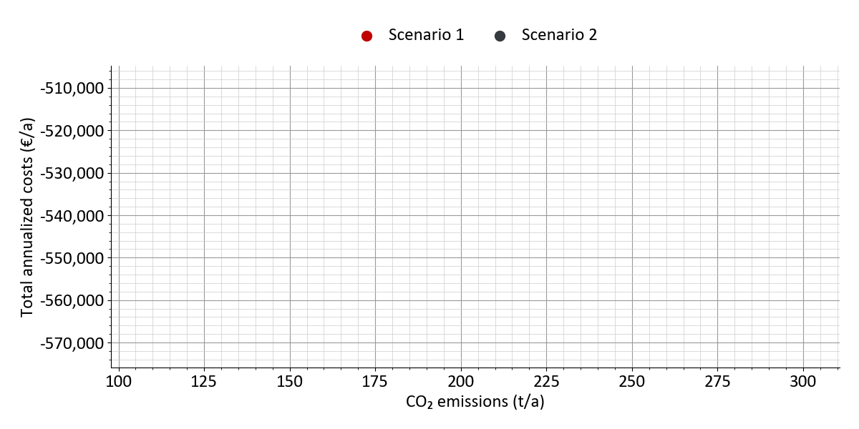
Figure 17: Total costs and emissions
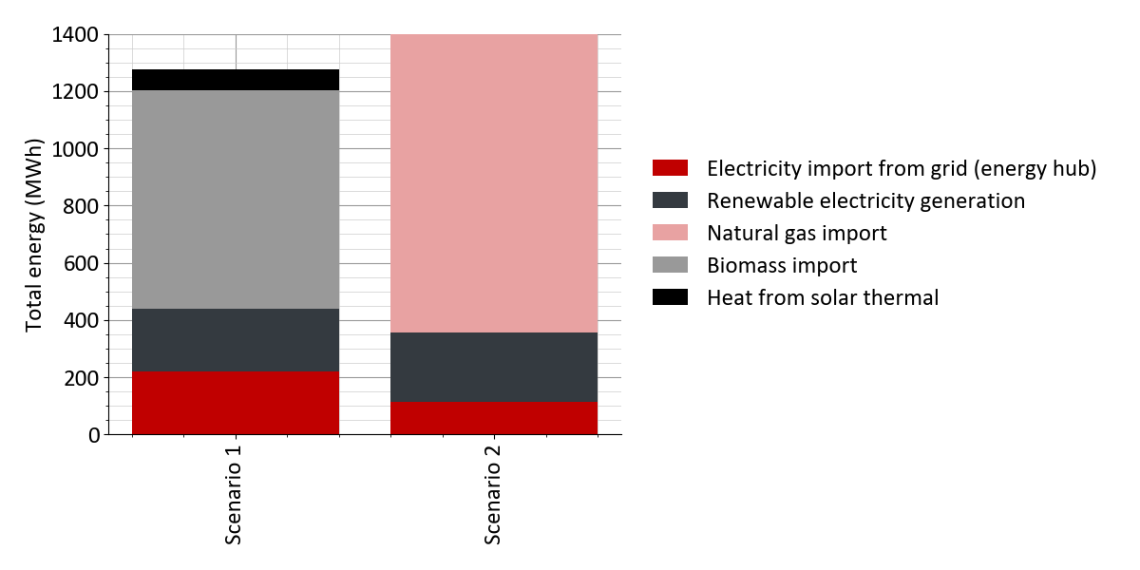
Figure 18: Energy import and feed-in
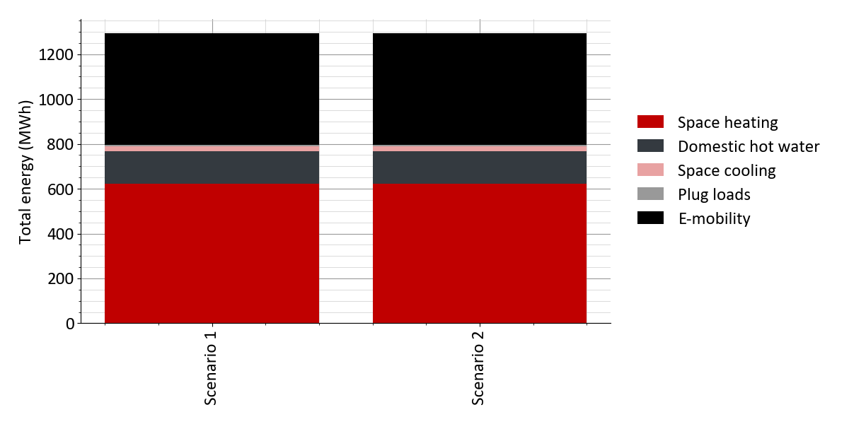
Figure 19: Energy demands
Table 54: Emissions and primary energy
 | Scenario 1 | Scenario 2
CO₂ emissions | 108 t | 301 t
CO₂ emissions per heat demand | 141 g/kWh | 392 g/kWh
CO₂ emissions per energy demand | 83 g/kWh | 233 g/kWh
CO₂ emissions per floor area | 15.9 kg/m² | 44.2 kg/m²
Primary energy | 550 MWh | 1,353 MWh
Primary energy per heat demand | 0.72 kWh/kWh | 1.8 kWh/kWh
Primary energy per energy demand | 0.43 kWh/kWh | 1 kWh/kWh
Primary energy per floor area | 81 kWh/m² | 199 kWh/m²

6 Appendix
The appendix provides a detailed overview of the methodology and approach used in this study. It lists all project settings used for the simulation: from the district heating network and pipe parameters to the parameters for energy hub design and simulation, as well as the economic parameters, general project settings, and a detailed representation of the weather data profiles used.

6.1 Methodology
The results presented in this report were obtained using simulation-based design methods. These are based both on scientifically sound calculation approaches and practical design heuristics. By applying simulation methods with an hourly temporal resolution, quasi-static hydraulic and thermal calculations, and techno-economic optimization models, robust planning results are achieved for sustainable and economically efficient district solutions. The structured planning approach is divided into the following methodological steps:
Calculation of buildings and load profiles
Based on building and demand data, load profiles for space heating and domestic hot water demands are generated. These take into account climatic conditions, usage profiles, and specific building parameters to ensure a realistic representation of energy demand. Compared to the use of annual values, the analysis of high-resolution temporal profiles offers the advantage of considering the temporal correlation between the generation of renewable energy on the one hand and the likewise time-varying energy demand on the other when designing system and storage technologies. An hourly resolution (8,760 values per year) is generally sufficient to capture the essential temporal dependencies. At the district level, heat demands may include space heating and domestic hot water demands. Cooling demands mainly consist of requirements for space cooling and possibly process cooling (e.g., for cold storage or IT infrastructure). In addition to thermal demands, electricity demands may also be considered: on the one hand, electricity required to operate building systems (e.g., for water-to-water or air-to-water heat pumps), referred to in this report as 'auxiliary electricity'; on the other hand, final energy demands may arise for user electricity (lighting, household appliances, etc.) or electromobility (electricity for operating EV charging stations). Seasonal trends for space heating and cooling are generated using the degree-day method. To calculate the hourly load profile, these are overlaid with standard load profiles for different day types (weekday, Saturday, and Sunday) to approximate typical behavior-based consumption patterns in buildings.
Calculation and dimensioning of heat network
Using the calculated load profiles, the district heating network is dimensioned and the hydraulically most suitable diameter is determined for each pipe section. Heat losses are calculated on an hourly basis according to the methods described in DIN EN 13941. The calculation of ground temperatures is based on simplified physical models, which are calibrated and validated using measurement time series or alternatively based on empirical values. Design criteria such as pressure drop limits (Pa/m) and/or maximum flow velocity can be defined individually for each pipe section and diameter. Passive low-temperature district heating networks are designed with decentralized circulation pumps in the buildings, taking into account the maximum pump head.
Design and simulation of energy hub
A techno-economic design optimization for the energy hub is performed using a mixed-integer linear programming (MILP) model, which is implemented in the commercial software nPro Energy (www.npro.energy). The applied mathematical optimization model calculates the optimal system size and configuration based on technical and economic objectives (e.g., net present value, CO₂ emissions, degree of self-sufficiency). The calculation models for system design and operation simulation are based on recognized and well-established mathematical optimization approaches in energy research, which take into account hourly energy balances for a typical design year as well as simplified component models with constant and time-varying efficiencies. The design calculation assumes ideal operating behavior, such as perfect forecasting of future demands and ideally modulating system technologies.
Economic evaluation and scenario comparison
Based on the results of the energy system simulation, an economic analysis is carried out. The assessment is performed using the dynamic net present value method and the calculation approaches outlined in VDI 2067. In addition to operating costs, one-time investments are included in the calculation via annuities. Furthermore, residual values of non-depreciated assets and reinvestments are taken into account. To assess whether a project is economically viable, heat prices for demand coverage can be defined. These heat prices represent the revenue streams paid by end users (tenants or building owners) to the energy system operator. They may include energy rates, capacity charges, annual base fees, and one-time connection fees. The economic evaluation is based on recognized indicators such as net present value, payback period, internal rate of return, or levelized cost of heat. Together with environmental indicators such as CO₂ emissions, the various supply options can be compared in terms of technical and economic performance to identify the best solution with respect to economic and ecological objectives.
This holistic, systematic, and standardized planning approach enables reliable, transparent, and comprehensible decision-making for further planning in complex supply areas. The presented results of the simulations and optimizations thus serve as a well-founded basis for subsequent detailed planning.

6.2 Buildings

6.2.1 Buildings: Economic parameters
Table 55: Cost parameters decentral technologies for scenario 'Scenario 1'
 | Specific investment costs (cost data points) | Lifetime | Annual maintenance costs | Subsidy
Electric heating rod (domestic hot water) | 5 kW: 80 €/kW  10 kW: 50 €/kW  20 kW: 35 €/kW  50 kW: 18 €/kW | 20 years | 1 % of investment | 40 %
Air-source heat pump | 5 kW: 2300 €/kW  10 kW: 1800 €/kW  20 kW: 1500 €/kW  30 kW: 1400 €/kW  40 kW: 1300 €/kW  50 kW: 1200 €/kW  60 kW: 1200 €/kW  80 kW: 1200 €/kW  110 kW: 1200 €/kW | 20 years | 2 % of investment | 0 %
Air chiller | 5 kW: 1300 €/kW  20 kW: 900 €/kW  100 kW: 700 €/kW  250 kW: 600 €/kW  500 kW: 450 €/kW | 20 years | 2 % of investment | 0 %
Storage (domestic hot water) | 130 l: 8 €/l  150 l: 7 €/l  300 l: 5.3 €/l  500 l: 4.8 €/l  1000 l: 4.5 €/l | 30 years | 0 % of investment | 40 %
Heat transfer station | 15 kW: 380 €/kW  30 kW: 250 €/kW  100 kW: 150 €/kW  500 kW: 85 €/kW  2000 kW: 55 €/kW  10000 kW: 34 €/kW | 40 years | 1 % of investment | 40 %

Table 56: Cost parameters decentral technologies for scenario 'Scenario 2'
 | Specific investment costs (cost data points) | Lifetime | Annual maintenance costs | Subsidy
Electric heating rod | 2 kW: 200 €/kW  5 kW: 100 €/kW  10 kW: 75 €/kW  20 kW: 60 €/kW  50 kW: 50 €/kW  100 kW: 40 €/kW | 25 years | 1 % of investment | 0 %
Electric heating rod (domestic hot water) | 5 kW: 80 €/kW  10 kW: 50 €/kW  20 kW: 35 €/kW  50 kW: 18 €/kW | 20 years | 1 % of investment | 40 %
Ground-source heat pump | 5 kW: 3000 €/kW  10 kW: 2100 €/kW  20 kW: 1500 €/kW  30 kW: 1200 €/kW  40 kW: 1100 €/kW  50 kW: 1000 €/kW  60 kW: 900 €/kW  80 kW: 800 €/kW  110 kW: 700 €/kW | 20 years | 2 % of investment | 0 %
Air-source heat pump | 5 kW: 2300 €/kW  10 kW: 1800 €/kW  20 kW: 1500 €/kW  30 kW: 1400 €/kW  40 kW: 1300 €/kW  50 kW: 1200 €/kW  60 kW: 1200 €/kW  80 kW: 1200 €/kW  110 kW: 1200 €/kW | 20 years | 2 % of investment | 0 %
Air chiller | 5 kW: 1300 €/kW  20 kW: 900 €/kW  100 kW: 700 €/kW  250 kW: 600 €/kW  500 kW: 450 €/kW | 20 years | 2 % of investment | 0 %
Storage (domestic hot water) | 130 l: 8 €/l  150 l: 7 €/l  300 l: 5.3 €/l  500 l: 4.8 €/l  1000 l: 4.5 €/l | 30 years | 0 % of investment | 40 %
Heat transfer station | 15 kW: 380 €/kW  30 kW: 250 €/kW  100 kW: 150 €/kW  500 kW: 85 €/kW  2000 kW: 55 €/kW  10000 kW: 34 €/kW | 40 years | 1 % of investment | 40 %
Geothermal boreholes | 5 kW: 2500 €/kW  10 kW: 1800 €/kW  20 kW: 1500 €/kW  40 kW: 1400 €/kW  60 kW: 1300 €/kW  80 kW: 1300 €/kW  110 kW: 1200 €/kW | 50 years | 1 % of investment | 40 %

6.3 Heat network

6.3.1 Heat network: General parameters
Table 57: Heat network settings
 | All scenarios
Consider heat losses | yes
Surcharge (fittings, etc.) | 20 %
Network temperature | constant
Design criteria | Pressure gradient and flow velocity
Diversity factor (method) | Neglect diversity (f=1)
Diversity factor only for residential buildings | no
Diversity factor DHW: calculation method | TU Dresden
Heat carrier fluid | Water
Thermal conductivity | 1.5 W/mK
Ground temperature: Option | calculated
Depth | 1 m

Table 58: Hydraulic settings
 | All scenarios
Circulation pump | Central pump
Pressure in pressure maintenance | 3 bar
Pressure loss fittings | 25 %
Pressure loss substations | 0.3 bar
Pressure loss energy hub: Option | fixed
Pressure loss energy hub | 0.2 bar
Waste heat feed-in | Return to supply
Temperature difference | 20 K

6.3.2 Heat network: Pipe parameters
Table 59: Pipe parameters: Kunststoff (Doppelrohr): BruggPipes: CALPEX DUO (normal) for scenario 'Scenario 1'
Nominal diameter | Outer diameter (pipe) | Thickness (pipe) | Outer diameter (case) | Thickness (case) | Installation depth | Pipe distance | Thermal conductivity (insulation) | Roughness
DN | mm | mm | mm | mm | m | mm | W/mK | mm
20 | 25 | 2.3 | 93 | 2.1 | 1.2 | 33 | 0.02 | 0.007
25 | 32 | 2.9 | 113 | 2.3 | 1.2 | 40 | 0.02 | 0.007
32 | 40 | 3.7 | 128 | 2.7 | 1.2 | 50 | 0.02 | 0.007
40 | 50 | 4.6 | 163 | 3.2 | 1.2 | 60 | 0.02 | 0.007
50 | 63 | 5.8 | 183 | 3.3 | 1.2 | 73 | 0.02 | 0.007
65 | 75 | 6.8 | 202 | 3.3 | 1.2 | 85 | 0.02 | 0.007

Table 60: Pipe parameters: Kunststoff (Doppelrohr): BruggPipes: CALPEX DUO (normal) for scenario 'Scenario 2'
Nominal diameter | Outer diameter (pipe) | Thickness (pipe) | Outer diameter (case) | Thickness (case) | Installation depth | Pipe distance | Thermal conductivity (insulation) | Roughness
DN | mm | mm | mm | mm | m | mm | W/mK | mm
20 | 25 | 2.3 | 78 | 1.9 | 1.2 | 228 | 0.02 | 0.007
25 | 32 | 2.9 | 78 | 1.9 | 1.2 | 228 | 0.02 | 0.007
32 | 40 | 3.7 | 93 | 2.1 | 1.2 | 243 | 0.02 | 0.007
40 | 50 | 4.6 | 113 | 2.3 | 1.2 | 263 | 0.02 | 0.007
50 | 63 | 5.8 | 128 | 2.7 | 1.2 | 278 | 0.02 | 0.007
65 | 75 | 6.8 | 143 | 2.9 | 1.2 | 293 | 0.02 | 0.007
80 | 90 | 8.2 | 163 | 3.2 | 1.2 | 313 | 0.02 | 0.007
100 | 110 | 10 | 183 | 3.3 | 1.2 | 333 | 0.02 | 0.007
125 | 140 | 12.7 | 202 | 3.3 | 1.2 | 352 | 0.02 | 0.007
150 | 160 | 14.6 | 250 | 3.9 | 1.2 | 500 | 0.02 | 0.007

Table 61: Pipe costs for all scenarios
Nominal diameter | Pipe cost | Installation | Total
mm | €/m | €/m | €/m
32 | 79 | 740 | 819
50 | 96 | 830 | 926
80 | 130 | 970 | 1,100
100 | 160 | 1,100 | 1,260
150 | 230 | 1,300 | 1,530
200 | 320 | 1,500 | 1,820
300 | 560 | 1,800 | 2,360
400 | 860 | 2,100 | 2,960
500 | 1,200 | 2,300 | 3,500
600 | 1,600 | 2,500 | 4,100
800 | 2,700 | 2,600 | 5,300

6.3.3 Heat network: Design criteria
Table 62: Sizing criteria: Kunststoff (Doppelrohr): BruggPipes: CALPEX DUO (normal) for scenario 'Scenario 1'
Nominal diameter | Max. pressure gradient | Max. flow velocity
DN | Pa/m | m/s
20 | 200 | 0.9
25 | 200 | 0.9
32 | 200 | 0.93
40 | 200 | 0.98
50 | 200 | 1
65 | 200 | 1.1

Table 63: Sizing criteria: Kunststoff (Doppelrohr): BruggPipes: CALPEX DUO (normal) for scenario 'Scenario 2'
Nominal diameter | Max. pressure gradient | Max. flow velocity
DN | Pa/m | m/s
20 | 200 | 0.9
25 | 200 | 0.9
32 | 200 | 0.93
40 | 200 | 0.98
50 | 200 | 1
65 | 200 | 1.1
80 | 200 | 1.2
100 | 200 | 1.4
125 | 200 | 1.6
150 | 200 | 1.9

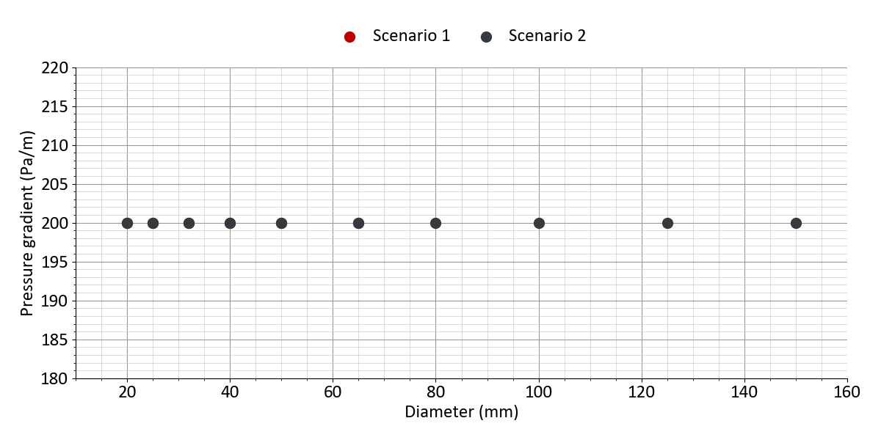
Figure 20: Design criteria: pressure gradient (Kunststoff (Doppelrohr): BruggPipes: CALPEX DUO (normal))
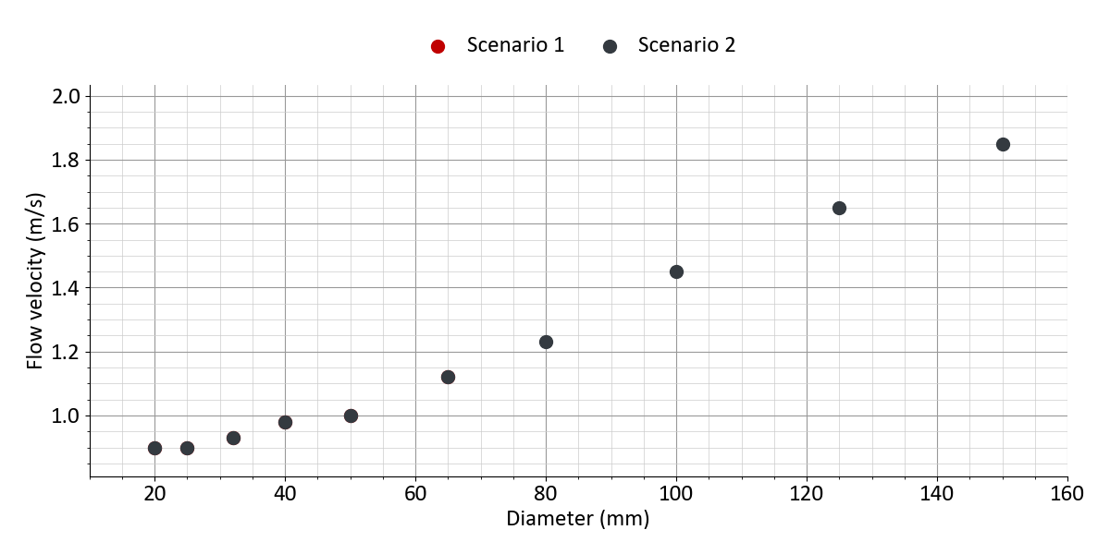
Figure 21: Design criteria: flow velocity (Kunststoff (Doppelrohr): BruggPipes: CALPEX DUO (normal))

6.3.4 Heat network: Fluid parameters
Table 64: Fluid parameters
 | All scenarios
Heat carrier fluid | Water
Density | 981 kg/m³
Viscosity | 0.0004 Pa/s
Specific heat capacity | 4.187 kJ/kgK

6.4 Energy hub

6.4.1 Energy hub: General parameters
Table 65: Settings of the design optimization
 | All scenarios
Optimization objective | Net present value / total annualized costs
Consider renewables to cover peak loads | yes
Conservative system design | yes
Set number of design days | no
Set time limit for calculation | no

Table 66: Settings of energy demands
 | All scenarios
Split into high- and low-temperature heat demand | no
Plug loads demand covered by energy hub | yes
Electricity for e-mobility covered by energy hub | yes
Electricity for building energy systems covered by energy hub | yes
Electricity for pumps covered by energy hub | yes
Hydrogen demand profile uploaded | no

Table 67: Ecologic parameters
 | All scenarios
Limit CO₂ emissions | no
Limit primary energy consumption | no

Table 68: Emission and primary energy factors for scenario 'Scenario 1'
 | CO₂ emissions | Primary energy factor
Electricity import | 350 g/kWh | 1.8
Electricity feed-in | 0 g/kWh | 0
Biomass import | 40 g/kWh | 0.2

Table 69: Emission and primary energy factors for scenario 'Scenario 2'
 | CO₂ emissions | Primary energy factor
Electricity import | 350 g/kWh | 1.8
Electricity feed-in | 0 g/kWh | 0
Natural gas import | 250 g/kWh | 1.1

6.4.2 Energy hub: Technology settings
Table 70: Biomass CHP 1: Settings
 | Scenario 1 | Scenario 2
Enabled | yes | yes
Define optimization interval | no | no
Generates high-temp. heat | no | no
Generates low-temp. heat | yes | yes
Electrical efficiency | 35 % | 35 %
Thermal efficiency | 50 % | 50 %
Fuel type | Biomass | Natural Gas
Direct electricity feed-in | no | no

Table 71: Photovoltaics: Settings
 | All scenarios
Enabled | yes
Lower area capacity limit | 0 m²
Upper area capacity limit | 62,500 m²
Lower power capacity limit | 0 kWₚ
Upper power capacity limit | 10,000 kWₚ
Area concurrence with solar thermal | no
Tilt angle | 30 °
East-west orientation (azimuth) | 0 °
Inverter efficiency | 96 %
System losses | 14 %
PV module type | Polycrystalline
Module efficiency | 16 %
Temperature coefficient | 0.42 %/°C
Set electricity price | no
Electricity generation constraint | no

Table 72: Solar thermal: Settings
 | Scenario 1 | Scenario 2
Enabled | yes | no
Lower limit | 1,000 m² | ---
Upper limit | 10,000 m² | ---
Area concurrence with PV | no | ---
Tilt angle | 30 ° | ---
East-west orientation (azimuth) | 0 ° | ---
Mean collector temperature | 80 °C | ---
Collector type | Flat-plate collector | ---

Table 73: Geothermal probes 1: Settings
 | Scenario 1 | Scenario 2
Enabled | yes | no
Geothermal technology | Geothermal probes | ---
Extraction temperature | 10 °C | ---
Define optimization interval | no | ---
Can generate heat | yes | ---
Can generate cold | no | ---
Generates high-temp. heat | no | ---
Generates low-temp. heat | yes | ---
Limit heat extraction | no | ---
Install heat pump (High temp.) | no | ---
Install heat pump | yes | ---
Heat: COP settings | Constant value | ---
Heat: Constant COP value | 4 | ---
Define heat pump capacity | no | ---
Limit cool extraction | no | ---
Install chiller | no | ---
Enforce regeneration | no | ---

Table 74: Air-source heat pump: Settings
 | Scenario 1 | Scenario 2
Enabled | no | yes
Define optimization interval | --- | no
Nominal COP | --- | 4
Can generate heat | --- | yes
Can generate cold | --- | yes
Generates high-temp. heat | --- | no
Generates low-temp. heat | --- | yes
Use heat for regeneration | --- | no
HT heat: COP settings | --- | Calculate COP (Carnot)
HT heat: Carnot efficiency | --- | Medium efficiency (50 %)
HT heat: Maximum COP | --- | 6
Heat: COP settings | --- | Calculate COP (Carnot)
Heat: Carnot efficiency | --- | Medium efficiency (50 %)
Heat: Maximum COP | --- | 6
Cooling: COP settings | --- | Calculate COP (Carnot)
Cooling: Carnot efficiency | --- | Medium efficiency (50 %)
Cooling: Maximum COP | --- | 6

Table 75: Heat storage: Settings
 | Scenario 1 | Scenario 2
Enabled | no | yes
Define optimization interval | --- | no
Long term storage possible | --- | no
Stand-by-losses | --- | 20 % per 5days
Temperature range | --- | 20 K
Limit state of charge | --- | no
Limit charging time/power | --- | no

6.4.3 Energy hub: Economic parameters
Table 76: Cost parameters for scenario 'Scenario 1'
 | Specific investment costs | Lifetime | Annual maintenance costs | Subsidy | Existing with remaining lifetime
Biomass CHP 1 | 1,300 €/kWₑₗ | 15 years | 8 % of investment | 0 % | ---
Photovoltaics | 1,100 €/kWₚ | 20 years | 1 % of investment | 0 % | ---
Solar thermal | 400 €/m² | 20 years | 1.5 % of investment | 40 % | ---
Geothermal probes 1 | 1,000 €/kWₜₕ | 50 years | 0 % of investment | 40 % | ---
Heat pump (Geothermal probes 1) | 1,000 €/kWₜₕ | 20 years | 2 % of investment | 40 % | ---

Table 77: Cost parameters for scenario 'Scenario 2'
 | Specific investment costs | Lifetime | Annual maintenance costs | Subsidy | Existing with remaining lifetime
Gas CHP 1 | 1,300 €/kWₑₗ | 15 years | 8 % of investment | 0 % | ---
Photovoltaics | 1,100 €/kWₚ | 20 years | 1 % of investment | 0 % | ---
Air-source heat pump | 1,100 €/kWₜₕ | 20 years | 2.5 % of investment | 40 % | ---
Heat storage | 500 €/m³ | 20 years | 1 % of investment | 0 % | ---

6.4.4 Energy hub: Import and feed-in
Table 78: Electricity grid
 | All scenarios
Electricity import (energy hub) | yes
Supply price | 0.2 €/kWh
Limit annual import | no
Annual price increase (option) | No change
Electricity feed-in | yes
Feed-in tariff | 0.04 €/kWh
Limit annual feed-in | no
Limit grid capacity | no
Grid capacity | no

Table 79: Natural gas
 | Scenario 1 | Scenario 2
Natural gas import | no | yes
Supply price | --- | 0.08 €/kWh
Limit annual import | --- | no
Annual price increase (option) | --- | No change
Limit grid capacity | --- | no
Grid capacity | --- | no

Table 80: Biomass
 | Scenario 1 | Scenario 2
Biomass import | yes | no
Supply price | 0.08 €/kWh | ---
Limit annual import | no | ---
Annual price increase (option) | No change | ---

6.5 Economic parameters
Table 81: Economic parameters
 | All scenarios
Imputed interest | 5 %
Observation period | 20 years
Year 1 of observation period | 2027
Inflation rate | 0 %
Operating cost subsidy (BEW) of large-scale heat pumps | no
Operating cost subsidy (BEW) of solar thermal collectors | no
CO₂ price option | No pricing

Table 82: Other costs: One-time costs for all scenarios
 | Specific investment costs | Lifetime | Maintenance costs | Subsidy
Gebäude Energiezentrale | 150,000 € | 20 years | 0 % | 0 %
Netzpumpe, Druckhaltung, Armaturen | 30,000 € | 20 years | 1 % | 40 %
Planungskosten | 100,000 € | 20 years | 0 % | 50 %

Table 83: Other costs: Annual costs for all scenarios
 | Annual costs | Subsidy
Verwaltung | 10,000 € | 40 %

Table 84: Revenue settings: Components
 | All scenarios
Energy price | yes
Capacity price | yes
Base price | no
One-time connection fee | yes

Table 85: Revenue settings: Prices for all scenarios
 | Supply price | Capacity price | Heat network connection
One-time connection fees | --- | --- | 8,000 €
Heat demand | 0.18 €/kWh | 50 €/kW | ---
Cooling demand | 0.15 €/kWh | 50 €/kW | ---
Plug loads | 0.3 €/kWh | 50 €/kW | ---
E-mobility | 0.3 €/kWh | 50 €/kW | ---

6.6 Project and weather data

6.6.1 General project data
Table 86: Project settings
 | All scenarios
Min. temp. diff. water/water | 2
Public holidays | yes
Time change | no
First day of year | Monday
Version of simulation core | 4.6

Table 87: Geographical location (weather data)
 | All scenarios
City | Düsseldorf
Country | Germany

6.6.2 Weather data
Table 88: Customization of weather data
 | All scenarios
Air temperature increase/decrease | no
Specify minimum temperature | no
Specify maximum temperature | no
GHI profile increase/decrease | no
DNI profile increase/decrease | no
Wind speed increase/decrease | no

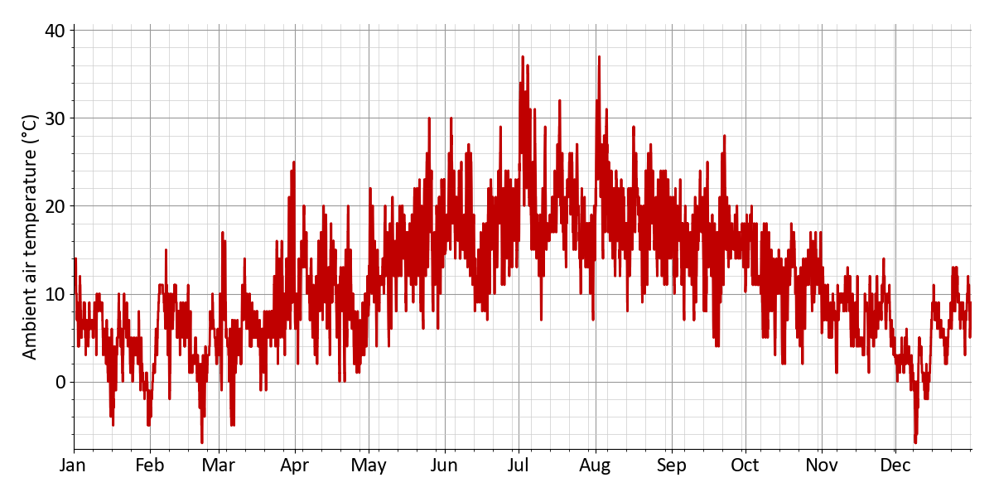
Figure 22: Ambient air temperature (Annual profile)
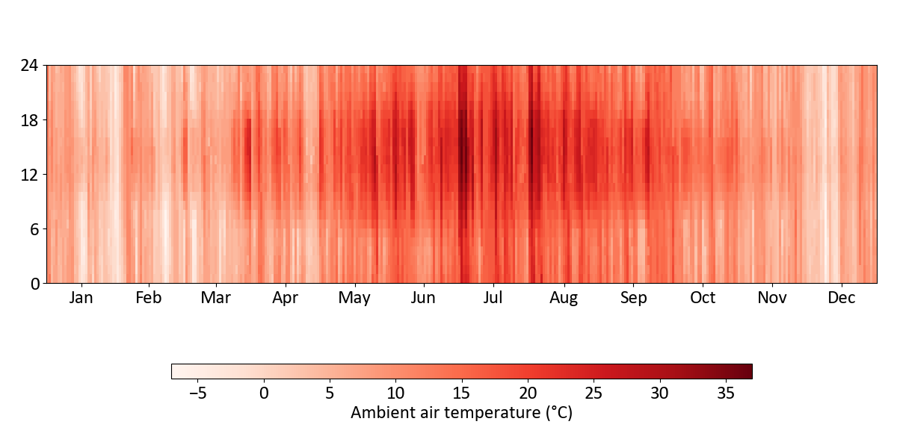
Figure 23: Ambient air temperature (Heatmap)
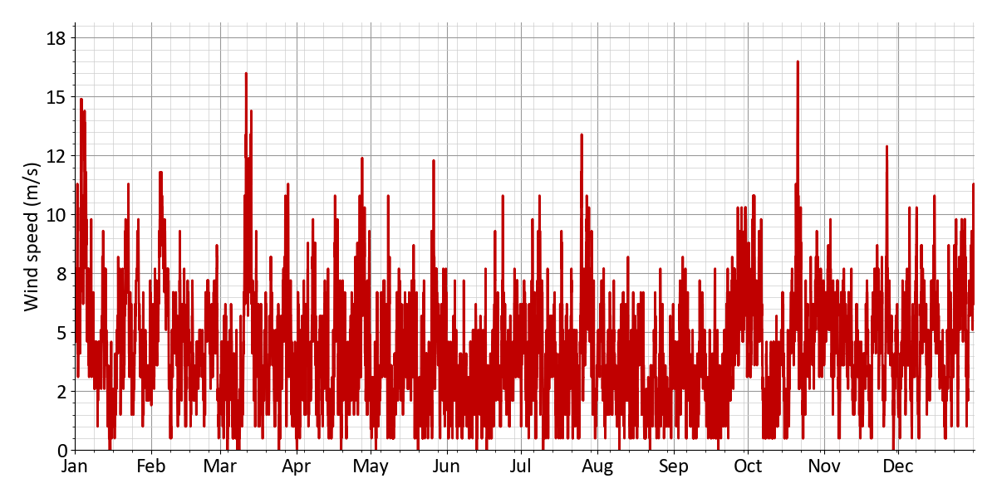
Figure 24: Wind speed (Annual profile)
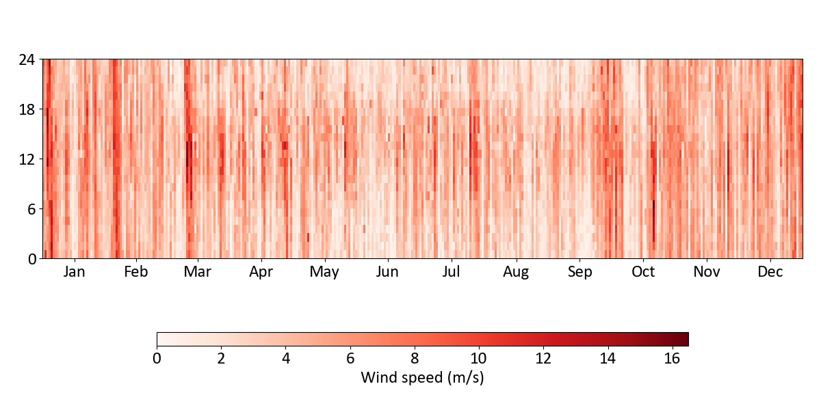
Figure 25: Wind speed (Heatmap)
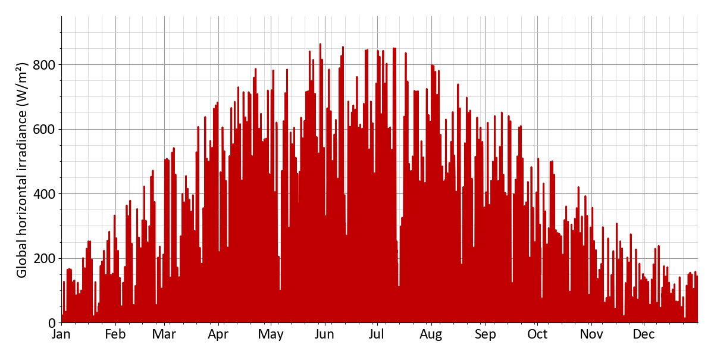
Figure 26: Global horizontal irradiance (annual profile)
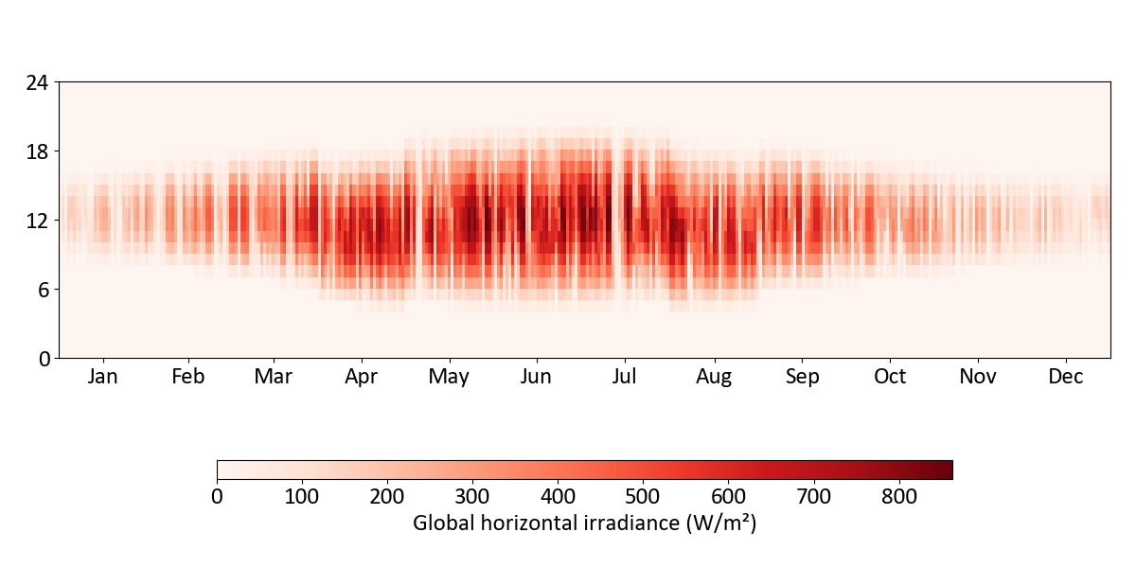
Figure 27: Global horizontal irradiance (Heatmap)
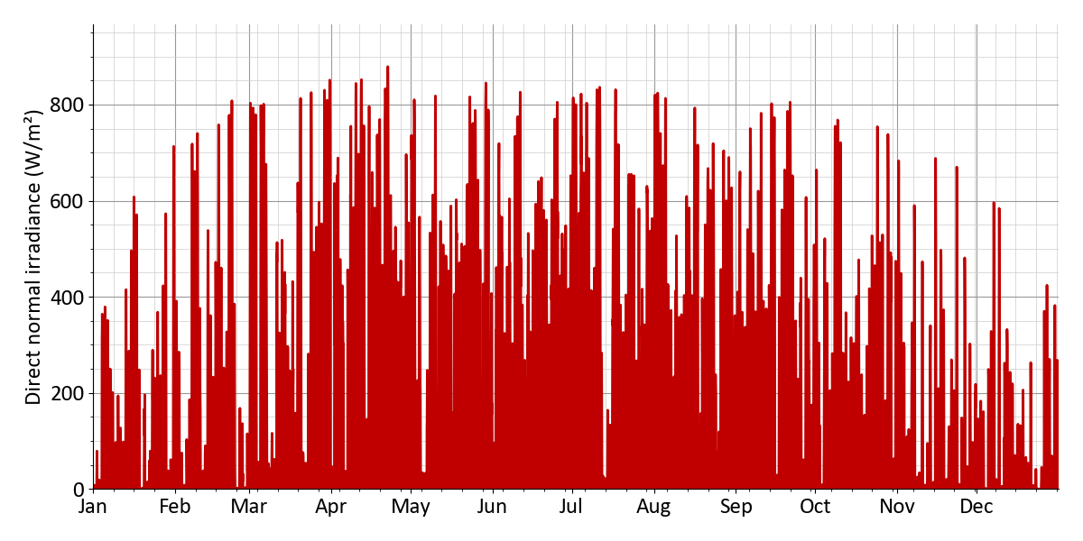
Figure 28: Direct normal irradiance (Annual profile)
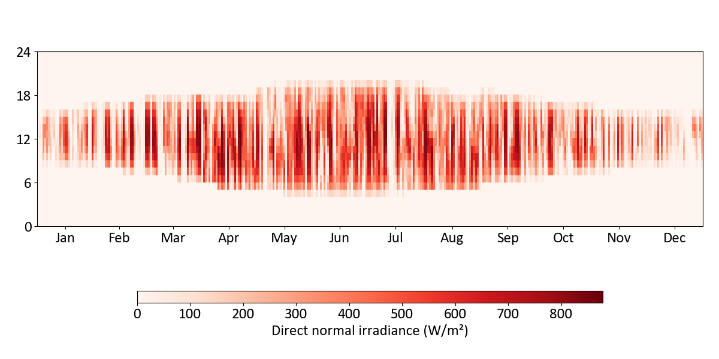
Figure 29: Direct normal irradiance (Heatmap)
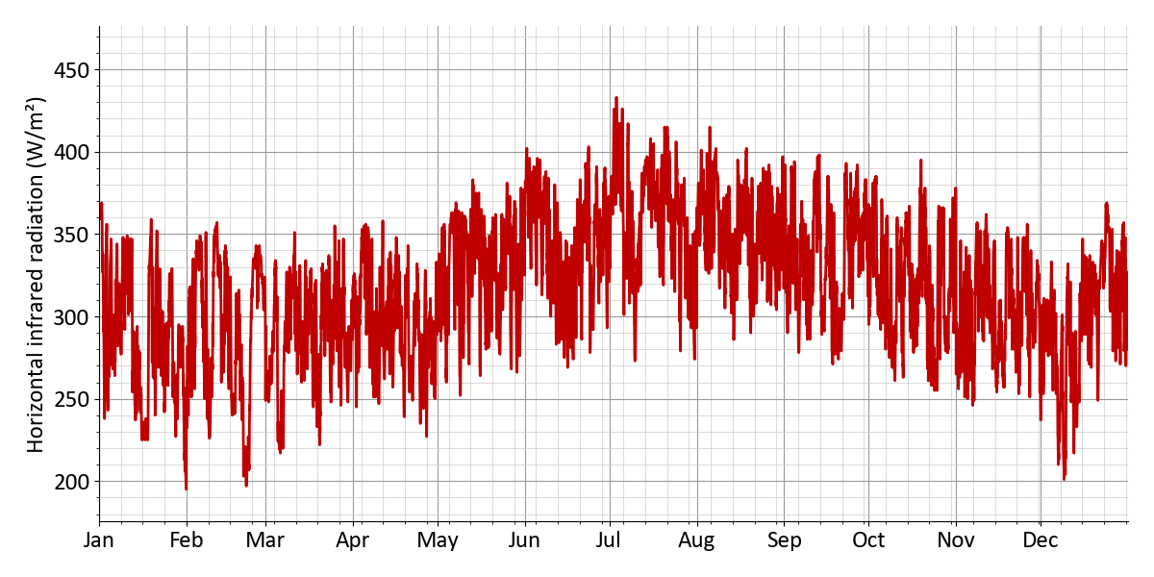
Figure 30: Horizontal infrared radiation (Annual profile)
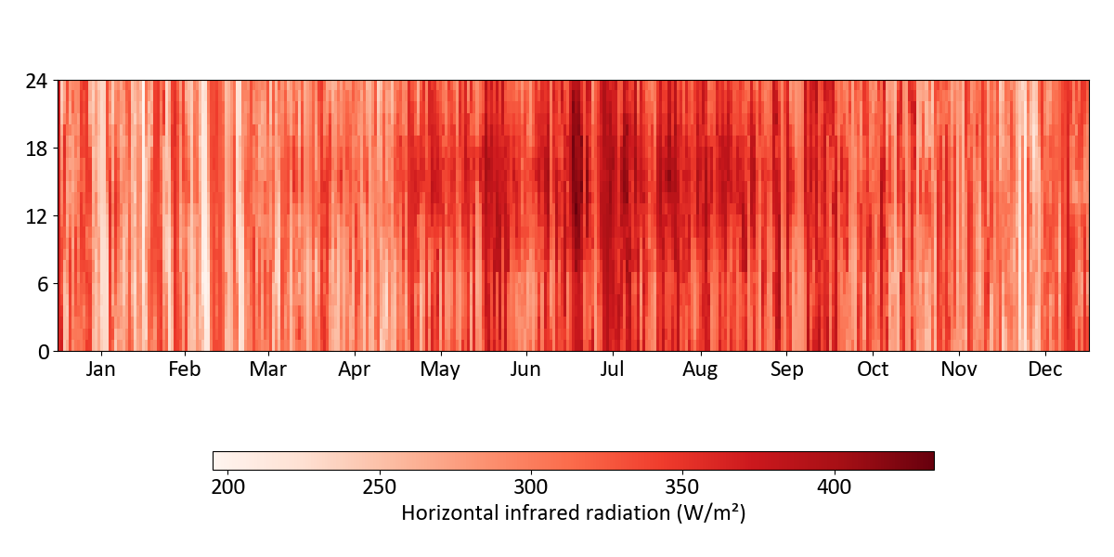
Figure 31: Horizontal infrared radiation (Heatmap)

6.7 Additional information and data sources
This report includes map data © OpenStreetMap contributors, licensed under the Open Database License (ODbL).

